Hijrah: The Onset of Islamic Calendar

Hijrah or Migration is the journey of Prophet Muhammad SAW from Makkah to Medina after thirteen years of persecution and hardships at the hands of his own family and tribe.
There are detailed accounts of it mentioned in many books and from multiple perspectives hence my goal is to help you extract messages from the story, rather than reiterating it. One crucial point to remember is that all events and decisions surrounding the migration were ordained by Allah SWT and were not generated by Prophet SAW or his companions. Their role was to accept, obey and fulfill the commands of Allah SWT.
Definition Of Hijrah
Linguistically, the word hijrah comes from the root word ha-ja-ra which means to let go, to completely leave something, to get away; status of separation; to change status—physically, emotionally, of belief, place, or habits. Thus, it is a word with multiple broad meanings.
From Islamic point of view, a person goes through various journeys of migration in his life where he strives and struggles against situations; which in other words is known as jihad. This is a constant state of struggle which will last until our death. The first state of migration is to migrate from disbelief to belief; from disobedience to obedience; from following desire, nafs, devil, temptation—jibillla (genetics) to the surrender and submission to the will of Allah SWT following the noble example of Prophet Muhammad SAW. This includes migration from the love of material life to the love of hereafter; the migration from being obsessed with carnal desires to sacrificing all you have for the pleasure of Allah SWT and the benefit of mankind.
Hence, we can see that there are many forms of migrations and when you examine Qur’an and Ahadeeth, there is a very important element that we can learn from this topic: Unless migration takes place, one cannot climb up the ladder of spirituality; neither can one develop himself and achieve salvation and closeness to Allah SWT. It is this internal migration that allows a person to challenge and eventually change the status quo.

The Purpose Of Migration
The result of the migration depends on the intention.
Rasul Allah SAW said:
"Verily actions are by intentions, and for every person is what he intended. So the one whose hijra was to Allaah and His Messenger, then his hijrah was to Allaah and His Messenger. And the one whose hijrah was for the world to gain from it, or a woman to marry her, then his hijrah was to what he made hijrah for."
Now let’s examine why the migration of the Prophet SAW was very significant to him, to the companions, to Islam, and the future of mankind. Based on that we will be able to reflect on our lives and see if we have migrated or are willing to do so.
What Were the Conditions before the Prophet’s Migration?
Prophet SAW endured hardships and various forms of oppression and aggression, on himself and his companions, for a period of thirteen years. This hostile environment kept getting worse until there came a point where Muslims could not grow and live freely in peace to nurture their faith and to spread the message of Islam. The opposition reached a point where normal life and safety was impossible for individuals or groups of Muslims. When this situation became unbearable, Allah SWT allowed Muslims to leave to a better environment.
Here we need to stop and examine ourselves; we have to ask if we are living in an environment—individually or collectively—which is preventing us from developing our faith and spreading it; thus preventing us from fulfilling the purpose of our lives? If this is the case, then Islam advices us to move to an environment that is conducive to our faith and allows us to live freely.
A very important point to note here is that according to the sunnah of Allah, the main obstacle in the middle of a situation is not the oppression or opposition, rather it is the love and attachment of a person towards a person, place or object. The companions of the Prophet SAW were ordered to migrate and they left behind their beloved country, land, oasis, trees, water wells, animals—meaning everything of value that they owned. In simple words, they lost everything to fulfill one single command of migration—and even that to an unknown place with an unknown future.
The reason I explain it in these words is because the goal of migration is high. It is to check your sincerity, love, and your obedience to Allah SWT. It is simple yet very tough; this is where majority of the people become weak inside and are defeated in their spiritual struggles.
From A Shallow External Analysis,
The Journey Of The Prophet From Makkah To Medina
Might Seem That Of Weakness And Defeat;
But In Reality It Was A Strong Display Of Obedience And Faith
Which Was Rewarded Many Years Later By Allah SWT
In The Form Of Strength, Victory, Ability, And Elevation
Today—individuals, families or societies—are being held back from taking the steps towards migration due to their attachment to material life. This is the main point which I want you to comprehend through this article.
Immigrants and Supporters Receive the Honor and Acceptance of Allah
The Medinan Host--Al-Ansar:
The local residents of Medina who embraced Islam and welcomed Makkan migrants were asked to share all that they owned with their migrant brothers. They came to be known as Al-Ansar, the supporters, and received the pleasure of Allah in this life and the hereafter.
When We Discuss The Topic Of Migration
We Have To Understand As A Muslim That…
At Any Given Moment,
We Are Either On The Journey Of Migration Ourselves,
Or Are Supporters Of Immigrants.
This cycle will continue until the end of life but today we do not comprehend it and this is why the rich become richer, the poor become poorer, and the net of brotherhood between Muslims has been ripped apart. I heard a person say once that rich Muslims are in reality very poor because what they have, they don’t own; it’s in reality just a trust which they are required to spend according to the commands of Allah. By this way, the more one earns and owns, the poorer he will be on the Day of Judgment because we don’t own anything in life except what we spend in the way of Allah SWT. This struggle and support for sabeelillah is what generates the bond of brotherhood and strengthens us in order to establish the deen of Allah on earth.
This incidence of migration generated the first Muslim nation: the nucleus of which were the Muhajireen and Ansar. Allah SWT allowed them to love each other, support each other and sacrifice for each other in order to establish the Muslim nation. The pillars of this nation were the love of Allah, his Prophet SAW, of believers, and of Akhirah above any other love. Once we are able to establish that, the rest becomes easy and is given as a gift from Allah SWT. This love garners the blessings of Allah SWT and elevates Muslims who in turn elevate the deen of Allah.
Now go ahead and read the story of migration of Rasul Allah SAW from every aspect or listen to it from different scholars and I want you to come to a conclusion—Where are you? Are you in Makkah or Medina? Are you an immigrant? Supporter? Or both? What is your goal? And what do you want to accomplish?
Ponder over the following verses and ahadeeth related to this topic; contemplate, think about them and try to gain wisdom from them.
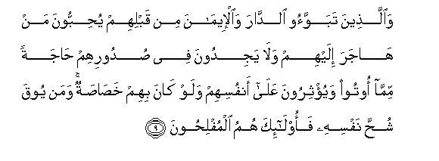
59:9 But those who before them, had homes (in Medina) and had adopted the Faith,- show their affection to such as came to them for refuge, and entertain no desire in their hearts for things given to the (latter), but give them preference over themselves, even though poverty was their (own lot). And those saved from the covetousness of their own souls,- they are the ones that achieve prosperity.
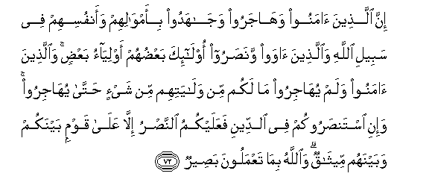
8:72 Those who believed, and adopted exile, and fought for the Faith, with their property and their persons, in the cause of Allah, as well as those who gave (them) asylum and aid,- these are (all) friends and protectors, one of another. As to those who believed but came not into exile, ye owe no duty of protection to them until they come into exile; but if they seek your aid in religion, it is your duty to help them, except against a people with whom ye have a treaty of mutual alliance. And (remember) Allah seeth all that ye do.
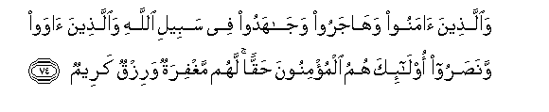
8:74 Those who believe, and adopt exile, and fight for the Faith, in the cause of Allah as well as those who give (them) asylum and aid,- these are (all) in very truth the Believers: for them is the forgiveness of sins and a provision most generous.
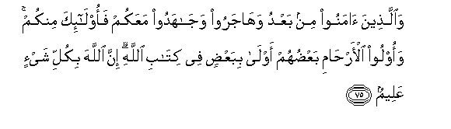
8:75 And those who accept Faith subsequently, and adopt exile, and fight for the Faith in your company,- they are of you. But kindred by blood have prior rights against each other in the Book of Allah. Verily Allah is well-acquainted with all things.
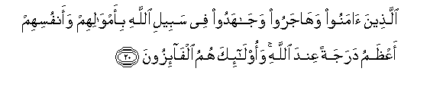
9:20 Those who believe, and suffer exile and strive with might and main, in Allah's cause, with their goods and their persons, have the highest rank in the sight of Allah; they are the people who will achieve (salvation).
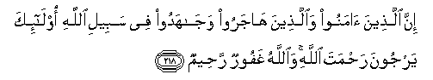
2:218 Those who believed and those who suffered exile and fought (and strove and struggled) in the path of Allah,- they have the hope of the Mercy of Allah. And Allah is Oft-forgiving, Most Merciful.

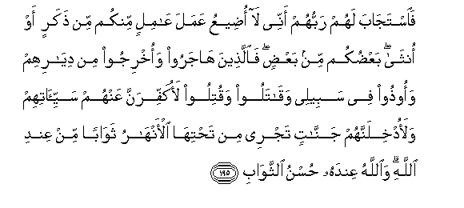
3:195 And their Lord hath accepted of them, and answered them: "Never will I suffer to be lost the work of any of you, be he male or female: Ye are members, one of another: Those who have left their homes, or been driven out therefrom, or suffered harm in My Cause, or fought or been slain,- verily, I will blot out from them their iniquities, and admit them into Gardens with rivers flowing beneath;- A reward from the presence of Allah, and from His presence is the best of rewards."
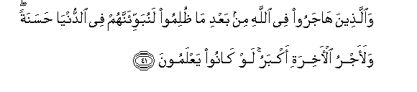
16:41 To those who leave their homes in the cause of Allah, after suffering oppression,- We will assuredly give a goodly home in this world; but truly the reward of the Hereafter will be greater. If they only realised (this)!
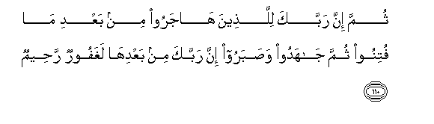
16:110 But verily thy Lord,- to those who leave their homes after trials and persecutions,- and who thereafter strive and fight for the faith and patiently persevere,- Thy Lord, after all this is oft-forgiving, Most Merciful.
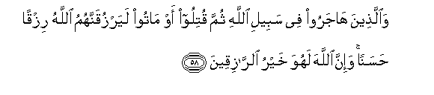
22:58 Those who leave their homes in the cause of Allah, and are then slain or die,- On them will Allah bestow verily a goodly Provision: Truly Allah is He Who bestows the best provision.

8:72 Those who believed, and adopted exile, and fought for the Faith, with their property and their persons, in the cause of Allah, as well as those who gave (them) asylum and aid,- these are (all) friends and protectors, one of another. As to those who believed but came not into exile, ye owe no duty of protection to them until they come into exile; but if they seek your aid in religion, it is your duty to help them, except against a people with whom ye have a treaty of mutual alliance. And (remember) Allah seeth all that ye do.
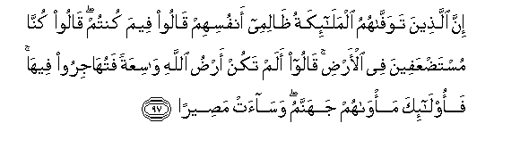
4:97 When angels take the souls of those who die in sin against their souls, they say: "In what (plight) Were ye?" They reply: "Weak and oppressed Were we in the earth." They say: "Was not the earth of Allah spacious enough for you to move yourselves away (From evil)?" Such men will find their abode in Hell,- What an evil refuge! –
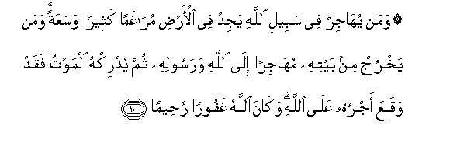
4:100 He who forsakes his home in the cause of Allah, finds in the earth Many a refuge, wide and spacious: Should he die as a refugee from home for Allah and His Messenger, His reward becomes due and sure with Allah. And Allah is Oft-forgiving, Most Merciful.
8:72 Those who believed, and adopted exile, and fought for the Faith, with their property and their persons, in the cause of Allah, as well as those who gave (them) asylum and aid,- these are (all) friends and protectors, one of another. As to those who believed but came not into exile, ye owe no duty of protection to them until they come into exile; but if they seek your aid in religion, it is your duty to help them, except against a people with whom ye have a treaty of mutual alliance. And (remember) Allah seeth all that ye do.
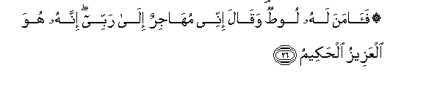
29:26 But Lut had faith in Him: He said: "I will leave home for the sake of my Lord: for He is Exalted in Might, and Wise."
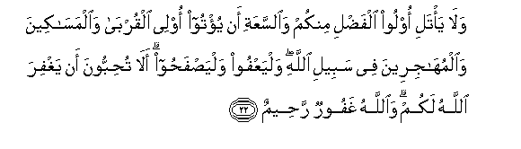
24:22 Let not those among you who are endued with grace and amplitude of means resolve by oath against helping their kinsmen, those in want, and those who have left their homes in Allah's cause: let them forgive and overlook, do you not wish that Allah should forgive you? For Allah is Oft-Forgiving, Most Merciful.
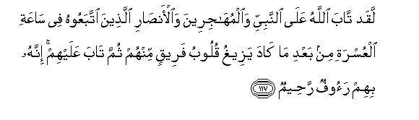
9:117 Allah turned with favour to the Prophet, the Muhajirs, and the Ansar,- who followed him in a time of distress, after that the hearts of a part of them had nearly swerved (from duty); but He turned to them (also): for He is unto them Most Kind, Most Merciful.
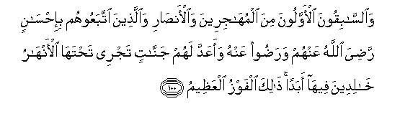
9:100 The vanguard (of Islam)- the first of those who forsook (their homes) and of those who gave them aid, and (also) those who follow them in (all) good deeds,- well- pleased is Allah with them, as are they with Him: for them hath He prepared gardens under which rivers flow, to dwell therein for ever: that is the supreme felicity.

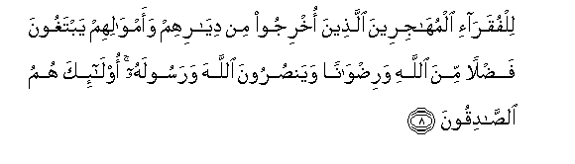
59:8 (Some part is due) to the indigent Muhajirs, those who were expelled from their homes and their property, while seeking Grace from Allah and (His) Good Pleasure, and aiding Allah and His Messenger. such are indeed the sincere ones:-
Anas Ibn Malik related that Allah's Apostle said, "There is no life except the life of the Hereafter; so, O Allah! Improve the state of the Ansar and the muhajirun." And Anas added that the Prophet also said, "O Allah! Forgive the Ansar."
The Prophet said, "A Muslim is the one who avoids harming Muslims with his tongue and hands. And a muhajir (emigrant) is the one who gives up (abandons) all what Allah has forbidden."
If we divert from the path of migration and become busy with the materialistic accomplishments of this transitory world, then we are asking for the sunnah of Allah to be repeated--which is the eventual disgrace in this life and the hereafter. The fall of Muslim Spain, Baghdad, and the Central Asian civilizations are some examples of this sunnah of Allah SWT. The following verses will help you comprehend the message further, InshaAllah:
Surah Al-An'am: 115—117
The word of thy Lord doth find its fulfilment in truth and in justice: None can change His words: for He is the one who heareth and knoweth all. Wert thou to follow the common run of those on earth, they will lead thee away from the way of Allah. They follow nothing but conjecture: they do nothing but lie. Thy Lord knoweth best who strayeth from His way: He knoweth best who they are that receive His guidance.

Surah Al-An'am: 128—135
One day will He gather them all together, (and say): "O ye assembly of Jinns! Much (toll) did ye take of men." Their friends amongst men will say: "Our Lord! we made profit from each other: but (alas!) we reached our term - which thou didst appoint for us." He will say: "The Fire be your dwelling-place: you will dwell therein for ever, except as Allah willeth." for thy Lord is full of wisdom and knowledge. Thus do we make the wrong-doers turn to each other, because of what they earn. "O ye assembly of Jinns and men! came there not unto you apostles from amongst you, setting forth unto you My signs, and warning you of the meeting of this Day of yours?" They will say: "We bear witness against ourselves." It was the life of this world that deceived them. So against themselves will they bear witness that they rejected Faith. (The apostles were sent) thus, for thy Lord would not destroy for their wrong-doing men's habitations whilst their occupants were unwarned. To all are degrees (or ranks) according to their deeds: for thy Lord is not unmindful of anything that they do. Thy Lord is self-sufficient, full of Mercy: if it were His will, He could destroy you, and in your place appoint whom He will as your successors, even as He raised you up from the posterity of other people. All that hath been promised unto you will come to pass: nor can ye frustrate it (in the least bit). Say: "O my people! Do whatever ye can: I will do (my part): soon will ye know who it is whose end will be (best) in the Hereafter: certain it is that the wrong- doers will not prosper."

Surah Al-An'am: 155
And this is a Book which We have revealed as a blessing: so follow it and be righteous, that ye may receive mercy.

Surah Al-An'am: 157—160
Or lest ye should say: "If the Book had only been sent down to us, we should have followed its guidance better than they." Now then hath come unto you a clear (sign) from your Lord,- and a guide and a mercy: then who could do more wrong than one who rejecteth Allah's signs, and turneth away therefrom? In good time shall We requite those who turn away from Our signs, with a dreadful penalty, for their turning away. Are they waiting to see if the angels come to them, or thy Lord (Himself), or certain of the signs of thy Lord! the day that certain of the signs of thy Lord do come, no good will it do to a soul to believe in them then if it believed not before nor earned righteousness through its faith. Say: "Wait ye: we too are waiting." As for those who divide their religion and break up into sects, thou hast no part in them in the least: their affair is with Allah. He will in the end tell them the truth of all that they did. He that doeth good shall have ten times as much to his credit: He that doeth evil shall only be recompensed according to his evil: no wrong shall be done unto (any of) them.

Surah Al-An'am: 104—106
"Now have come to you, from your Lord, proofs (to open your eyes): if any will see, it will be for (the good of) his own soul; if any will be blind, it will be to his own (harm): I am not (here) to watch over your doings."Thus do we explain the signs by various (symbols): that they may say, "Thou hast taught (us) diligently," and that We may make the matter clear to those who know. Follow what thou art taught by inspiration from thy Lord: there is no god but He: and turn aside from those who join gods with Allah.

Surah Al-An'am: 92
And this is a Book which We have sent down, bringing blessings, and confirming (the revelations) which came before it: that thou mayest warn the mother of cities and all around her. Those who believe in the Hereafter believe in this (Book), and they are constant in guarding their prayers.

Surah Al-An'am: 70
Leave alone those who take their religion to be mere play and amusement, and are deceived by the life of this world. But proclaim (to them) this (truth): that every soul delivers itself to ruin by its own acts: it will find for itself no protector or intercessor except Allah. if it offered every ransom, (or reparation), none will be accepted: such is (the end of) those who deliver themselves to ruin by their own acts: they will have for drink (only) boiling water, and for punishment, one most grievous: for they persisted in rejecting Allah.

Surah Al-An'am: 68
When thou seest men engaged in vain discourse about Our signs, turn away from them unless they turn to a different theme. If Satan ever makes thee forget, then after recollection, sit not thou in the company of those who do wrong.

Surah Al-An'am: 66—67

But thy people reject this, though it is the truth. Say: "Not mine is the responsibility for arranging your affairs; For every message is a limit of time, and soon shall ye know it."

Surah Al-An'am: 54—65
When those come to thee who believe in Our signs, Say: "Peace be on you: Your Lord hath inscribed for Himself (the rule of) mercy: verily, if any of you did evil in ignorance, and thereafter repented, and amend (his conduct), lo! He is Oft- forgiving, Most Merciful. Thus do We explain the signs in detail: that the way of the sinners may be shown up. Say: "I am forbidden to worship those - others than Allah - whom ye call upon." Say: "I will not follow your wain desires: If I did, I would stray from the path, and be not of the company of those who receive guidance." Say: "For me, I (work) on a clear sign from my Lord, but ye reject Him. What ye would see hastened, is not in my power. The command rests with none but Allah. He declares the truth, and He is the best of judges." Say: "If what ye would see hastened were in my power, the matter would be settled at once between you and me. But Allah knoweth best those who do wrong." With Him are the keys of the unseen, the treasures that none knoweth but He. He knoweth whatever there is on the earth and in the sea. Not a leaf doth fall but with His knowledge: there is not a grain in the darkness (or depths) of the earth, nor anything fresh or dry (green or withered), but is (inscribed) in a record clear (to those who can read). It is He who doth take your souls by night, and hath knowledge of all that ye have done by day: by day doth He raise you up again; that a term appointed be fulfilled; In the end unto Him will be your return; then will He show you the truth of all that ye did. He is the irresistible, (watching) from above over His worshippers, and He sets guardians over you. At length, when death approaches one of you, Our angels take his soul, and they never fail in their duty. Then are men returned unto Allah, their protector, the (only) reality: Is not His the command? and He is the swiftest in taking account. Say: "Who is it that delivereth you from the dark recesses of land and sea, when ye call upon Him in humility and silent terror: 'If He only delivers us from these (dangers), (we vow) we shall truly show our gratitude'.?" Say "It is Allah that delivereth you from these and all (other) distresses: and yet ye worship false gods!" Say: "He hath power to send calamities on you, from above and below, or to cover you with confusion in party strife, giving you a taste of mutual vengeance - each from the other." See how We explain the signs by various (symbols); that they may understand.

Surah Kahf: 54—59

We have explained in detail in this Qur'an, for the benefit of mankind, every kind of similitude: but man is, in most things, contentious. And what is there to keep back men from believing, now that Guidance has come to them, nor from praying for forgiveness from their Lord, but that (they ask that) the ways of the ancients be repeated with them, or the Wrath be brought to them face to face? We only send the apostles to give Glad Tidings and to give warnings: But the unbelievers dispute with vain argument, in order therewith to weaken the truth, and they treat My Signs as a jest, as also the fact that they are warned! And who doth more wrong than one who is reminded of the Signs of his Lord, but turns away from them, forgetting the (deeds) which his hands have sent forth? Verily We have set veils over their hearts lest they should understand this, and over their ears, deafness, if thou callest them to guidance, even then will they never accept guidance. But your Lord is Most forgiving, full of Mercy. If He were to call them (at once) to account for what they have earned, then surely He would have hastened their punishment, but they have their appointed time, beyond which they will find no refuge. Such were the populations we destroyed when they committed iniquities; but we fixed an appointed time for their destruction.

When Does It Become Necessary to Migrate:
Islam is deen, a way of life, which governs all aspects of our lives from fulfilling our basic carnal needs to the government of a nation. The message of Islam is to establish the khilafah or the religion of Allah in our lives and eventually in earth. Islam teaches us that any time we are in a hostile environment which is preventing us from growing in faith and establishing the deen of Allah in our lives, we have to struggle and migrate to a healthy environment which will allow us to freely implement our religion.
At any given time, we are either in a state of receiving or giving. We can either be sharing goodness or receiving it, or sharing evil or receiving it. If we are in a hostile environment, we cannot share or receive goodness hence we become vulnerable towards becoming corrupted. At this point, we have to migrate because if we do not do so, we will be enslaved to an environment which can paralyze our spiritual growth and weaken us to the point we are neither able to practice the deen in our lives nor carry it to mankind.
This migration can only happen when we are fully committed to the momentous task granted to us: the call of Islam to humanity. This commitment to Allah and His religion has to be above attachment to any relationship, place, or object because the journey of Iman is of higher priority than everything else. This gives us strength to sacrifice any worldly material to achieve the level Allah wants us to achieve. This is the opposite of what we see today; today we are afraid to migrate because we are scared to lose material status, a loved one, or a worldly opportunity. A person will never be able to fully migrate until he has complete reliance and trust in Allah SWT and believes that Allah SWT will be there for him at any given time.
The companions of RasulAllah SAW had this unshakable trust and belief in Allah and that is why they were able to accomplish what we cannot even comprehend today. Below we will provide glimpses from the lives of a few companions whose contributions towards the migration of our Prophet SAW as well as their own migrations are like shining stars on the sky of heroism and self sacrifice.
AbuBakr As-Siddeeq RA:
AbuBakr RA has no parallel in faith. He is the illustrious figure in the realm of belief after the messengers and prophets. He was chosen by Allah SWT to accompany the Prophet SAW on this most dangerous yet significant journey. Allah SWT honored him with the title of “second of the two” in the Qur’an by mentioning his companionship of the Prophet SAW during hijrah. AbuBakr RA cried with joy when he was told by the Prophet SAW that he will be accompanying him (SAW) on the journey. He (RA) is the one who arranged the mounts as well as the guide for the journey and it was his family that faithfully kept their secret until the threat of Quraysh retaliation was averted. It was Abdullah, the son of AbuBakr who gathered the news during the day from Quraysh and informed Prophet SAW and his father at night while they were hiding in the cave of Thawr. It was the brave, young daughter of AbuBakr, Asma, who was responsible for providing food to the refugees on the treacherous mountain. It was the slave of AbuBakr RA who grazed his animals around the mountain trek leading to the cave in order to hide the visitors’ treks as well as to assure the safety of the noble migrants.
It was AbuBakr who would enter any cave first during their journey to make sure he is the one stung instead of the Prophet SAW if there is a snake or scorpion hiding inside. He (RA) would ride on the right, left, front, and behind the Prophet SAW and when questioned said that he couldn’t help doing it when he perceived the danger that might be inflicted on the Prophet SAW by his enemies. It was the young daughter of this noble family, Aisha, who was granted the honor of being the mother of the believers and one of the noblest scholars of Islam.
Ali Ibn Abi Talib RA:
He is the cousin of the Prophet, his son-in-law and one of the earliest and youngest convert to Islam. When Allah ordered His Prophet SAW to migrate, it was Ali that he SAW chose with the task of returning the trusts of the Makkans that were in his possession. It was Ali that he trusted because of his courage and nobility. Imagine the danger of the task when men are waiting outside to stab the Prophet SAW to death and by impersonating him, Ali is at the risk of being killed. What kind of love and trust does it take to accept a task like that?
Zanneera RA:
The story of Zanneera is that of courage and faith for believers at all times. She was a freed slave who attempted to migrate but was captured by her tribe and severely punished to the point she lost her eyesight. Her tribe claimed that it was a punishment from the pagan gods for her embracing Islam. She made du’a to Allah SWT, begging him not to let her be a source of fitna for Islam by her tribe claiming so. Allah SWT sent an angel from the heaven with a bucket of water that cured her and led her tribe to Islam.
Allah SWT granted these people his pleasure and those who follow them in the following words:
The vanguard (of Islam)- the first of those who forsook (their homes) and of those who gave them aid, and (also) those who follow them in (all) good deeds,- well- pleased is Allah with them, as are they with Him: for them hath He prepared gardens under which rivers flow, to dwell therein for ever: that is the supreme felicity. (9:100)

If we sincerely compare our lives to theirs, we will notice that we do opposite of what they did. They sacrificed their dunya for akhirah whereas we sacrifice our akhirah for duniya. Allah SWT, by His mercy, has left open the door of His pleasure that the companions attained for those who strive to follow their example. The real migration to the way of Allah SWT is our only hope of success in this life and the hereafter, and it is a journey worth taking.

Daee Ahmed Moait
www.noora1.com

