قاموس السعادة فى القرآن
THE CONSTITUTION OF HAPPINESS IN QUR’AN

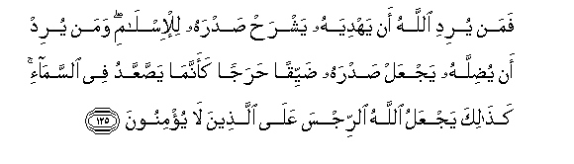
So whoever Allah wants to guide - He expands his breast to [contain] Islam; and whoever He wants to misguide - He makes his breast tight and constricted as though he were climbing into the sky. Thus does Allah place defilement upon those who do not believe. [Al-An’am 6:125]
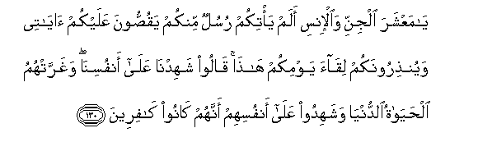
"O company of jinn and mankind, did there not come to you messengers from among you, relating to you My verses and warning you of the meeting of this Day of yours?" They will say, "We bear witness against ourselves"; and the worldly life had deluded them, and they will bear witness against themselves that they were disbelievers. [Al-An’am 6:130]
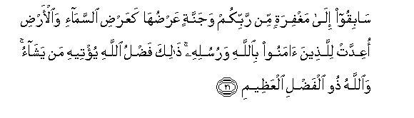
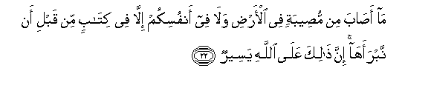
Race toward forgiveness from your Lord and a Garden whose width is like the width of the heavens and earth, prepared for those who believed in Allah and His messengers. That is the bounty of Allah which He gives to whom He wills, and Allah is the possessor of great bounty.
No disaster strikes upon the earth or among yourselves except that it is in a register before We bring it into being - indeed that, for Allah , is easy – [Al-Hadid 57:21—22]
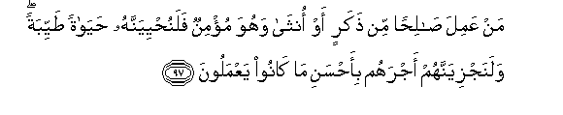
Whoever does righteousness, whether male or female, while he is a believer - We will surely cause him to live a good life, and We will surely give them their reward [in the Hereafter] according to the best of what they used to do. [An-Nahl 16:97]
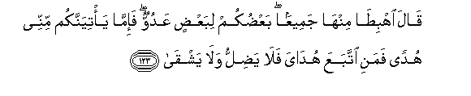
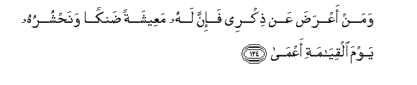
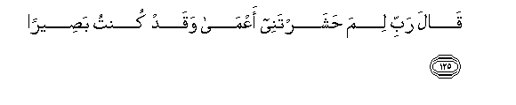
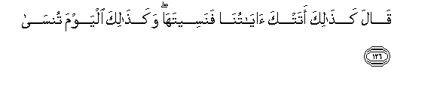
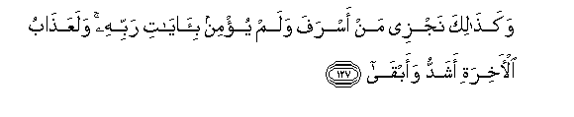
[ Allah ] said, "Descend from Paradise - all, [your descendants] being enemies to one another. And if there should come to you guidance from Me - then whoever follows My guidance will neither go astray [in the world] nor suffer [in the Hereafter].
And whoever turns away from My remembrance - indeed, he will have a depressed life, and We will gather him on the Day of Resurrection blind."
He will say, "My Lord, why have you raised me blind while I was [once] seeing?"
[ Allah ] will say, "Thus did Our signs come to you, and you forgot them; and thus will you this Day be forgotten."
And thus do We recompense he who transgressed and did not believe in the signs of his Lord. And the punishment of the Hereafter is more severe and more enduring. [TaHa 20:123—127]
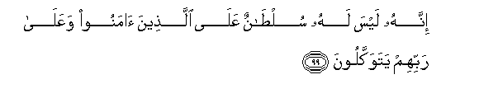

Indeed, there is for him no authority over those who have believed and rely upon their Lord.
His authority is only over those who take him as an ally and those who through him associate others with Allah. [An-Nahl 16:99—100]

