CONDITION OF THE UMMAH

PART 2

WHO IS RUNNING THE SHOW?
September 7th 2001


Exalt the name of your Lord, the Most High, Who created and proportioned, And Who destined and [then] guided. (Al A’la 87:1—3)
DO WE KNOW OUR RABB?
In these verses we are reminded to glorify Allah’s magnificence and grandeur in His role as our Rabb. Rabb is a term that encompasses many meanings: provider, sustainer, ruler, controller, master, governor and the caretaker, all in one. The relationship of the Rabb and his slave is much more intimate than the relationship of a Deity and his devotee.
Allah SWT uses the term Rabb as a means to reassure His slaves that they are in good hands. The Rabb who is managing their affairs is the one who has created them and all that is around them in perfect order. This eliminates any reason for doubt or uncertainty from the slaves and assures them that they are in good hands.
Allah SWT is not only the Rabb who has perfected His creation; He SWT is also Al-Qadir—the one who has destined. Nothing can happen without the will and permission of Allah. His knowledge and ability (qudrah) are above and beyond our limited understanding. Before He SWT even created anything, He decided our taqdeer, fate — meaning nothing happens at random or accidentally, without the wisdom of Allah SWT.
Many of Allah SWT’s attributes point to His all encompassing taqdeer:
- Al-Hakeem (The Wise),
- As-Samee’ (The All Hearer),
- Al-Baseer (The All Seer),
- Al-Khabeer (The All Knower),
- Al-Lateef (The one who has the ultimate detailed knowledge of all things—seen and unseen, past and present.)
Belief in these attributes removes all anxieties, uncertainties and sorrows from the believers and allows them to have more productive and fulfilling lives than the unbelievers.
WE ARE BELIEVERS OF QADR—
GOOD AND BAD
Belief in the Qadr or destiny is a part of our faith. We have to believe that if something happens without our interference and plan, then it is our destiny which was ordained by Allah SWT.
When we face the Qadr that Allah SWT has ordained for us, we have three duties as believers:
1. To thank Allah SWT whether we like or dislike what happened.
2. To believe that whatever happened was best for us.
3. To be patient and believe in the promise of Allah SWT even if we do not comprehend what is going on and think that it might be harmful for us.
It is not the quality of believers to be agitated when something against their will happens and be afraid of the ensuing circumstances. They remain calm and collected because of their belief in their Rabb as As-Samee’, Al-Baseer and Al-Qadir. Agitation, uncertainty, and doubt are qualities of disbelievers and those of very weak iman. It leads them to lose this life and the hereafter as Allah SWT points out in the following verses:
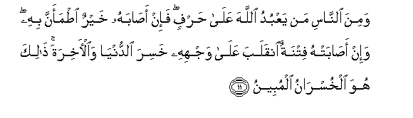
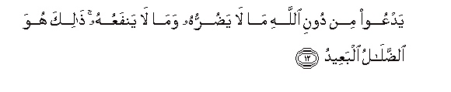
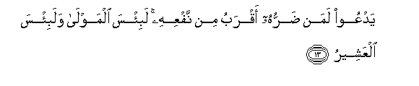
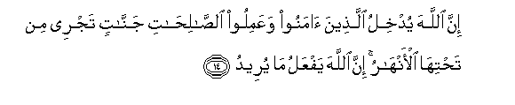
And of the people is he who worships Allah on an edge. If he is touched by good, he is reassured by it; but if he is struck by trial, he turns on his face [to the other direction]. He has lost [this] world and the Hereafter. That is what is the manifest loss.
He invokes instead of Allah that which neither harms him nor benefits him. That is what is the extreme error.
He invokes one whose harm is closer than his benefit - how wretched the protector and how wretched the associate.
Indeed, Allah will admit those who believe and do righteous deeds to gardens beneath which rivers flow. Indeed, Allah does what He intends. (Hajj 22: 11—14)
These verses carry a warning for those who believe and worship Allah but their belief in the Qadr is so weak it causes them to be rebellious and miserable when something against their will happens. This in fact takes them out of the state of belief.
PLACING OURSELVES AMONG THE REVELATION
Allah SWT revealed the Qur’an over a period of twenty-three years. Thirteen years of that time were spent in Makkah and the last ten in Medina. The teachings in Makkah and Medina were very different. The first period focused solely on the development of iman and Yaqeen — faith and certainty of belief in Allah — and the latter dealt with rules, regulations, and affairs of a developing nation.
Islamic scholars believe this pattern to be the sunnah of Allah and suggest that anyone who wants to revive Islam anytime, anywhere in the world has to follow this pattern of revelation. This makes it very important for us to reflect at our state of affairs and determine where we are today — Makkah or Medina.
No Muslim scholar will disagree with the opinion that we are at the beginning of the Makkan period. There are many parallels that can be drawn between our time and the time of Makkan society at the advent of Islam — economic, social, moral, and ethical.
When Islam first came, every Muslim had to develop his faith and was entrusted with two duties: to spread the message of Islam (also known as d’awah) and to support each other.
During the Makkan period, Muslims were a minority in a non-Muslim majority land and all the odds were against them. At this stage there was no struggle or resistance other than that of tongue and money. Those who were able to, spent all that they could in the path of Allah SWT. People like Abu Bakr RA, Uthman RA, and Khadeeja RA earned their ranks and status by spending all that they had in support of d’awah. The rich supported not only the poor and needy Muslims, but also Non-Muslims with whom they shared peaceful relations. The goal was one—Ta’leef al Qulub—unity of the hearts!
How many of us can spend our money the way Khadeeja RA did to the point the wealthiest woman in the Arabian Peninsula left this world in a state when she had almost nothing left?
How many of us won’t buckle under the kinds of physical abuse and suffering that Bilal RA and Khubaib RA did in order to uphold their faith?
How many of us can endure the challenges and remain steadfast like Salman Al-Farsi for the sake of our guidance?
There is no way we can spread Islam and revive its teachings in the world without willingness to spend and sacrifice whatever it takes of time, money and effort to elevate the deen of Allah—the kind of willingness and zeal displayed by the companions of the Prophet SAW.
WHO CAN WE BLAME BUT OURSELVES?
The Muslims of our generation have disregarded the importance of one aspect of their lives— their deen itself!
We care more about ourselves than about Islam and its future! We have forgotten Allah’s role as our Rabb and are so indulged in our own affairs that we are losing both this world and the next. Allah SWT has accepted the responsibility of being our Rabb and He will fulfill His responsibility. All He wants in return is our efforts for His deen!
Just look at what our negligence has done to the world?
What have we done in the lands we have migrated to?
What is the image of Islam and Muslims in those lands? Why?
We are satisfied with building beautiful masajid and schools while we have the relics of Al-Andalus among us. Despite its grandeur, wealth and beauty, we lost it. It is not the buildings that we need, rather hearts that are devoted to Allah, unity, brotherhood, leadership, and for each one of us—man, woman and child—to be role model and ambassador of Islam.
This has to be both internal and external!
Internal: By having a sincere intention to be the one who elevates the deen of Allah and spreads the message.
External: By our manners, character, behavior, respect, consideration, generosity, cleanliness, honesty, keeping our commitment etc.
The turmoil in the Muslim world and the current humiliating situation of Muslims everywhere is a wake-up call from Allah SWT. It is a nudge for us to get back on the right path. If we do not wake up, the subsequent calamities will be even more severe.
Allah SWT has a sunnah which never changes. Allah SWT will revive His deen — with us or without us. This revival will follow the same path that led to the spread of Islam in the Arabian Peninsula fourteen hundred years ago; it will not happen in any other way.
Today, majority of the Muslim groups that are trying to spread Islam are jumping the sunnah of Allah SWT; according to which the first step in revival of the deen is d’awah to the oneness of Allah. This sunnah is part of the Shari’ah; just like we cannot change the sequence of wudu and salah, we cannot change the sequence of the spread of the message of Islam. Can we perform sujood before the ruku’ even though both are part of salah? No. The sequence has to be observed!
No group or ideology will get the support of Allah or victory from Him because none of them follow the right sunnah of Allah and His Prophet.
Muslim groups today focus only on certain parts of Islam, while setting aside other important aspects of it.
Who has given us the right to do that?
Islam was completed by Prophet Muhammad SAW; we have to follow his methods and his teachings in order to gain blessings and victory from Allah SWT, not our whims and intellect. That is the real following of the sunnah of Allah and His Prophet SAW.
Our iman is so shaky that any difficulty, hardship, calamity — personal or societal — can weaken it. The fact that we are willing to abandon our faith and compromise its teachings out of fear of discrimination or loss of worldly status shows that our iman was never really established.
Two thirds of the Qur’an was revealed in Makkah and it talks about only one topic—Iman and Yaqeen! Today we are bereft of the sweetness of our deen, its very crux, which is iman, yaqeen, relaiance and trust in Allah SWT!
ARE WE BETTER THAN THE PROPHETS?
All the surahs in the Qur’an that start with the names of the messengers and prophets were revealed approximately during one year known as Aam al Huzn or the year of sorrow. This was the year when Prophet SAW lost his uncle and beloved wife Khadeeja RA and herewith lost both his physical and emotional support.
He was left without any means in his own land which he loved! Everything was against him and his companions. At this difficult time Allah SWT revealed these surahs to remind him that trials are a part of this journey of faith; that no one will pass this life without struggles; and that the higher the status of a person in the sight of his Lord, the more severe his trials will be.
The Story of Yusuf AS:
Yusuf AS’ story is called the most beautiful story by Allah SWT Himself. It is a proof of the might of Allah SWT and His taqdeer. Yusuf AS was snatched from the care of his father who was a Prophet and could have given him the best education. He was thrown in a well where he should have died, but was brought out and sent to a land where he was meant to alter the course of history. The life of Yusuf AS serves as a stark reminder of who is really running the show!
The Story of Musa AS:
The life of Musa AS is in defiance of all odds. Under the reign of the relentless Pharaoh, his odds of survival were low. His survival is the story of a Rabb taking care of His charge. It is the power and taqdeer of the One who is running the show! From his mother putting him in the river as a child to him crossing the split sea with the Children of Israel, Musa’s story is one that can make any believer prostrate to his Lord out of awe and wonder.
The Story of Yunus AS:
Yunus AS was swallowed by a whale and remained there until Allah SWT ordained. Why did Allah SWT put him in the belly of the whale? His mistake was using his own reasoning over the commands of Allah SWT. When asked to give d’awah, he changed the location because he felt the people he was asked to give d’awah to would not listen. For doing so, he was punished. Allah SWT did what never happened in history before. He SWT allowed the entire village to enter the fold of Islam without any messenger!
What lesson is Allah SWT teaching us?
He SWT is letting us know who the doer of all things is! Who is Al-Fattah (the opener) and Al-Hadi (the one who guides)!
Similar messages can be extracted from the stories of Isa AS, Hud AS, and Zakariyah AS. We will all receive our trials according to the level of our iman. The stronger the iman, the more severe the trials will be and the higher the reward will be. Regardless of the severity of the trials and tribulations, we cannot change the methods and commands of Allah SWT.
(Note: Please visit www.noora1.com for the videos and articles about the lives of the Messengers and Prophets.)
ACTIONS SPEAK LOUDER THAN WORDS
The problem is that our attitude towards d’awah is that of self glorification. Instead of begging Allah SWT for support and acceptance, we do it as if we have done Allah SWT a favor by telling others about Islam (Astaghfirullah).
We are farmers sowing the seeds. It is not in our power to grow the trees; it is in the hands of Allah SWT. From the time of the collapse of Ottoman Empire until now, all the Islamic groups have been aiming for the wrong goals. Their focus is on establishing the government or Khilafah, not on developing people’s faith.
How can one implement the rule of Allah over people who don’t even know Allah SWT?
We talk about the Western world. We complain about American foreign policy. We discuss the doings of United Nations. But where is our devotion to Allah SWT—our Rabb and His commands? Who do we believe is running the show?
If we were to implement only one sunnah, which is also a wajib, or mandatory, we can burn all the negative media coverage of Islam. This sunnah is the ‘right of the neighbor.’ If everyone takes care of their neighbors according to the teachings of Allah SWT and His Prophet SAW, Muslims would face less animosity and begin to change attitudes. Islamic history is filled with glorious examples of the Prophet SAW and his companions adhering to this practice.
We have the story of a neighbor of the Prophet SAW who tried her best to irritate him by throwing garbage in his way every day. One day, he SAW did not find any garbage which made him inquire about the old woman and he came to know that she was sick. The Prophet SAW went to visit her and offer any assistance she might need. The old woman was extremely humbled and ashamed of her actions. The compassion of the Prophet SAW moved her so much that she became convinced that Islam must be a true religion.
Abdullah Ibn Umar RA, son of Umar Ibn Khattab RA was known for his staunch following of the sunnah of the Prophet SAW. Once he slaughtered a sheep with the help of another Muslim. He told the fellow Muslim to take the best part of the sheep and give it to his Jewish neighbor. The man was surprised at this and asked Abdullah for the reason to which he RA said: “I saw the one better than you and me doing better than that” (meaning RasulAllah SAW).
If we don’t show non-Muslims what Islam is, who will?
All of our actions are seeds that we are planting. These seeds are either of flowers and fruits or thorns.
What does Allah SWT want from us?
He SWT wants us to exemplify the teachings of this religion in our actions and behavior. We can’t just talk the talk; we have to walk the walk. We have to put the seeds of generosity and kindness in our communities.
If we, Muslims, live according to the teachings of Islam we can change perceptions of our religion and alter the effects of the negative propaganda surrounding it. The only way enemies of Islam and those who sincerely do not know about the faith can succeed in spreading the wrong image of Islam is if we allow them with our negligence and the corrupted image of Islam by us!
No blaming, no complaining!
WARNINGS FROM ALLAH SWT
Calamities are a wake-up call from Allah SWT. They are used as a means of sifting—Allah SWT uses them to separate the believers from disbelievers and hypocrites. In Makkah, there were no hypocrites. Holding onto Islam was like holding onto a burning coal. It was not easy and the sunnah of Allah never changes!
If we don’t act now and change our actions and behavior and accept the responsibility of d’awah that Allah SWT has placed on us, the subsequent calamity will be tougher!
If we think that our money or status will save us, we do not know the sunnah of Allah. Everyone has to go through the sifter. It happened in Bosnia and Albania and it will happen everywhere else. We only have to look at the steady rise of Islamophobia in the Western world to drive this point home.
Allah SWT says in the Qur’an:

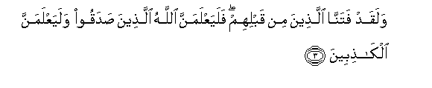
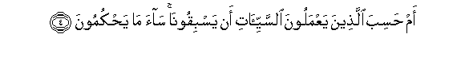
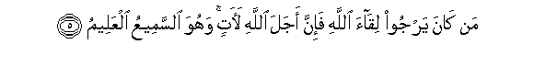
Alif, Lam, Meem. Do the people think that they will be left to say, "We believe" and they will not be tried? But We have certainly tried those before them, and Allah will surely make evident those who are truthful, and He will surely make evident the liars. Or do those who do evil deeds think they can outrun Us? Evil is what they judge. Whoever should hope for the meeting with Allah - indeed, the term decreed by Allah is coming. And He is the Hearing, the Knowing. (Al Ankabut 29:1—5)
HONOR IS IN THE HANDS OF OUR RABB
We can consistently derive one message from the Qur’an:
If we honor Allah SWT and the job that He has given us, He will give us victory and honor. If we do not honor Allah SWT and deny His message, we will be disgraced!
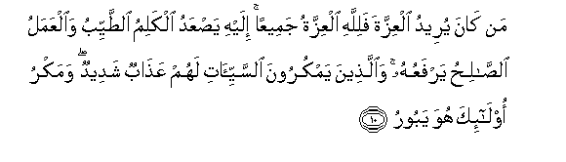
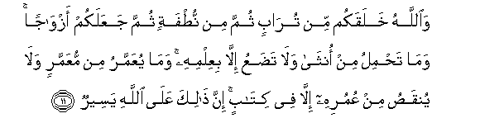
Whoever desires honor [through power] - then to Allah belongs all honor. To Him ascends good speech, and righteous work raises it. But they who plot evil deeds will have a severe punishment, and the plotting of those - it will perish. And Allah created you from dust, then from a sperm-drop; then He made you mates. And no female conceives nor does she give birth except with His knowledge. And no aged person is granted [additional] life nor is his lifespan lessened but that it is in a register. Indeed, that for Allah is easy. (Al Fatir 35: 10-11)
Honor is a status that Allah gives us in our hearts! If we are killed but we have Allah in our hearts, it is an honor. Whereas if we are millionaires but do not have Allah SWT in our hearts, it is a disgrace.
How do we know whether we are honored or not?
When we have…
- no fear of anyone in our hearts except that of Allah SWT,
- when we do not care for anyone’s approval except that of Allah SWT, and
- when our love for Allah and His deen is above all else and we are willing to sacrifice all that we have for this love
…we have been honored by our Rabb!
WHERE IS OUR FAITH?
A group of Muslims tried to guard Ali RA during the time of civil strife. He asked them whether they were trying to protect him from his enemy or his destiny. They replied, “The enemy.” He RA said, “My enemy cannot do anything to me without the qadr of Allah and you cannot stop the qadr of Allah, so leave.”
This is a glorious example of Iman and Yaqeen in the One who is in command!
May Allah SWT allow us to wake up from this state of heedlessness before it is too late and allow us to recognize the qualities of our Rabb—the One who is really running the show!

Refer to the article series “Journey of Victory vs. Journey of Defeat” for an in-depth understanding of this topic.

