In The Name of Allah, The Beneficent The Merciful
Journey of Victory vs. Journey of Defeat
In the previous articles, we have already established the understanding that victory and defeat are purely internal affairs. When a person is victorious inside, this victory is manifested outside, and the same goes for defeat. We have talked about the dangers of relaxation when it comes to following the deen, the elements of victory and defeat, and how to be vigilant about your actions to determine if you are on the journey of victory or defeat. We discussed the sunnah of Allah and how it is the same regardless of time, place, and people; as well as the pillars of victory which are needed for the facilitation of the construction of strong, sturdy people and nation. In this article we will look at the word ‘victory’ itself and how it is used by Allah SWT in Qur’an, InshaAllah.
Victory: In the Words of the Almighty
Nasr or victory encompasses meanings like support, help, and provision, taking care of your affairs, or giving you the upper hand. Allah SWT has used the word Nasr about 110 times through the Qur’an in multiple variations depending on the context. In Surah 110 titled An-Nasr, Allah SWT says:

When comes the Help of Allah, and Victory, And thou dost see the people enter Allah's Religion in crowds, Celebrate the praises of thy Lord, and pray for His Forgiveness: For He is Oft-Returning (in Grace and Mercy).
Victory for Prophet Muhammad SAW was to convey the message of Islam and for Allah to accept his work and spread it.
In Surah Al-Imran, ayah 123 Allah SWT says:
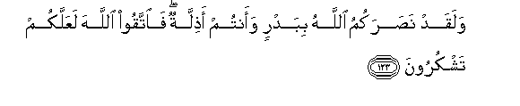
Allah had helped you at Badr, when ye were a contemptible little force; then fear Allah. Thus May ye show your gratitude.
At this instance, the word victory means upper hand and divine support in the battlefield.
Allah SWT goes on to say in Surah Tawba, ayah 25:
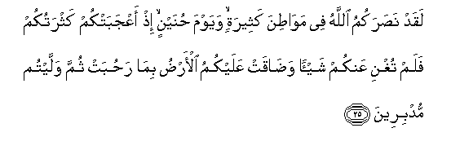
Assuredly Allah did help you in many battle-fields and on the day of Hunain: Behold! your great numbers elated you, but they availed you naught: the land, for all that it is wide, did constrain you, and ye turned back in retreat.

Allah SWT is reminding believers about the hardship at Hunain when they were excited about their large numbers yet it didn’t help them; it was Allah who gave them victory after this severe hardship. Allah SWT is making something very clear: It is not the ammunition or your large numbers, rather it is ONLY Allah that grants you victory.

In Surah Anfal, ayah 74 the word Nasr takes on a different meaning:
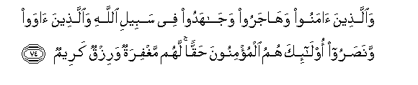
Those who believe, and adopt exile, and fight for the Faith, in the cause of Allah as well as those who give (them) asylum and aid,- these are (all) in very truth the Believers: for them is the forgiveness of sins and a provision most generous.

Surah A’raf, ayah 157:

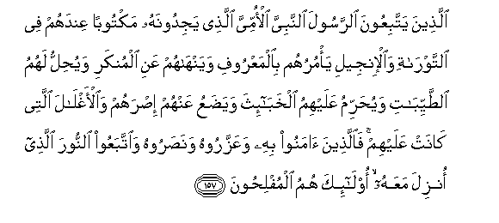
"Those who follow the apostle, the unlettered Prophet, whom they find mentioned in their own (scriptures),- in the law and the Gospel;- for he commands them what is just and forbids them what is evil; he allows them as lawful what is good (and pure) and prohibits them from what is bad (and impure); He releases them from their heavy burdens and from the yokes that are upon them. So it is those who believe in him, honour him, help him, and follow the light which is sent down with him,- it is they who will prosper."
Surah Muhammad, ayah 7:

O ye who believe! If ye will aid (the cause of) Allah, He will aid you, and plant your feet firmly.
Allah SWT wants us to hold Him higher than anything in our lives and He will give us victory. He SWT goes on to reaffirm that in the following verses:

Surah Ghafir, ayah 51:
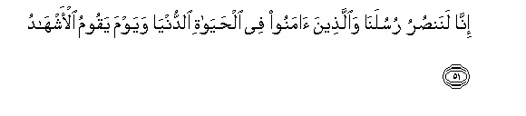
“We will, without doubt, help our apostles and those who believe, (both) in this world's life and on the Day when the Witnesses will stand forth”

Surah Rum, ayah 5:

With the help of Allah. He helps whom He will, and He is exalted in might, most merciful.
Surah Fath, ayah 3:

And that Allah may help thee with powerful help.

Surah Al-Imran, ayah 160:
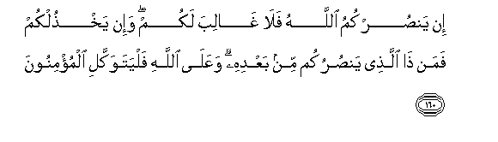
If Allah helps you, none can overcome you: If He forsakes you, who is there, after that, that can help you? in Allah, then, Let believers put their trust.

Surah Hajj, ayah 40:
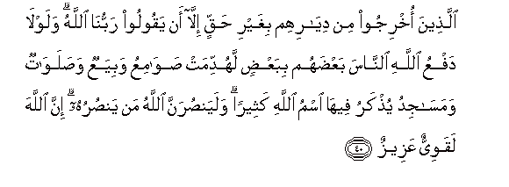
(They are) those who have been expelled from their homes in defiance of right,- (for no cause) except that they say, "our Lord is Allah.. Did not Allah check one set of people by means of another, there would surely have been pulled down monasteries, churches, synagogues, and mosques, in which the name of Allah is commemorated in abundant measure. Allah will certainly aid those who aid his (cause);- for verily Allah is full of Strength, Exalted in Might, (able to enforce His Will).

Surah Ghafir, ayah 29:
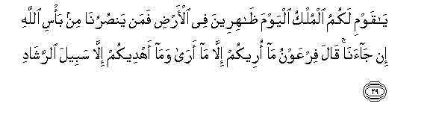
"O my People! Yours is the dominion this day: Ye have the upper hand in the land: but who will help us from the Punishment of Allah, should it befall us?" Pharaoh said: "I but point out to you that which I see (myself); Nor do I guide you but to the Path of Right!"
If you have a calamity and Allah removes it, is it not victory? Is finding the right spouse not a victory? Is Allah SWT taking care of your needs not a victory? Is Allah’s guidance and His support to you not victory?

Surah Hadid, ayah 25:

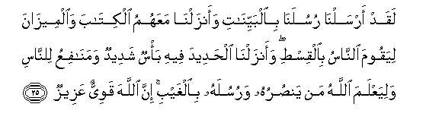
We sent aforetime our apostles with Clear Signs and sent down with them the Book and the Balance (of Right and Wrong), that men may stand forth in justice; and We sent down Iron, in which is (material for) mighty war, as well as many benefits for mankind, that Allah may test who it is that will help, Unseen, Him and His apostles: For Allah is Full of Strength, Exalted in Might (and able to enforce His Will).

Allah SWT is assuring us that He knows what is at the bottom of our hearts. He knows what we really want; how much we trust Him, rely on Him, and want to elevate His name.

In Surah Baqara, ayah 214 Allah SWT is reassuring the believers:


Verily the help of Allah is (always) near.

The case is closed; things are not going to change—Allah will grant victory to the believers. It is the hypocrites and people with weak faith who doubt this promise of Allah.

Surah Al-Imran, ayah 126:
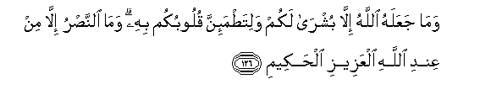
Allah made it but a message of hope for you, and an assurance to your hearts: (in any case) there is no help except from Allah. The Exalted, the Wise.

Emphasis is on the word EXCEPT; there is no one else who can grant victory except Allah ONLY. We also see a pattern with the verses related to victory—they usually end with the names of Allah like Al-Aziz (The Victorious), Ar-Raheem (The All-Merciful), Al-Hakim (The Perfectly Wise), Al-Qawwi (The Possessor of All Strength); all of which denote strength and power so as to dispel any doubts in the hearts of the servants.

Surah Rum, ayah 47:
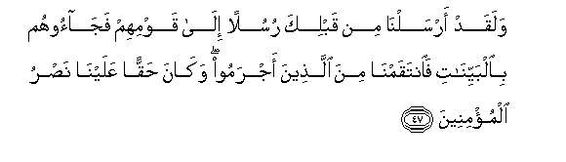
We did indeed send, before thee, apostles to their (respective) peoples, and they came to them with Clear Signs: then, to those who transgressed, We meted out Retribution: and it was due from Us to aid those who believed.

Allah SWT uses past tense of the word victory while talking about the reward which will be awarded in the future. This denotes that it is the constitution of Allah from which He SWT will not deter.

So far we have established the understanding that the word Nasr was used in the Qur’an in various contexts and there are different levels and styles of victory that Allah SWT grants believers. Now we are moving onto the next phase where it is essential for us to question ourselves, our behavior, and lifestyle to determine which category of humanity we belong to: victorious or defeated.

Surah Saff, ayah 13:

And another (favour will He bestow,) which ye do love,- help from Allah and a speedy victory. So give the Glad Tidings to the Believers.

Again, Allah SWT is establishing the fact that it is the believers—those with real faith in their hearts—who will receive victory from Allah SWT; or in other words, those who are victorious inside, will be granted victory outside.

In Surah An’am, ayah 34 Allah SWT is giving strength to the believers by reminding them of the hardship bore by the chosen messengers of Allah and how they were able to overcome it:
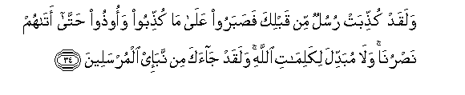
Rejected were the apostles before thee: with patience and constancy they bore their rejection and their wrongs, until Our aid did reach them: there is none that can alter the words (and decrees) of Allah. Already hast thou received some account of those apostles.

Iman and Patience are the two major stops on this journey to victory; they feed off of each other and provide the fuel that the person needs for continuation.

Allah SWT goes on to say in Surah Yusuf, ayah 110:

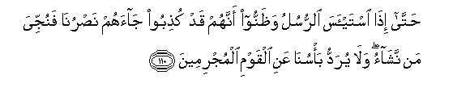

(Respite will be granted) until, when the apostles give up hope (of their people) and (come to) think that they were treated as liars, there reaches them Our help, and those whom We will are delivered into safety. But never will be warded off our punishment from those who are in sin.

Allah SWT is strengthening believers by telling them never to despair since victory is often send by Allah once a person reaches the level of desperation and no hope is left except with Allah alone. We have the example of Musa (AS) who was in a great predicament while rescuing Children of Israel from the tyranny of Pharaoh; while leading them out of Egypt, he had Red Sea in front of him and the army of Pharaoh approaching from the back. It was at a time of such desperation that Allah SWT opened up the sea so the entire nation could walk across to the other side. How many times have we heard of chronically ill patients who were given a few days by the doctor to live and they end up living for years by the will of Allah. We will tie all the examples back to our original point that if you believe Allah SWT will open, He promises to open—even after some time. Our problem today is that we set time frames for ourselves. We have no right to set time restrictions that Allah has to open at such and such time; it is not only rude but borders on Shirk (associating partners with Allah).

In Surah Al-Imran, the word Nasr takes on the meaning of support and guardianship:

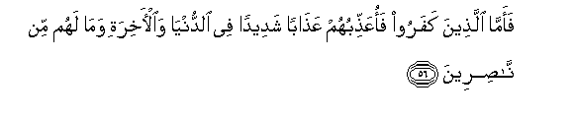
"As to those who reject faith, I will punish them with terrible agony in this world and in the Hereafter, nor will they have anyone to help." (3: 56)

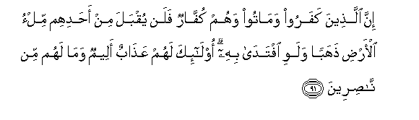
As to those who reject Faith, and die rejecting,- never would be accepted from any such as much gold as the earth contains, though they should offer it for ransom. For such is (in store) a penalty grievous, and they will find no helpers. (3:91)


Nay, Allah is your protector, and He is the best of helpers. (3:150)

The word support in itself has multiple meanings; a sinner needs to be supported by Allah in order to move away from the state of sins to the state of obedience. This support in the form of forgiveness is victory from Allah.
Just like sins, from any other state of weakness there is only one rescuer and supporter—Allah SWT.
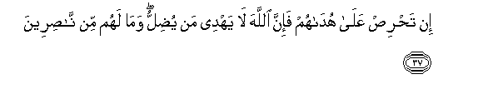

If thou art anxious for their guidance, yet Allah guideth not such as He leaves to stray, and there is none to help them. (Nahl: 37)
The word Nasr takes the meaning of ‘help’ in the following verses:

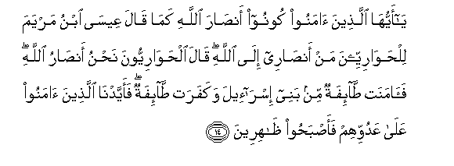
O ye who believe! Be ye helpers of Allah. As said Jesus the son of Mary to the Disciples, "Who will be my helpers to (the work of) Allah." Said the disciples, "We are Allah's helpers!" then a portion of the Children of Israel believed, and a portion disbelieved. But We gave power to those who believed, against their enemies, and they became the ones that prevailed. (Saff: 14)

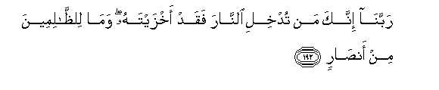
"Our Lord! any whom Thou dost admit to the Fire, Truly Thou coverest with shame, and never will wrong-doers Find any helpers! (Imran: 192)

At this point we can make the claim that the ultimate victory is to believe and carry the message of Allah; not only through our words but through our character, behavior, spending, and dealings. In order to reach this stage, a person has to have a high level of iman and constant vigilance of one’s actions. As we discussed in the previous articles of this series, if you want to check the level of your iman, see where your efforts, love, thinking, expenditure, and fear are focused. If you fear or love someone more than Allah, if your energy is focused on making someone other than Allah SWT happy—then the iman is low.
Companions of Prophet SAW had reached the highest level of freedom from all attachments other than Allah whereas today we fear everything—economy, flu, husband, boss, sickness, money; all because we are defeated inside and lack the real faith in our hearts.

Companions’ Lives: A Reflection of Qur’an

Companions of Prophet SAW are a shining star and guiding light for all believers till the Day of Judgment. We will relate a few stories here from the lives of the companions that describe the character of the companions and their freedom from all fears and attachments other than Allah SWT.

It is reported that a group of companions were travelling when they encountered a lion. Abdullah Ibn Umar approached the lion, held it by its ear and ordered it to leave upon which the lion whimpered and left. When asked about his action, he made the following statement: “If you fear Allah, Allah promises to make everything fear you. But if your fear of Allah is low, Allah makes you afraid of everything.”

Allah SWT helped and strengthened the companions on multiple occasions with His angels, including the battles of Badr, Uhud, Hunain, and Khandaq.

A companion of Prophet SAW was captured by a robber who seemed determined to kill him; at this he (RA) asked permission to pray two rakah. Before he had finished his salah, someone approached the robber and killed him. The companion inquired and was informed that it was an angel from the fourth heaven. The angel informed the companion that when he made du’a the whole sky shook and multiple angels requested Allah to come and help you and I was granted permission.

- Some of the companions saw angels. Angels supported them when they got lost, visited them when they recited Quran, and attended their janazah (funeral). Some companions talked to angels and in some cases angels spoke on their behalf. Handala (RA) was given bath by the angels after his death. Sa’d Ibn Muadh had 70,000 angels along with Jibraeel who came to attend his janazah. Allah SWT gave them multiple other karamaat (special super-natural powers) such as:
- He SWT shook the heart of the enemy upon beholding the companions;
- Allah supported them by enabling dirt to win the battle for them by destroying the enemy camp. Allah SWT informed Muhammad SAW of it in the following words:

When thou threwest (a handful of dust), it was not thy act, but Allah’s
Chap 8 Verse 17

- Allah made the enemy appear small in the companions’ eyes and allowed them to appear larger than their actual number in the eyes of the enemy.
- He SWT blinded the enemies until companions escaped from trouble.
- When they called Allah, it shook the heart of their enemy.
- Allah granted them accepted du’a. A woman companion from Muhajireen (immigrants from Makkah) lost her son. Before the funeral she requested to be left alone and made du’a to Allah supplicating Him to return her son. At that the son got up and lived till after the demise of Prophet SAW. We also have the example of Imam Al-Baahili who spent all his money in the way of Allah and when his wife informed him that there was nothing left whatsoever for their sustenance he decided to go to the masjid to make salah. While he was away, his wife found 300 gold coins under his bed and she decided to cover them to see what he will do. When he returned from the masjid, he went to his bed to sleep and discovered the money there. He declared the greatness of Allah saying “Allah u Akbar” three times and didn’t show any surprise. His wife thought that he had the money all along and had hid it from her. Upon confrontation, he declared that he didn’t have money but he had absolute belief in Allah that He would give him when he asked.
- Allah SWT allowed His beloved prophet to perform miracles on the companions. We have the story of venerable companion ’Ain al Qataada who was protecting Prophet SAW in the battle of Badr when an arrow injured one of his eyes to the point his eye fell out of the socket. He approached Prophet SAW in this condition; Prophet SAW made du’a for him and inserted his eye back in the socket and supplicated to Allah to make it the best eye. It is reported that he was not only able to see with it but used to sew his own clothing and thread the needle until the age of 90.
- Umar RA was able to see visions of his army fighting in distant lands and was able to give them commands which they heard thousands of miles away. Once Umar was on the pulpit when he had the vision of his army in Persia being attacked, and he gave command to the general of the army saying “O Saree’ go towards the mountain” and Saree’ was able to hear him and secure the army from prospective onslaught.
- Allah SWT allowed jinn to work for the companions and to lead them through the desert; He also allowed companions to give jinn dawah.
- Companions heard inanimate objects like the tree trunk that cried at its separation from Prophet SAW, and the fingers of Prophet SAW and water praising Allah.
- They were able to talk to dead people in the grave.
- There were incidents of companions’ graves being relocated after decades due to flooding or construction and their bodies were still fresh and wounds still bleeding.
- Companions had other creatures of Allah helping them in their task of spreading the message of Islam. There is a report of a shepherd whose sheep was taken by a wolf and he ran after the wolf to rescue it. Wolf spoke to him in Arabic and asked why he is trying to steal the provision Allah had provided him with. The shepherd was thunderstruck and asked how a wolf can communicate in Arabic; upon which the wolf said, I am more surprised at the fact that Allah has sent a messenger to you and you don’t believe in him. A wolf gave da’wah to a human!
- Once there was a huge fire in Madinah, a man name Tamim Ad-Dari ordered the fire to go down—
  - And it did.
- Allah SWT allowed some companions’ fingers to be lighted as candles in order to guide them in their journeys, such as Hasan (RA) and Husain (RA).
- Whenever companions made du’a, Allah sent the rain.
- Companions, along with their entire armies, walked on water.
- Companions were granted blessings in water and food to the point the meal that was supposed to fill two people ended up filling hundreds without diminishing in quantity.
- They received provision from Allah in a way they never expected. We have the stories of companions who were found by their captives to be having delicious fruits in jail when the fruits were not even in season. A venerable woman named Zanneera got thirsty in the middle of a desert and supplicated to Allah upon which a bucket from the heaven was sent to quench her thirst. She claimed to never have encountered thirst after that.
- Allah SWT granted them cure from sicknesses and ailments just by recitation of Qur’an and Du’a.
- Allah SWT withheld the effects of heat, cold and poison from the companions. Khalid Ibn Waleed drank an entire bottle of venomous poison and it didn’t affect him.
- Some of the companions had their youth returned to them at old age.
- Companions saw each other and their beloved Prophet Muhammad SAW in dreams frequently.

Upon close observation we can see that everything that they wanted, however impossible, was granted to them by their Lord Allah SWT; all because of their absolute iman and trust in Allah. These stories are incomprehensible for us since we believe in ourselves and our eyes more than the promise of Allah whereas the companions believed in the promises of Allah over their own observations. Almighty Allah is the same; His promises, His sunnah, and His Qur’an is the same. So if we change our ways and develop real faith in our hearts and align our lives with the companions, the way they are supposed to be—then there is no reason we should not receive the victory of Allah SWT in whatever form or shape we might need it.

Conclusion:

Nasr or victory is an affair that belongs to Allah SWT alone. We have inshaAllah established the understanding that the core meaning of victory is to believe, trust, and rely in Allah. Regardless of the kind and extent of problems you have in your life, start the internal journey of Iman and you will see what Allah SWT will do for you. Instead of fighting the world for your rights, fight yourself and your devils and you will see how Allah SWT will manage all your affairs. Read Qur’an until it changes you; struggle to overcome your nafs (carnal desires); develop good manners; and exercise real generosity for the sake of Allah and His message. This will open the doors of bigger and higher victories from Allah SWT for you. When you compare the amount of time you spend in this life with Akhirah, it will be easy for you to sacrifice this world for the infinite luxury of Jannah (paradise).

This will allow you to reach the state that the companions of Prophet SAW reached which is the state of wilayah (guardian friend). Once we accept Allah as our Wali and rely ONLY on Him for all our needs, He accepts us as His Wali and makes it His priority to take care of all our affairs to our heart’s contentment. Allah SWT assures the believers of this support in the following Hadeeth Qudsi:

On the authority of Abu Hurayrah (may Allah be pleased with him), who said that the Messenger of Allah (peace be upon him) said: Allah (mighty and sublime be He) said:
Whosoever shows enmity to someone devoted to Me, I shall be at war with him. My servant draws not near to Me with anything more loved by Me than the religious duties I have enjoined upon him, and My servant continues to draw near to Me with supererogatory works so that I shall love him. When I love him I am his hearing with which he hears, his seeing with which he sees, his hand with which he strikes and his foot with which he walks. Were he to ask [something] of Me, I would surely give it to him, and were he to ask Me for refuge, I would surely grant him it. I do not hesitate about anything as much as I hesitate about [seizing] the soul of My faithful servant: he hates death and I hate hurting him.
It was related by al-Bukhari.
In Surah Yunus, ayah 62—66 Allah SWT says:


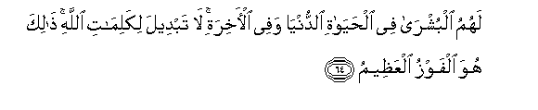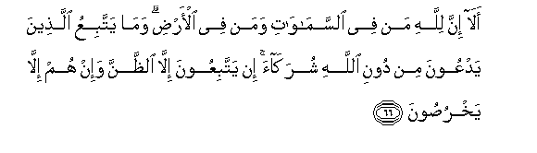
Behold! verily on the friends of Allah there is no fear, nor shall they grieve; Those who believe and (constantly) guard against evil;For them are glad tidings, in the life of the present and in the Hereafter; no change can there be in the words of Allah. This is indeed the supreme felicity. Let not their speech grieve thee: for all power and honour belong to Allah. It is He Who heareth and knoweth (all things). Behold! verily to Allah belong all creatures, in the heavens and on earth. What do they follow who worship as His "partners" other than Allah. They follow nothing but fancy, and they do nothing but lie.

Allah SWT goes on to say in Surah Fussilat, ayah 30—35:
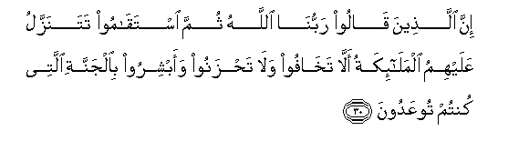
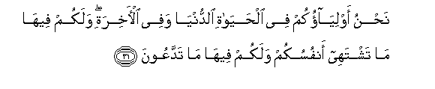

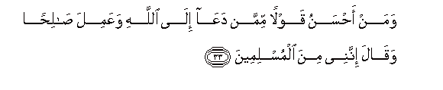
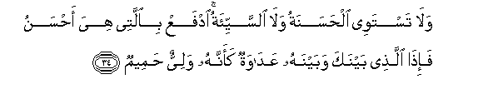

In the case of those who say, "Our Lord is Allah., and, further, stand straight and steadfast, the angels descend on them (from time to time): "Fear ye not!" (they suggest), "Nor grieve! but receive the Glad Tidings of the Garden (of Bliss), the which ye were promised! "We are your protectors in this life and in the Hereafter: therein shall ye have all that your souls shall desire; therein shall ye have all that ye ask for!- "A hospitable gift from one Oft-Forgiving, Most Merciful!" Who is better in speech than one who calls (men) to Allah, works righteousness, and says, "I am of those who bow in Islam"? Nor can goodness and Evil be equal. Repel (Evil) with what is better: Then will he between whom and thee was hatred become as it were thy friend and intimate! And no one will be granted such goodness except those who exercise patience and self-restraint,- none but persons of the greatest good fortune.

May Allah SWT unite our hearts to Him to make us realize who He really is and allow us to gain true victory with His pleasure, mercy, and forgiveness. Ameen.

