In The Name of Allah, The Beneficent The Merciful
Journey of Victory vs. Journey of Defeat
Part 4
In the previous articles, we have already established the understanding that victory and defeat are purely internal affairs. When a person is victorious inside, this victory is manifested outside, and the same goes for defeat. We have talked about the dangers of relaxation when it comes to following the deen, the elements of victory and defeat, and how to be vigilant about your actions to determine if you are on the journey of victory or defeat. In this article, we will examine the sunnah of Allah, His way of dealing with His creation, that never changes. If we comprehend the sunnah of Allah, we will understand which actions will bring us victory and which will cause defeat.
Our Lives in the Light of Sunnah of Allah
Qur’an contains the guidance for humanity until the end of time. Allah SWT has repeatedly mentioned that Qur’an has been sent down as a comprehensive book that contains instructions for everyone in all situations. Allah SWT says:


Nothing have we omitted from the Book, and they (all) shall be gathered to their Lord in the end. (6:38)
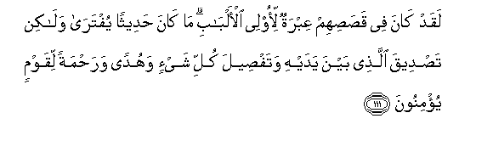
There is, in their stories, instruction for men endued with understanding. It is not a tale invented, but a confirmation of what went before it, a detailed exposition of all things, and a guide and a mercy to any such as believe. (12:111)
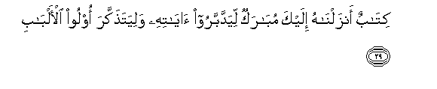
(Here is) a Book which We have sent down unto thee, full of blessings, that they may mediate on its Signs, and that men of understanding may receive admonition. (38:29)
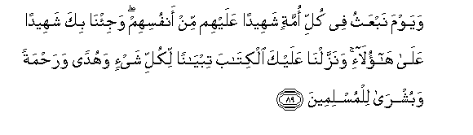
One day We shall raise from all Peoples a witness against them, from amongst themselves: and We shall bring thee as a witness against these (thy people): and We have sent down to thee the Book explaining all things, a Guide, a Mercy, and Glad Tidings to Muslims. (16: 89)
Since Allah SWT, by His mercy, has not left out anything from this book, He has also told us the sequence of gaining victory and closeness to Him. In this article, we will InshaAllah discuss this sunnah or sequence of Allah’s dealings with His creation.
The highest spiritual goal of any human being is to attain closeness to the Creator until one becomes His beloved. This struggle for closeness is like an unlimited ocean where the deeper one goes; the more one realizes its vastness and the pleasure of swimming in it. Any sincere person knows that it is a life long struggle and no one can reach the end of this ocean. So the question should be: How do I get closer to Allah until I become beloved to Him? How can I change my condition of internal defeat to an absolute victory between myself and Allah?
Allah SWT says:

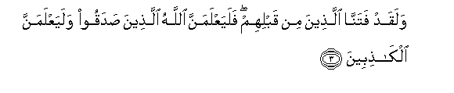
A.L.M. Do men think that they will be left alone on saying, "We believe", and that they will not be tested? We did test those before them, and Allah will certainly know those who are true from those who are false. (29:1—3)
He (SWT) goes on to say:

For those whose hopes are in the meeting with Allah (in the Hereafter, let them strive); for the term (appointed) by Allah is surely coming and He hears and knows (all things). And if any strive (with might and main), they do so for their own souls: for Allah is free of all needs from all creation. (29:5—6)

And those who strive in Our (cause), We will certainly guide them to our Paths: For verily Allah is with those who do right. (29:69)
Allah SWT goes on to encourage believers for persistence in the following words:
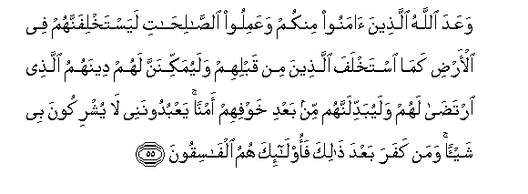
Allah has promised, to those among you who believe and work righteous deeds, that He will, of a surety, grant them in the land, inheritance (of power), as He granted it to those before them; that He will establish in authority their religion - the one which He has chosen for them; and that He will change (their state), after the fear in which they (lived), to one of security and peace: 'They will worship Me (alone) and not associate aught with Me. 'If any do reject Faith after this, they are rebellious and wicked. (24:55)
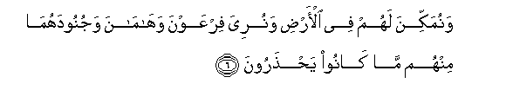
To establish a firm place for them in the land, and to show Pharaoh, Haman, and their hosts, at their hands, the very things against which they were taking precautions. (28:6)
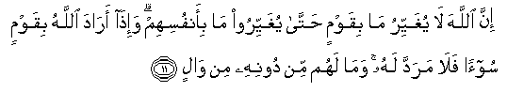
Verily never will Allah change the condition of a people until they change it themselves (with their own souls). But when (once) Allah willeth a people's punishment, there can be no turning it back, nor will they find, besides Him, any to protect. (13:11)
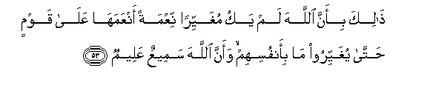
"Because Allah will never change the grace which He hath bestowed on a people until they change what is in their (own) souls: and verily Allah is He Who heareth and knoweth (all things)." (8:53)
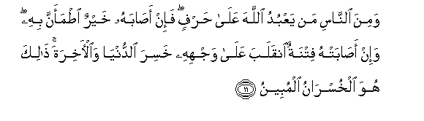
There are among men some who serve Allah, as it were, on the verge: if good befalls them, they are, therewith, well content; but if a trial comes to them, they turn on their faces: they lose both this world and the Hereafter: that is loss for all to see! (22:11)
These ayaat are providing answers to our question. So, what is the point of mentioning them? Since Allah SWT has a sunnah, system which never changes, then if we do what other victorious people did, we will also gain victory. Vice versa, if we follow the footsteps of the defeated ones, we cannot expect anything but defeat.
The Advantages of Knowing the Sunnah of Allah:
The biggest advantage of knowing the sunnah of Allah is that it brings certainty, peace of mind, and confidence because you know what to expect under certain circumstances. For example, Allah SWT said: “If ye are grateful, I will add more (favors) unto you; But if ye show ingratitude, truly My punishment is terrible indeed." Since the system of Allah never changes, if a person is being grumpy and ungrateful about what his situation is, then can he expect anything other than defeat?
If we do not comprehend the sunnah of Allah, we will be defeated. Since we will not know what is expected of us or what can happen, we will have uncertainty, doubt, lack of confidence, inability to handle a situation calmly—basically we will be manipulated by Shaytaan which brings nothing except defeat.
Imam Shafi’i was once asked: Do we gain victory first, or we get trialed first? He said, you will never gain victory until you are trialed first. So, this journey of closeness to Allah is full of trials and tribulation. It is a journey of loneliness, hardship, odds, opposition, enmity from kith and kin, desire of the change of environment, and alienation from those we love. But the study of the sunnah of Allah also tells us that this journey is one of opening after trials, and of pleasures after difficulties.
The sunnah of Allah never changes even though time, place, and situations may change. If you comprehend Qur’an, you will find your story in it. You can follow the elements of victory mentioned in the story and achieve victory. This requires one to know the elements of victory which are
- pillars of Iman,
- patience with Iman, and
- patience with the sunnah of Allah.
We have the story of Ibraheem (AS) in the Qur’an which is full of advices and implementation of the elements of victory. Ibraheem (AS)’s entire life was filled with trials and tribulations which he overcame with his iman and trust in Allah; this in turn granted him love of Allah SWT until he became Khaleel-ul-lah or the intimate friend of Allah. Not only that, he was granted the honor of being the father of all messengers and prophets after him, as well as the builder (or re-builder) of the house of Allah. We will analyze the story of Ibraheem and as we do that, readers should compare his trials to their own as well as their behavior to his during the trials.
Ibraheem (AS) was the son of an esteemed idol maker; at the tender age of six or seven he was assigned the task of selling these idols in the market. He couldn’t bring himself to sell ‘god’ and refused to do so for which he was repeatedly beaten. He refused to relent and grew up with faith in his heart until he challenged the society by breaking all the small idols in a temple and blaming it on the largest idol which he left untouched. This brought him to the attention of the tyrant king Nimrud who wanted to make an example of him by punishing him publicly. He ordered for a large fire to be built which was heated for several days and Ibraheem was thrown in there. While he was ready to be thrown, Angel Jibraeel came to him and asked him if he would like him to destroy the people. Ibraheem asked if Allah had sent him; he said no, I came on my own account with the permission of Allah. Ibraheem (AS) told him that he doesn’t want his help. Then the angel of rain came and offered to save him by bringing rain onto the fire. Ibraheem (AS) asked him if Allah had sent him, and the angel of rain gave the same reply as Angel Jibraeel; Ibraheem (AS) declined his help as well. When he was thrown into the fire, Allah SWT told the fire to “be cool and peaceful upon Ibraheem.” According to some reports, Ibraheem (AS) mentioned that the best moments of his life were those that he spent in the fire.
Ibraheem grew and married a beautiful woman named Sarah. Sarah was unable to conceive and Ibraheem (AS) wanted a son who would carry on the legacy of prophet-hood and invite people to Allah. Sarah offered her slave Hajrah as a wife to Ibraheem so he could procreate and leave his legacy in earth. Allah SWT allowed Hajrah to give birth to a child called Ismaeel; at the time of Ismaeel’s birth, Ibraheem (AS) was a very old man, thus the love for his child was certainly great. When Ismaeel was still a nursing infant, Allah ordered Ibraheem (AS) to leave him and his mother at a barren valley with very little water and dates. Allah tested Hajar and upon passing her test, she was granted the well of Zamzam from Allah. Once Ismaeel grew and became a young adult, an age where a father develops natural affection and pride in his son, Ibraheem (AS) was ordered by Allah to sacrifice his son; the most difficult test any parent can go through. Ibraheem (AS) gave Allah victory by obeying his orders and was in turn given victory by Allah as his son was replaced by a ram from heaven under the sacrificial knife. Allah honored both father and son by letting them re-built the Kabah, the house of Allah, the most esteemed place on earth. And the biggest opening and victory came to him when Allah asked him to call people to Hajj. Ibraheem (AS) asked Allah how people are going to hear him and Allah responded to him saying his job is to call and it is Allah’s responsibility to get his call heard. Till the end of time, every soul that is written to perform Hajj is actually responding to the call of Ibraheem (AS).
We can see through the story of Ibraheem (AS) the succession of trials; every time Ibraheem (AS) passed the trial, he received victory; yet at the same time, the next trial was harder and the next victory was even greater than the previous one. So what is the sunnah of Allah? The higher a person climbs on the spiritual ladder, the tougher the trials become; and the more a person passes the trials being sincere to Allah, the more victorious he becomes in this world and in front of Allah SWT. Ibraheem’s legacy is celebrated every year on Eid al Adha by Muslims. Why? Because Allah wants us to remember his story and derive the messages for ourselves from his life.
The essence of the story and the messages are many but mainly Allah SWT is telling you to sacrifice whatever it takes for the pleasure of Allah; spend whatever you have for Allah; and detach yourself from everything except Allah. Basically, if you give Allah victory, He will give you victory!
We will list out the main sunnah of Allah and discuss them in the context of our contemporary lives, InshaAllah.
- Defeated individuals produce defeated families; defeated families create a defeated nation. This defeat causes moral values to be eradicated from a society which in turn creates more defeated individuals—this is what has happened to the Muslim world today.
This problem can be resolved because all that is required is for individuals to rise and reach spiritual victory.
- When individuals or nations accept this defeat and their talk and actions become those of defeated people.
If and when Allah loves a person, He allows him to realize this defeat and allows him to think about his situation. This is the first step on the ladder of victory.
- Once this thinking is developed, it develops awareness and the desire to change condition and achieve victory.
- The awakened person looks for a doctor, someone who can help him overcome his weaknesses and spiritual diseases; this doctor is a person whom Allah loves and chooses to spread His message. We have such heroes mentioned in the Qur’an, for ex. Taloot, the unknown man from Aal-Yasin, the young boy from Ashab-al-Ukhdood, believer from the palace of Fir’awn etc.
Allah wants us to come closer to this person so he can help us come out of this state of defeat and achieve high spiritual status. This person that one chooses as a doctor has to be someone who has attained internal victory between himself and Allah and has developed characteristics of a true believer. People always look for outside status whereas it is spiritual status that Allah (SWT) cares about. None of the heroes mentioned earlier held any high degrees and almost all of them were ordinary individuals but Allah had endowed them with knowledge, wisdom, and leadership.
- The next sunnah is the requirement to comprehend the relationship between people and this spiritual person Allah chooses over them. We will use the example of Taloot who had no money nor status and name; Bani Israel complained about his “inferiority”, but it was worldly inferiority—Allah looks for spiritual superiority and nothing else!
We need humility in order to accept the authority of people above us. Isa (AS) and Musa (AS) were also simple people and it has to be simple people so we know that Allah is the owner of all abilities and we need Him; so we can’t say that it is because of special abilities of the person that he was chosen since it will be committing shirk, or associating partners with Allah. This leader has to be chosen by people and cannot impose himself over others.
There are a few other sunnah that are included in this category and these are the set of qualities this chosen person has to have:
  - Obedience
  - Manner and Character
  - Sincerity, Iman, and Trust in Allah.
The more a person is closer to Allah, the more he will have the qualities of an accepted leader.
We will use the example of Yusuf (AS) here. Yusuf (AS) was the son of a prophet and beloved to his father. From such a high status, he became a victim of envy and jealousy of his brothers and was thrown into the depths of a well. He started his journey of the unknown when he was sold into slavery and taken to Egypt. There he was raised in the house of a well-off person until he was trialed with the temptations in the form of a woman. He was able to resist the temptation and chose prison over denying the commands of Allah. He stayed in prison for years until Allah SWT not only freed him but gave him prestige and honor in land.
When we compare our lives to the life of Yusuf (AS) and compare our trials with his, who endured more? Do we have any right to complain and nag about our situations? If we complain, Allah will bring Yusuf (AS) to compare the situations of the two. If Allah can make Yusuf somebody so great, is he not able to take care of us as well? Victory ONLY comes when you show Allah that you are ONLY for Him. A true believer should not have any hesitation when it comes to sacrificing for Allah.
- Allah expects us to completely surrender to Him with sincerity; when we reach this level, just Du’a will be enough to bring us the victory from Allah SWT.
To summarize it all, conditions are created for us only as a trial to check who we are. Allah SWT is pure and grants ultimate victories only to those who are completely pure to Him. If we try to avoid the sunnah of Allah and try to run away from fitnah, Allah will put us in a bigger fitnah because He SWT doesn’t want us to run away from situations, rather to overcome them.
How to determine if we are being trialed with a fitnah?
We have to check our hearts; if there is too much love, too much fear, too much desire for something—anything too much is a fitnah for us. Basically, anything or any situation that preoccupies us to the point we forget the owner of situation is fintah. It is against the journey of Iman and becomes a blockade between us and Allah. This brings us back to the message of Islam—that if people have real Iman, they will have the patience and wisdom to deal with the situations that are ordained for them. The benefit of knowing the sunnah of Allah is that in trying times we will not be influenced by culture, custom, or ideologies; rather we will focus on being patient with the message of Allah and His will.
How do I gain victory from trials?
Victory is tawfiq (ability) from Allah; Allah grants it to whomever He wills. Our job is to belong to Allah SWT and to show Him that we are pure and sincere to Him like Ibraheem (AS) and Yusuf (AS). We have to grant Allah’s message victory and Allah will grant us victory—if He likes. We will be tested for our efforts, not if we were granted victory or not. Of course there are elements of victory which we need to follow in order to change our situations but our focus should be on tilling the soil, not picking the fruit.

O ye who believe! If ye will aid (the cause of) Allah, He will aid you, and plant your feet firmly. (47:7)
At this point, we will InshaAllah emphasize where victory is coming from and who Allah will give it to.
Reflection over Elements of Victory and Elements of Defeat
Principals govern victory:
Below we will discuss the Principals of gaining victory. If we hold onto these principals, then we gain victory. According to our obedience to the sunnah of Allah, if we reach the accepted level, He SWT will grant us tawfiq and victory. We need to govern the following aspects of our lives with strict principals:
- Emotions:
Emotions are against the message of Islam. Islam is based on principals and according to the sunnah of Allah, if we hold onto the principals of Islam we will gain victory from Allah. It needs knowledge and consultation; neither money nor people can bring this victory.
Lack of Iman makes us think emotionally or mentally analyze the problem. How do we combat that?
- Dawah to Allah.
- To choose and obey the people who can help you get close to Allah.
- Decisions:
The decisions we make in our lives have to be governed by Islamic principles. The steps we take towards accomplishing anything have to be calm and should bring benefit; if they can bring harm, then it is better to delay them. This needs far sightedness and a lot of wisdom.
- Revenge:
Prophets and Messengers never took revenge or dealt with people harshly even when they were wronged or brutalized, because elevating the message and protecting it from bad reputation is more important than setting the records straight.
- Follow-up & Consultation:
We need baseera (internal vision) to choose the individual who has the quality to carry the message and have to not only follow them but help them carry on the message. At the beginning of your journey, when you don’t have the knowledge yet, hold onto anyone you find to be carrying the qualities.
In conclusion, we will list the ayaat of Qur’an, which emphasize our topic, for readers to examine and reflect over. It is paramount to remember that if we try to hurry the sequence of Allah, it will never work and we will fail.
Sequence of the Victory of Allah through Qur’an:
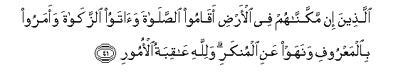
(They are) those who, if We establish them in the land, establish regular prayer and give regular charity, enjoin the right and forbid wrong: with Allah rests the end (and decision) of (all) affairs. (22: 41)
According to the ayah, the qualities of the victorious person are that they:
- Establish Salah,
- Give Zakah,
- Command what is right and forbid what is wrong, and
- Believe that ending belongs to Allah
We have to firmly believe that we have no control over the outcome and ending. When we respect Allah, we respect the ending Allah gives us. When we complain about the ending, it means we have no respect for Allah SWT.
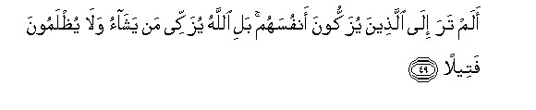
Hast thou not turned Thy vision to those who claim sanctity for themselves? Nay-but Allah Doth sanctify whom He pleaseth. But never will they fail to receive justice in the least little thing. (4: 49)
This sanctification is a gift. Allah SWT’s sunnah is that He gives people dunya and status, and then puts them in a predicament where they have to choose between this world and the hereafter—to check what the person will choose.
A person has to be pure in this journey of attaining victory and quality. This level of purity is attained when nothing bothers a person except the fear that Allah might not accept one to be the carrier of this message. The following ayaat will reiterate this point, InshaAllah.
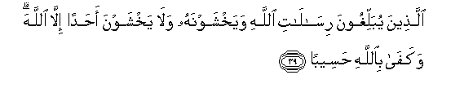
(It is the practice of those) who preach the Messages of Allah, and fear Him, and fear none but Allah. And enough is Allah to call (men) to account. (33:39)
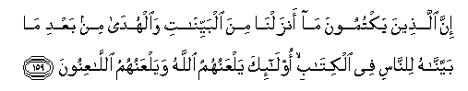
Those who conceal the clear (Signs) We have sent down, and the Guidance, after We have made it clear for the people in the Book,-on them shall be Allah's curse, and the curse of those entitled to curse…(2:159)
I can’t just think I am good and mind my own business. Condition of the ummah and spreading the message is your business.
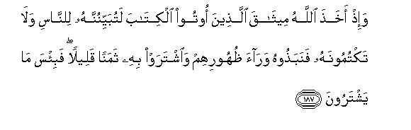
And remember Allah took a covenant from the People of the Book, to make it known and clear to mankind, and not to hide it; but they threw it away behind their backs, and purchased with it some miserable gain! And vile was the bargain they made! (3:187)
The moment we enslave ourselves to anyone other than Allah, we are on the journey of defeat.
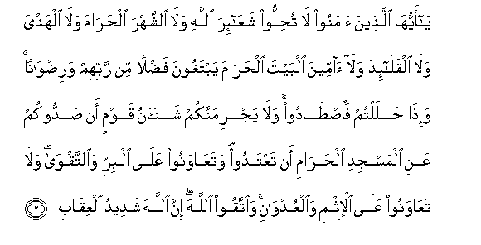
O ye who believe! Violate not the sanctity of the symbols of Allah, nor of the sacred month, nor of the animals brought for sacrifice, nor the garlands that mark out such animals, nor the people resorting to the sacred house, seeking of the bounty and good pleasure of their Lord. But when ye are clear of the sacred precincts and of pilgrim garb, ye may hunt and let not the hatred of some people in (once) shutting you out of the Sacred Mosque lead you to transgression (and hostility on your part). Help ye one another in righteousness and piety, but help ye not one another in sin and rancor: fear Allah. for Allah is strict in punishment. (5:2)
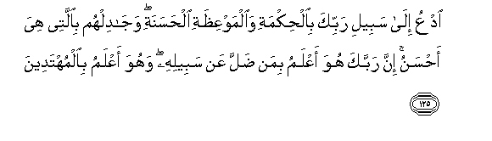
Invite (all) to the Way of thy Lord with wisdom and beautiful preaching; and argue with them in ways that are best and most gracious: for thy Lord knoweth best, who have strayed from His Path, and who receive guidance. (16:125)

O ye who believe! Why say ye that which ye do not? Grievously odious is it in the sight of Allah that ye say that which ye do not. (61:2-3)
The focus of our efforts should be to carry the message through our actions, to the best of our abilities.
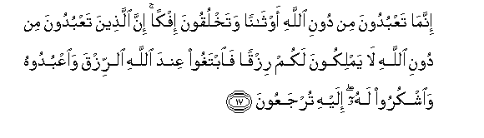
"For ye do worship idols besides Allah, and ye invent falsehood. The things that ye worship besides Allah have no power to give you sustenance: then seek ye sustenance from Allah, serve Him, and be grateful to Him: to Him will be your return. (29:17)
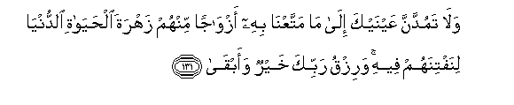
Nor strain thine eyes in longing for the things We have given for enjoyment to parties of them, the splendor of the life of this world, through which We test them: but the provision of thy Lord is better and more enduring. (20:131)

But teach (thy Message) for teaching benefits the Believers. I have only created Jinns and men, that they may serve Me. No Sustenance do I require of them, nor do I require that they should feed Me. For Allah is He Who gives (all) Sustenance,- Lord of Power,- Steadfast (for ever). (51:55—58)
Al Fudail ibn Iyaad (RA) said: Whoever fears Allah let him not be afraid of anyone; whoever fears other than Allah, there is no one that can benefit him.
A scholar said that there is no victory in life better than fear of Allah and the ability to make Salah on time.
How can we attain this Khushoo’ or internal fear of Allah?
Dhikr-ul-lah (remembrance of Allah) and Du’a (supplication); and these are the fruit of Iman and Yaqeen.
The reality of life and fear of Allah can only be attained with the internalization of death and belief that we will be presented to Allah SWT and will be accountable for our actions.
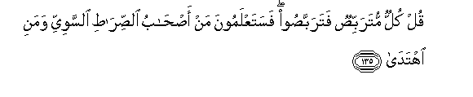
Say: "Each one (of us) is waiting: wait ye, therefore, and soon shall ye know who it is that is on the straight and even way, and who it is that has received Guidance." (20:135)
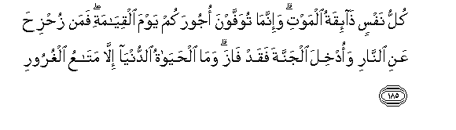
Every soul shall have a taste of death: And only on the Day of Judgment shall you be paid your full recompense. Only he who is saved far from the Fire and admitted to the Garden will have attained the object (of Life): For the life of this world is but goods and chattels of deception. (3:185)

Conclusion:
We need comprehensive knowledge of our deen; of ourselves and our situation; of the sunnah of Allah; of internal purification; and of who we are and where we are going. This will bring us victory and power.
One of the defeats a person can have is when Shaytaan makes one feel, “I can’t do it”, “I can’t reach my goal”, “its too hard or too far.” Despair of the victory from Allah is a sign of hypocrites and disbelievers. As we have been discussing, conditions will always be odd as seen from the lives of Prophets and Messengers. If the condition disables you and makes you defeated, don’t blame the condition, it is internal defeat of your Iman. If you believe as you ought to, Allah will change the condition. If the condition doesn’t change, meaning one hasn’t been completely purified yet. And the only way we can comprehend all of this is through knowing the sunnah of Allah.
This point can be understood by contemplating the following verse:

Nor would thy Lord be the One to destroy communities for a single wrong- doing, if its members were likely to mend. (11:117)
Who are the Muslihoon (those who mend)? These are people who do da’wah and invite others to the way of Allah SWT. A believer is very powerful and strong in his/her character and influence; this strength comes from being involved in da’wah, either active, or by setting the role model. Once the person gets away from da’wah, this strength degenerates and the person starts onto the journey of defeat. This sunnah of Allah translates to the nations as well. When the Muslim ummah was busy with the spreading of the message, Allah SWT elevated them and granted them victory; but once they got away from da’wah, the help of Allah was lifted and they were defeated.
Attaining victory from Allah is a life long struggle. It is up to Him (SWT) if He grants us the victory or not, but we have to be in a state of spiritual readiness so we can receive this victory from Him. Knowledge of the sunnah of Allah is paramount in our struggle for victory and attainment of love of Allah SWT. We pray to Allah SWT to grant us the wisdom and comprehension of His sunnah and accept us to be among the victorious ones; among those who spread His message and elevate the name of Islam.

Daee Ahmed Moait
www.noora1.com

