In The Name of Allah, The Beneficent The Merciful
Journey of Victory vs. Journey of Defeat
In the previous articles, we have already established the understanding that victory and defeat are purely internal affairs. When a person is victorious inside, this victory is manifested outside, and the same goes for defeat. We have talked about the dangers of relaxation when it comes to following the deen, as well as the elements of victory and defeat. In this article, we will try to see how we can find out if we are on the path of internal victory or defeat.

Self Monitoring: Am I on the Journey of Victory or Journey of Defeat?
Islam is the status of our lives. At any given time we are either in the state of Islam or out of Islam, based on the actions and decisions we make. If we are in state of Islam, we are on the journey of victory; and if our actions are otherwise then we are on the journey of defeat.
Allah SWT has given us the Qur’an which is the constitution of our lives. It is through the stories and events mentioned in the Qur’an that we derive messages and laws on how to govern ourselves. Qur’an is so comprehensive that a scholar said that every human being can find himself in it and know what is expected of him at any given time. Since Qur’an is the guidance till the end of time, Allah SWT has mentioned his sunan or His way of doing things, that chart out the system of the world for us. An example of that is the following ayah in surah Ibraheem:
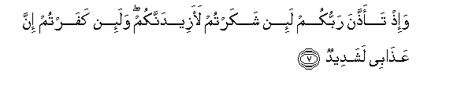
And remember! your Lord caused to be declared (publicly): "If ye are grateful, I will add more (favours) unto you; But if ye show ingratitude, truly My punishment is terrible indeed." 14:7
So the sunnah of Allah is that anytime a person is grateful, Allah will multiply His bounties on that person, and if the person is ungrateful then he/she will receive the torture of Allah. Just like that Allah SWT has also mentioned His sunnah of granting victory. In surah Qasas, verses 5 and 6 Allah SWT says:
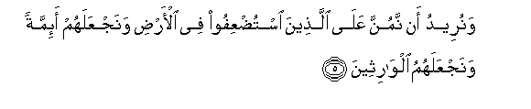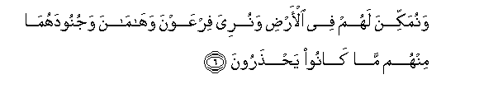
And We wished to be Gracious to those who were being depressed in the land, to make them leaders (in Faith) and make them heirs, To establish a firm place for them in the land, and to show Pharaoh, Haman, and their hosts, at their hands, the very things against which they were taking precautions.
This is the story of Prophet Musa (AS) and Allah SWT uses the word minna which means ‘a gift for the one who doesn’t deserve it’. So what is the sunnah of Allah? That before a person or a nation receives victory from Allah it has to reach a very low point in life. Once they are deprived of all means and have no support other than of Allah, and they have absolute belief in Him—that is when they will receive victory. The message is that Allah SWT doesn’t care if we have the highest education and technology, He can take the weakest among us and make them rise above everyone else. The more someone is weak and poor, the more they will rely on Allah SWT; and it is this reliance on Him that He SWT loves.
This takes us back to the elements of victory and defeat. The more a person believes, the more He will be humble to Allah and rely on Him and His promises, which are the qualities of a true believer. The more quality a person has, the more he will be thankful to Allah which is the sign of a victorious person.
Now the argument can arise that we are in the realm of reasoning and we have to do something. If your heart is corrupted, go ahead and do what you like but Allah will not be with you; and if Allah is not with you, is there anything that you can achieve? Allah has given us stories of really weak people who He gave upper hand in earth. He shared these stories with us to check what we are going to do. What kind of decisions we are going to make and would we have live according to the elements of victory that He has given us, or elements of defeat?
The sunnah of the victory of Allah is as follows: He puts us thorough hardships, when we are all the way down He opens for us a way, after that He gives us a trial to see what we are going to do and what kind of decisions we are going to make. These decisions help us monitor our life and determine if we are on the journey of victory or the journey of defeat.
Prophet SAW told us the following story which explains this point further:
Hadrat Abu Huraira (R.A.) relates that he heard the holy Prophet (Peace be upon him) say, Allah tested three persons from amongst Bani Israel, a leper, a bald headed man and a blind person. An angel was sent down to them in the form of a human being. He came to the leper and asked, "what is the thing you like the best?", "a fine colour, neat skin and cure from this disease for which people hate me." came the reply. The angel ran his hand over his body, his disease vanished and his body got a fine colour. Then the angel asked him what property he would like the best ? The man said, "camels or cows." (the writer is doubtful). The man was given a she camel ten months pregnant and the angel said, "may Allah bless it for thee."

Then the angel went to the bald headed man and asked the same. The man replied, "beautiful hair and cure of the ailment, for which people hate me." The angel ran his hand over his head and his disease was cured leaving him with beautiful hair. Then the angel asked him what property he would like the best ? The man replied, "a cow." Thus he was given a cow carrying a calf and the angel said, "may Allah bless it for thee."

Then the angel came to the man who was blind and asked the same. He asked that Allah restore his sight so that he may see the people around him. The angel ran his hands over his eyes and his sight was restored. Then the angel asked him what property he would like the best ? The man replied, "a goat." Thus he was given a she goat carrying a kid.

These animals in due course gave birth to their kids multiplying very soon so that one had a valley full of cows, bulls and a third of the valley full of goats. After some time the angel visited the leper in his original form and said to him, "I am a poor and needy person, having spent all my means of sustenance in the course of my journey, I beg you, in the name of Allah, who has given you a decent colour and a neat skin and much wealth, to furnish me with a camel to enable me complete my journey." The man expressed his inability to oblige the angel and said, "I have many obligations to fulfill." The angel said, "It appears as if I have seen you before. Are you not a leper, who shunned people and was poor, whom Allah enriched?" The man said, "I have inherited this property from my ancestors." The angel said, "If you are speaking a lie, may Allah return you to the condition in which you were."

Then he came to the bald headed person in the original form and repeated his request to him, and got a similar reply to the one he had received from the leper. The angel said, "If you are speaking a lie, may Allah return you to the condition in which you were."
Then the angel visited the blind man repeating his request once more. The man said, "indeed I was blind and Allah restored my eye sight. You may take what you will and leave what you like. By Allah I will not refuse you anything you may wish to take in the name of Allah, the Lord of honour and glory.

The angel said, "keep all you have. All three of you were being tried. Allah is indeed pleased with you and is angry with your companions." (Sahih Bukhari:Volume 4, Book 56, Number 670)

This story is to teach us the essence of the gift, which is to be grateful to Allah SWT. Allah is Al-Qadir, Controller of all things; Allah can switch any condition and snatch His gifts, or destroy a person. He snatches His gifts from us when we don’t respect them and this is a sign of arrogance, which is an element of defeat.
Allah SWT repeatedly tells us in the Qur’an about incidents of weaker beings and nations taking over much stronger ones; to calm our hearts and to let us know that it is not our strength, wealth, expertise, or any other factor that brings victory rather it is a gift of Allah that He gives to those He wants. The story of Taloot and Jaloot mentioned in Surah Al-Baqarah ayaat 247—252, is an example of that.
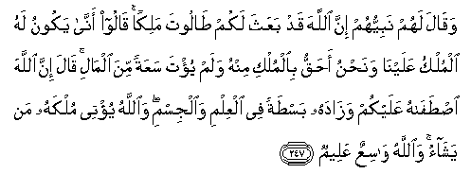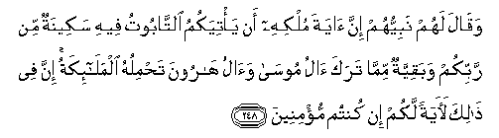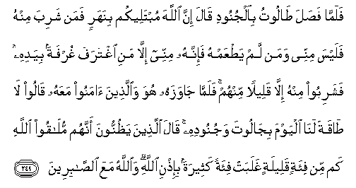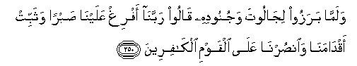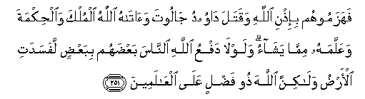Their Prophet said to them: "(Allah) hath appointed Talut as king over you." They said: "How can he exercise authority over us when we are better fitted than he to exercise authority, and he is not even gifted, with wealth in abundance?" He said: "(Allah) hath Chosen him above you, and hath gifted him abundantly with knowledge and bodily prowess: Allah Granteth His authority to whom He pleaseth. Allah careth for all, and He knoweth all things."
And (further) their Prophet said to them: "A Sign of his authority is that there shall come to you the Ark of the covenant, with (an assurance) therein of security from your Lord, and the relics left by the family of Moses and the family of Aaron, carried by angels. In this is a symbol for you if ye indeed have faith." When Talut set forth with the armies, he said: (Allah) will test you at the stream: if any drinks of its water, He goes not with my army: Only those who taste not of it go with me: A mere sip out of the hand is excused." but theyall drank of it, except a few. When they crossed the river,- He and the faithful ones with him,- they said: "This day We cannot cope with Goliath and his forces." but those who were convinced that they must meet Allah, said: "How oft, by Allah's will, Hath a small force vanquished a big one? Allah is with those who steadfastly persevere." When they advanced to meet Goliath and his forces, they prayed: "Our Lord! Pour out constancy on us and make our steps firm: Help us against those that reject faith." By Allah's will they routed them; and David slew Goliath; and Allah gave him power and wisdom and taught him whatever (else) He willed. And did not Allah Check one set of people by means of another, the earth would indeed be full of mischief: But Allah is full of bounty to all the worlds. These are the Signs of Allah. We rehearse them to thee in truth: verily Thou art one of the apostles.
Allah SWT chose Taloot to be the king because of his knowledge, wisdom, and strength; and ordered him to wage war against a mighty tyrant, Jaloot. When Taloot (AS) and his army came across a river after a long travel, Allah forbade them to drink anything more than a sip. The sunnah of Allah SWT is that He requires from believers what is usually against common sense and thinking. The purpose again is to check whether the decision is going to be according to Allah, or according to the person’s desire. Taloot’s soldiers deserted him until he had a very small army against a great one. Not only did the small army gain victory, but Allah SWT chose a young boy, Dawud (AS) to kill Jaloot to manifest the point that it is really not what we possess, but rather our spiritual status that brings us victory. It is the internal victory that is manifested outside.
Our biggest shortcoming that prevents us from gaining victory is our inability to detach ourselves from the worldly objects. In order to be victorious, we have to be pure to Allah and we will never be pure unless we learn to accept situations that are against our will. One element of victory is the belief in the Qadr of Allah; absolute belief that I will get what is written for me--nothing more and nothing less. What are trials of Allah if not to test us with things we don’t like?
How do we purify and detach ourselves from this world? Remember that no matter what your weaknesses or diseases of your heart, Allah is the owner of all treasures and He will give you whatever quality you sincerely strive for. Refer to the literature that talks about cleansing of the heart and soul; and most importantly, seek a companion and spiritual guide who will lead you down this path of purification and help you gain eternal victory. No matter how much worship one performs, if the heart is attached to dunya, happiness depends on material status, and the internal purification does not take place, there will not be any victory from Allah SWT.
There will be no victory until one goes through a series of trials and is purified. This was the sunnah of Allah with his beloved messengers, and this is going to remain His sunnah for everyone until the end of time. These trials can take any shape and form from migration, illness, torture, financial circumstances to family situation etc.
We have the example of Ayub (AS) who lost his health, wealth, family, and status—basically, Allah took all dunya from him. We also have the story of Musa (AS) who, from living as a prince in the palaces to a wandering shepherd in the desert, has to go through a series of trials in order to be purified and completely detached from worldly belongings. The main purpose of these trials besides purifying us is to sift believers from hypocrites. It is for Allah to check out who will honor His message, and who will sacrifice afterlife for this world. Detachment of world from our hearts is a journey in itself. It is through trial and error that we reach perfection; but it is not really perfection that Allah wants, rather a consistency in our choices and decisions. He wants to check what we will choose when the choices are presented to us: this world, or the hereafter? The biggest obstacle in the way of detaching ourselves from material world is our high nafs. As long as we do not submit our nafs to the will of Allah, we will never be able to achieve victory. Along with submission of nafs we need belief in the Qadr of Allah, absolute devotion, love, surrender, and fear to Him. If we are unable to do that then instead of achieving higher levels of spirituality, we will sink to the bottom pit of sicknesses such as jealousy, envy, hatred, discontentment etc.
Keeping the above discussed points in mind, a person can analyze which journey he is on: journey of victory or journey of defeat. If a person is on the journey of victory, he is willing to lose anything in order to save his Iman. His life is based on principals of Islam instead of his personal wishes and desires. He can regulate his behavior and it does not take a long time for him to overcome his weaknesses such as anger, frustration, and extreme likes and dislikes etc. If a person is on the path of defeat, he will give up his iman for any amount of worldly success. A defeated person will hold onto his weaknesses for a long time; the longer one holds onto these feelings, the longer it takes to rectify the situation. Thus, one’s decisions are influenced by his nafs and feelings instead of the message of Allah which lead him further down the path of defeat.
In conclusion, examine your actions and look at your decisions, you will know if you are on the journey of victory or defeat.

