This Life and the Hereafter
Elevation vs. Disgrace

Islam: Knowledge That Needs to Be Implemented
Why don't I get along with majority of the people?
Why am I only comfortable with myself? Am I antisocial?
Do I believe I am good enough? Or do I believe nobody is worthy enough to deserve my company?

These are some of the questions most people have asked themselves at one time or the other? Why is it that when people enter the journey of Iman and gain knowledge and understanding; instead of gaining more closeness to Allah and more quality, they go in reverse and instead start to become more rebellious, stubborn, blind, full of complains, and begin to blame their surroundings?

The ultimate disgrace from Allah (SWT) is to give you knowledge and snatch from you the ability and struggle to live the knowledge and to build good moral qualities which are meant to bring you closer to Him (SWT) and to put His (SWT)’s pleasure above your own.

Islam, a journey showing Allah (SWT) that you have completely submitted to Him (SWT) is manifested through fasting, one of the pillars of Islam. Fasting is to sacrifice your desire fee-sabi-lillah (for the sake of Allah). It is a training to obtain the qualities that Allah loves, which are a sign of belonging and tasleem (submission). Submission to the will of the Almighty is always a struggle against our own carnal desires. It requires faith, patience, and the will to behave according to what He (SWT) is pleased with at a time when Qadr (destiny) takes place or an unexpected situation is ordained for us. This is how Allah (SWT) tests the obedience of His slaves and this is His Sunnah, or way of doing things, which will never change. We can see it in Chapter 29 Al-Ankabut, verses 2 – 3 when Allah SWT says:
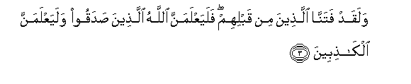
Do men think that they will be left alone on saying, "We believe", and that they will not be tested? We did test those before them, and Allah will certainly know those who are true from those who are false.
_____________________________________________________________________

Did You Ever Ponder?

When I read the Qur'an, hadith, life of the companions, or any Islamic literature for that matter, and I come across praise-worthy qualities that the earlier people had and I don't, what is my reaction?
Do I feel disheartened, give up and say: I do not have it and I can never reach this level; or
I am afraid if I ask Allah to give me the quality, I will get a calamity or a trial; or
I am satisfied where I am regardless of my spiritual status.

The alarming point here is that all the above mentioned sates of heart lead you towards kufr or denial of Allah SWT. By questioning Allah's power and ability you are inviting real calamity and hardship against yourself. It is the thinking influenced by shaytan which will result in Allah withholding His blessings from you and increasing your trials in life; and since it is all a reflection of weak Iman, it will lead to eventual failure in the hereafter.

This deficiency of Iman (faith) shows lack of trust in Allah SWT, as well as lack of humbleness and humility. People with such thinking do not ponder enough about Akhira (hereafter), lack hope and fear in Allah, and a desire to reach Jennah (paradise). Believing that you are not good enough is also deficiency of Iman; it prevents a person from trying to reach the mercy, pleasure, and love of Allah. This also prevents a person from trying to acquire the qualities of the companions and righteous predecessors, which in reality is lack of sincerity. This lack of sincerity is actually a result of lack of belief in the Qadr (ordainment) of Allah, and a lack of belief in His (SWT)’s names and attributes. All of this leads a person to a deeper state of Kufr; and the ultimate state of Kufr is to deny Allah SWT’s message and advice while persisting in following one’s Nafs (desires) and Shaytaan—even while claiming to be a Muslim.

On the other hand, when we look to the Qur'an and Hadith, we find that it is full of messages that invite us to rush and struggle with our intentions and actions to do what pleases Allah, even if we don’t have the means since it is the intentions that are rewarded.

The Forces Surrounding Us:
There are two forces that govern our lives:
- The force of elevation: to get us closer to Allah and His pleasure. This requires sincere intentions; good deeds; striving, struggling, giving, and sacrificing whatever we have and whatever we can for Allah’s sake. This will open the door of pleasure, rahma (mercy), and elevation from Allah for the person; which are the gifts of Allah for a Mu'min (believer).
- The force of evil: arrogance, stubbornness, laziness, ungratefulness, and absence of good intentions. This kind of person receives no personal gain, neither does he benefit others.

Allah SWT has revealed this Qur’an as a source of guidance for all mankind. It is so comprehensive that everyone will find him or herself in the Qur’an at any given time in their lives. Instead of defining specific incidents or people, Allah SWT has given general descriptions of characters in the Qur’an. It is these characteristics that tell us if we are being influenced by the force of elevation or force of evil. For example, any vigilant person can refer to the story of Habeel and Qabeel in the Qur’an and determine if his actions are closest to Habeel or Qabeel, and this will let him know his status in the eyes of Allah.

Characteristics of believers in the Qur’an are very consistent regardless of the time and the setting where the event takes place. A believer is constantly in a hurry to do whatever he can to please Allah and to benefit himself; he strives to elevate himself and the deen of Allah; he does not miss a chance of spreading righteousness, and be involved in every good possible to himself or to others; the one who Allah chooses to be a key of goodness, and a lock for evil. All this goodness is referred to as toobaa in the words of Rasul Allah (SAW) when he (SAW) said: The lucky one is the one who has toobaa (a high level, or a tree in paradise).

The Purpose of Gaining Knowledge:

If we gain all the knowledge in Islam, and then everybody isolates himself to his room or house and we perform only the rituals of Islam, how can we exercise, develop, implement, live, and obey the Message of Allah and the teachings of the Prophet (SAW)?
How can we function with society and obey the commands of Allah if we alienate ourselves from the rest of society?
What if we only engage with society depending on our mood?

When people behave in such a way, they are empty and are in a state of worshipping themselves; they are devoid of the light of Allah, even if they fulfill all the rituals.
Rasul Allah (SAW) has told us that Allah SWT sent him to teach manners and good conduct. If we reflect over the verses of the Qur’an, we will find three major elements in them:

1. Warning for what will happen if we are happy with the status quo.
2. The sunnah (way) of Allah is to trial us to check our sincerity and honesty.
3. The qualities of the believers which are beloved to Allah: the one who struggles, is in a rush to please Allah, and is always trying to be good.

Therefore, if you want to open the door of Rahma (mercy) and the pleasure of Allah, you have to be constantly initiating, sensing, running, and hurrying to accumulate any good deeds to please Allah. If you do not do so, the door of calamity will open and Allah SWT will snatch the Taufeeq (ability) and quality from you, because you denied Him and did not take advantage of the given opportunity. When Allah (SWT) abandons a person, He opens for him the door of dunya and gives him the material life; this brings blindness, and the habit of complaining and blaming others. This shows lack of gratefulness, contentment and thanks; meaning, this becomes this life becomes a journey of disgrace in this life and the hereafter.
If a person surrenders to his weakness, his genetic problems, the whisper of shaytaan, or to the status quo, do you know what it means? Absence of Iman (Faith)!

On the other hand, if a person believes in Allah (SWT), His power, might, and ability; then his sins, weakness, abilities, disabilities, genetics, environment, whatever it is—cannot stop him from intending to do good because Allah (SWT) is with him.

Again, all these topics go back to journey of Iman, thinking about and hoping to attain the highest place in Jennah, pleasing Allah, about fulfilling one’s duty on this earth, and about being an achiever.

Signs to Guide Me through My Life:

There are signs and rewards—seen and unseen— indicating initiators of good deeds.

- A person will have happiness, contentment, tranquility, wisdom, ability to comprehend the situations, and joy and peace in life. All this is just a fraction of the ultimate happiness, paradise, which is store for this person in the afterlife.
- Another sign is that people will love such a person and he will not find it difficult to deal and communicate with others.
- It will be easy to cope with situations.
- The person will find ease, peace, and tranquility in all his life’s activities - the ones he likes as well as the ones he does not like. This is the case when a person lives for Allah’s sake alone which in turn causes the person to be filled with such joy and tranquility that even calamity becomes a source of happiness.

Just like signs pointing out the initiators of good, there are also signs and punishments afflicting those who have neglected their Lord, Allah SWT.

- Loneliness, misery, uncertainty, fear of the future and of others, fear of doing and giving shadows the life of such people.
- There is perpetual worry about what can and cannot happen which removes all internal peace from the soul.
- The person never tastes the real happiness which can only come from belonging to Allah SWT.
- The person who forgets Allah, also forgets his goodness with people and finds no ease with any of his dealings.
- They are bereft of joy while either busy or free, and are constantly uptight and uncertain.
- They are constantly worried about gaining people’s approval of themselves which makes them anxious; this anxiety and lack of confidence eventually causes people to dislike them. This chokes them mentally and emotionally and they also begin to dislike people and become isolated from society.
Combine the above mentioned signs in a person with the diseases of the heart- arrogance, miserliness, jealousy, liking oneself, ego etc. and you have the classic characteristics of a failed human whose abode is eventually hellfire. They get tortured in this life and the hereafter; and leave behind no legacy worthy to be commemorated.

Allah SWT says in Chapter Al-Imran, verse 92:
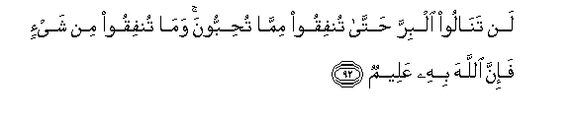

By no means shall you attain righteousness unless you give (freely) of that which you love; and whatever you give, of a truth Allah knows it well.

All good qualities emerge from giving and initiating while all the diseases of the heart and bad qualities spring from absence of giving, sharing, or sacrificing.

All of the above mentioned points are to prepare and enable you to live the message and to help you develop the intention to be among the chosen one, and it is up to Allah to give one the Tawfeeq (ability).

Reality of Life and Its Purpose: In the Words of the Almighty

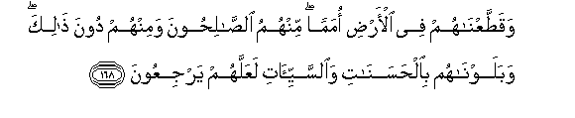
And We dispersed them as [separate] communities all over the earth; some of them were righteous, and some of them less than that: and the latter We tried with blessings as well as with afflictions, so that they might mend their ways. (7:168)

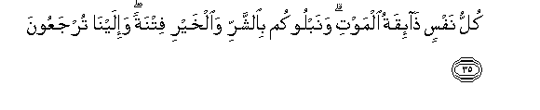
Every human being is bound to taste death; and We test you [all] through the bad and the good [things of life] by way of trial: and unto Us you all must return. (21:35)


Behold, We have willed that all beauty on earth be a means by which We put men to a test, [showing] which of them are best in conduct (18:7)

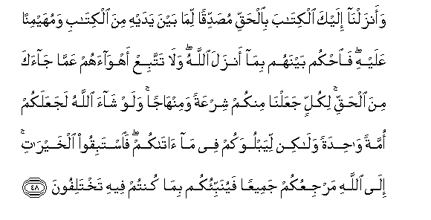
And unto thee [O Prophet] have We vouchsafed this divine writ, setting forth the truth, confirming the truth of whatever there still remains of earlier revelations and determining what is true therein. Judge, then, between the followers of earlier revelation in accordance with what God has bestowed from on high, and do not follow their errant views, forsaking the truth that has come unto thee. Unto every one of you have We appointed a [different] law and way of life. And if God had so willed, He could surely have made you all one single community: but [He willed it otherwise] in order to test you by means of what He has vouchsafed unto, you. Vie, then, with one another in doing good works! Unto God you all must return; and then He will make you truly understand all that on which you were wont to differ. (5:48)

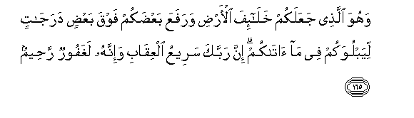
For, He it is who has made you inherit the earth, and has raised some of you by degrees above others, so that He might try you by means of what He has bestowed upon you. Verily, thy Sustainer is swift in retribution: yet, behold, He is indeed much-forgiving, a dispenser of grace (6:165)

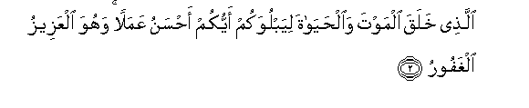
He who has created death as well as life, so that He might put you to a test [and thus show] which of you is best in conduct, and [make you realize that] He alone is almighty, truly forgiving (67:2)

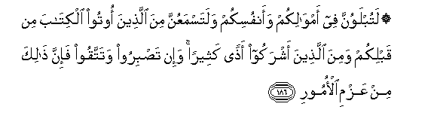
You shall most certainly be tried in your possessions and in your persons; and indeed you shall hear many hurtful things from those to whom revelation was granted before your time, as well as from those who have come to ascribe divinity to other beings beside God. But if you remain patient in adversity and conscious of Him - this, behold, is something to set one's heart upon. (3:186)

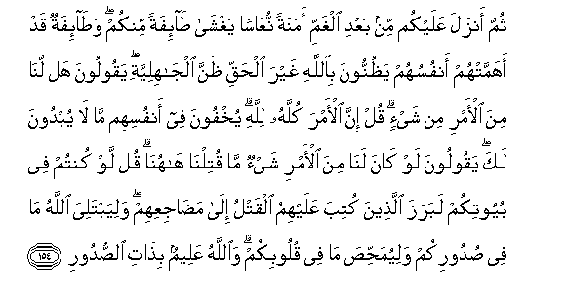
Then, after this woe, He sent down upon you a sense of security, an inner calm which enfolded some of you, whereas the others, who cared mainly for themselves, entertained wrong thoughts about God - thoughts of pagan ignorance - saying, "Did we, then, have any power of decision [in this matter]?" Say: "Verily, all power of decision does rest with God" - [but as for them,] they are trying to conceal within themselves that [weakness of faith] which they would not reveal unto thee, [O Prophet, by] saying, "If we had any power of decision, we would not have left so many dead behind." Say [unto them]: "Even if you had remained in your homes, those [of you] whose death had been ordained would indeed have gone forth to the places where they were destined to lie down." And [all this befell you] so that God might put to a test all that you harbor in your bosoms, and render your innermost hearts pure of all dross: for God is aware of what is in the hearts [of men]. (3:154)

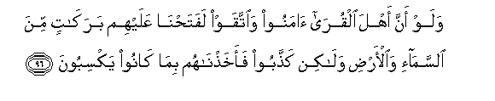
Yet if the people of those communities had but attained to faith and been conscious of Us, We would indeed have opened up for them blessings out of heaven and earth: but they gave the lie to the truth - and so We took them to task through what they [themselves] had been doing. (7:96)

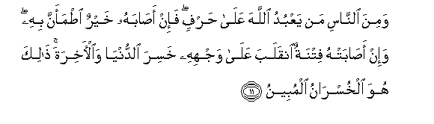
And there is, too, among men many a one who worships God on the border-line [of faith]: thus, if good befalls him, he is satisfied with Him; but if a trial assails him, he turns away utterly, losing [thereby both] this world and the life to come: [and] this, indeed, is a loss beyond compare! (22:11)

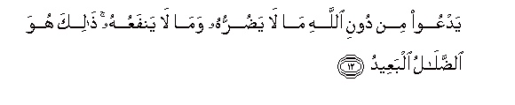
[By behaving thus,] he invokes, instead of God, something that can neither harm nor benefit him: [and] this is indeed the utmost one can go astray. (22:12)

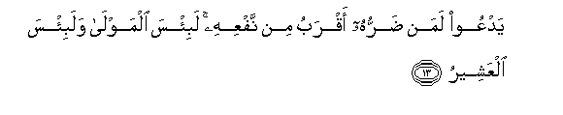
[And sometimes] he invokes [another human being] one that is far more likely to cause harm than benefit: vile, indeed, is such a patron and vile the follower! (22:13)
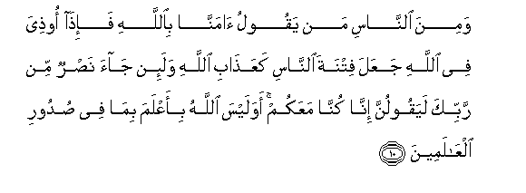
Now there is among men many a one who says [of himself and of others like him], “We do believe in God” - but whenever he is made to suffer in God’s cause, he thinks that persecution at the hands of man is as [much to be feared, or even more than,] God’s chastisement; whereas, if succor from thy Sustainer comes [to those who truly believe] he is sure to say. “Behold, we have always been with you!” Is not God fully aware of what is in the hearts of all creatures? (29:10)


And most certainly will God mark out those who have [truly] attained to faith, and most certainly will He mark out the hypocrites. (29:11)

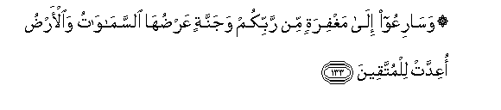
And vie with one another to attain to your Sustainer's forgiveness and to a paradise as vast as the heavens and the earth, which has been readied for the God-conscious (3:133)

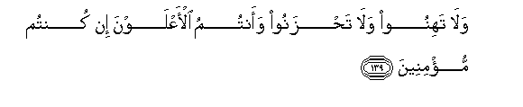
Be not, then, faint of heart, and grieve not: for you are bound to rise high if you are [truly] believers. (3:139)

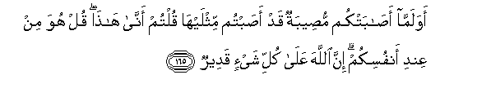
And do you, now that a calamity has befallen you after you had inflicted twice as much [on your foes], ask yourselves, "How has this come about?" Say: "It has come from your own selves." Verily, God has the power to will anything: (3:165)

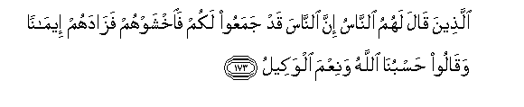
Those who have been warned by other people, "Behold, a host has gathered against you; so beware of them!" - Whereupon this only increased their faith, so that they answered, "God is enough for us; and how excellent a guardian is He! (3:173)

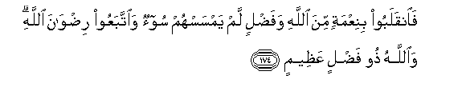
And returned [from the battle] with God's blessings and bounty, without having been touched by evil: for they had been striving after God's goodly acceptance - and God is limitless in His great bounty. (3:174)

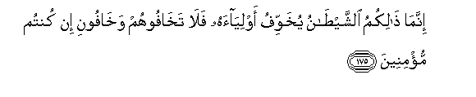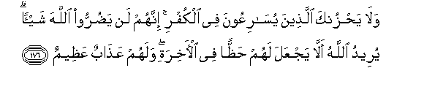
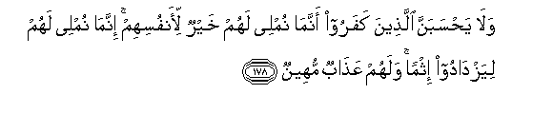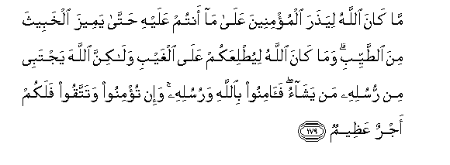
It is but Satan who instills [into you] fear of his allies: so fear them not, but fear Me, if you are [truly] believers! And be not grieved by those who vie with one another in denying the truth: verily, they can in no wise harm God. It is God's will that they shall have no share in the [blessings of the] life to come; and tremendous suffering awaits them. Verily, they who have bought a denial of the truth at the price of faith can in no wise harm God, whereas grievous suffering awaits them. And they should not think - they who are bent on denying the truth - that Our giving them rein is good for them: We give them rein only to let them grow in sinfulness; and shameful suffering awaits them. It is not God's will [O you who deny the truth] to abandon the believers to your way of life: [and] to that end He will set apart the bad from the good. And it is not God's will to give you insight into that which is beyond the reach of human perception: but [to that end] God elects whomsoever He wills from among His apostles. Believe, then, in God and His apostles; for if you believe and are conscious of Him, a magnificent requital awaits you. (3:175-179)

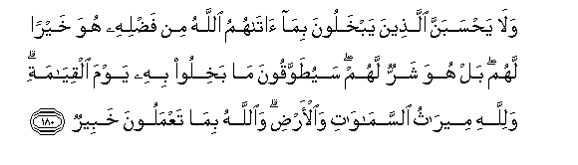
And they should not think - they who niggardly cling to all that God has granted them out of His bounty - that this is good for them: nay, it is bad for them. That to which they [so] niggardly cling will, on the Day of Resurrection, be hung about their necks: for unto God [alone] belongs the heritage of the heavens and of the earth; and God is aware of all that you do. (3:180)
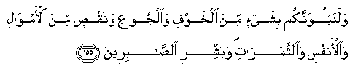


And most certainly shall We try you by means of danger, and hunger, and loss of worldly goods, of lives and of [labor's] fruits. But give glad tidings unto those who are patient in adversity; who, when calamity befalls them, say, "Verily, unto God do we belong and, verily, unto Him we shall return. It is they upon whom their Sustainer's blessings and grace are bestowed, and it is they, they who are on the right path! (2:155 – 157)


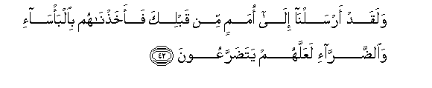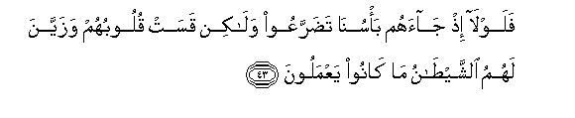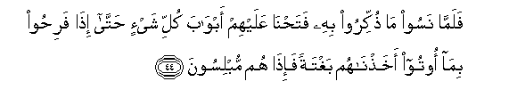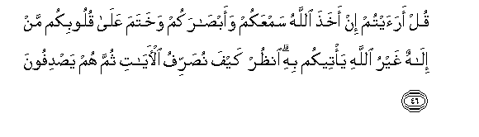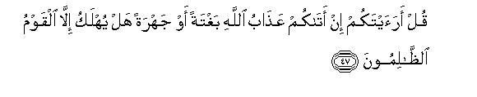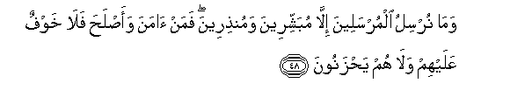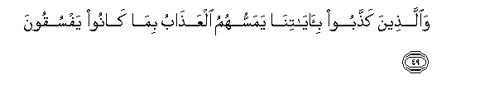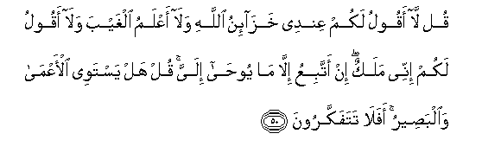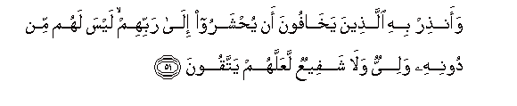
Nay, but it is Him alone that you will invoke - whereupon He may, if He so wills, remove that [ill] which caused you to call unto Him; and you will have forgotten all that to which you [now] ascribe divinity side by side with Him." And, indeed, We sent Our messages unto people before thy time, [O Prophet,] and visited them with misfortune and hardship so that they might humble themselves: when the misfortune decreed by Us befell them, they did not humble themselves, but rather their hearts grew hard, for Satan had made all their doings seem goodly to them. Then, when they had forgotten all that they had been told to take to heart, We threw open to them the gates of all [good] things until -even as they were rejoicing in what they had been granted - We suddenly took them to task: and lo! they were broken in spirit; and [in the end,] the last remnant of those folk who had been bent on evildoing was wiped out. For all praise is due to God, the Sustainer of all the worlds.
Say: "What do you think? If God should take away your hearing and your sight and seal your hearts - what deity but God is there that could bring it all back to you?" Behold how many facets we give to our messages-and yet they turn away in disdain! Say: "Can you imagine what your condition will be if God's chastisement befalls you, either suddenly or in a [gradually] perceptible manner? [But then-] will any but evildoing folk [ever] be destroyed? And We send [Our] message-bearers only as heralds of glad tidings and as warners: hence, all who believe and live righteously -no fear need they have, and neither shall they grieve; whereas those who give the lie to Our messages - suffering will afflict them in result of all their sinful doings. Say [O Prophet]: "I do not say unto you, 'God's treasures are with me,'; nor [do I say], 'I know the things that are beyond the reach of human perception'; nor do I say unto you, 'Behold, I am an angel': I but follow what is revealed to me." Say: "Can the blind and the seeing be deemed equal? Will you not, then, take thought?" And warn hereby those who fear lest they be gathered unto their Sustainer with none to protect them from Him or to intercede with Him, so that they might become [fully] conscious of Him. (6:41-51)

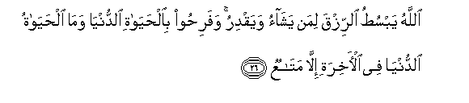
Allah grants abundant sustenance, or gives it in scant measure, unto whomever He wills; and they [who are given abundance] rejoice in the life of this world - even though, as compared with the life to come, the life of this world is naught but -a fleeting pleasure. (13:26)

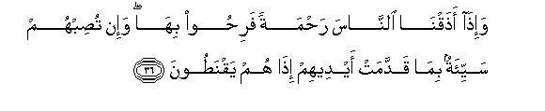
And [thus it is:] when we let men taste [Our] grace, they rejoice in it; but if evil befalls them as an outcome of what their own hands have wrought lo! they lose all hope! (30:36)

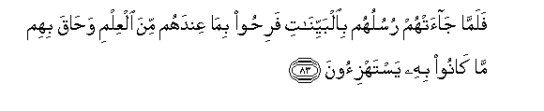
For when their apostles came to them with all evidence of the truth, they arrogantly exulted in whatever knowledge they [already] possessed: and [so, in the end,] they were overwhelmed by the very thing which they were wont to deride. (40:83)

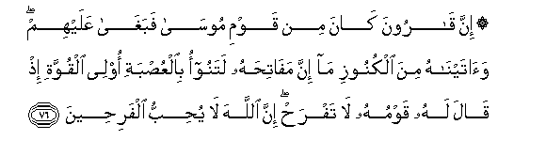
[Now] Qarun was one of the people of Moses; but he arrogantly exalted himself above them - simply because We had granted him such riches that his treasure-chests alone would surely have been too heavy a burden for a troop of ten men or even more. When [they perceived his arrogance,] his people said unto him: “Exult not [in thy wealth], for, verily, God does not love those who exult [in things vain]! (28:76)

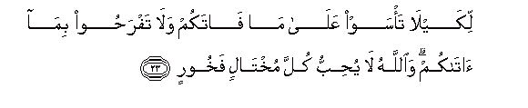
[Know this,] so that you may not despair over whatever [good] has escaped you nor exult [unduly] over whatever [good] has come to you: for, God does not love any of those who, out of self-conceit, act in a boastful manner (57:23)

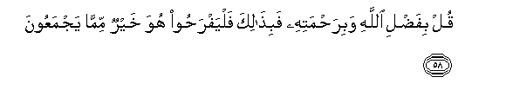
Say: "In [this] bounty of God and in His grace-in this, then, let them rejoice: it is better than all [the worldly wealth] that they may amass!" (10:58)

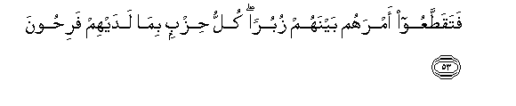
But they (who claim to follow you) have torn their unity wide asunder, piece by piece, each group delighting in [but] what they themselves possess [by way of tenets] (23:53)

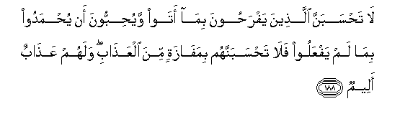
Think not that those who exult in what they have thus contrived, and who love to be praised for what they have not done - think not that they will escape suffering: for grievous suffering does await them [in the life to come]. (3:188)

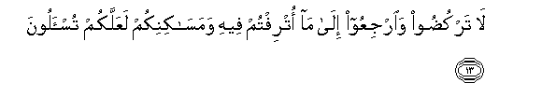
[and at the same time they seemed to hear a scornful voice]: “Do not try to flee, but return to all that [once] gave you pleasure and corrupted your whole being; and [return] to your homes, so that you might be called to account [for what you have done]!’’ (21:13)

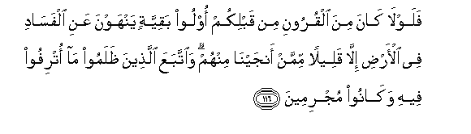
But, alas, among those generations [whom We destroyed] before your time there were no people endowed with any virtue - [people] who would speak out against the [spread of] corruption on earth -except the few of them whom We saved [because of their righteousness], whereas those who were bent on evildoing only pursued pleasures which corrupted their whole being, and so lost themselves in sinning. (11:116)

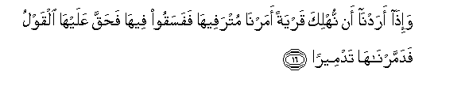
But when [this has been done, and] it is Our will to destroy a community, We convey Our last warning to those of its people who have lost themselves entirely in the pursuit of pleasures; and [if] they [continue to] act sinfully, the sentence [of doom] passed on the community takes effect, and We break it to smithereens. (17:16)

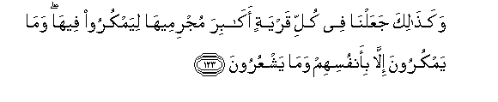
And it is in this way that We cause the great ones in every land to become its [greatest] evildoers, there to weave their schemes: yet it is only against themselves that they scheme -and they perceive it not. (6:123)

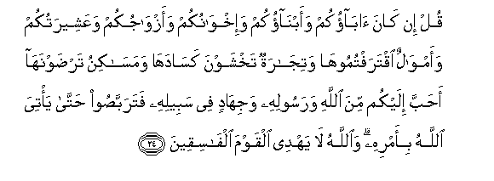
Say: "If your fathers and your sons and your brothers and your spouses and your clan, and the worldly goods which you have acquired, and the commerce whereof you fear a decline, and the dwellings in which you take pleasure - [if all these] are dearer to you than God and His Apostle and the struggle in His cause, then wait until God makes manifest His will; and [know that] God does not grace iniquitous folk with His guidance." (9:24)

Yet if the people of those communities had but attained to faith and been conscious of Us, We would indeed have opened up for them blessings out of heaven and earth: but they gave the lie to the truth - and so We took them to task through what they [themselves] had been doing. (7:96)

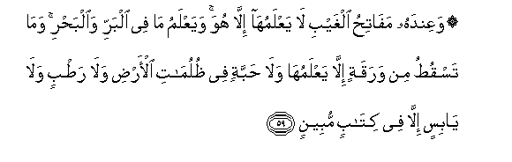
For, with Him (SWT) are the keys to the things that are beyond the reach of a created being's perception: none knows them but He. And He knows all that is on land and in the sea; and not a leaf falls but He knows it; and neither is there a grain in the earth's deep darkness, nor anything: living or dead, but is recorded in [His] clear decree. (6:59)
Conclusion:
The above discussed seemingly unrelated, yet connected questions are the key essence of our lives. The more we ponder and analyze our lives, keeping our intentions focused and our goals intact, the more it will be easier for us to make the right decisions that will keep us on the path of Akhirah (afterlife). We are going to leave this world regardless of how long our lives might be; the real issue of concern is how we are going to leave and where we will go. If we elevate our Lord (SWT) in this life and heed His advices, He (SWT) will elevate us in the hereafter; but if we forget about Him and what He (SWT) wants from us, then how can we expect anything except disgrace and humiliation in the life to come?
May Allah (SWT) allow us to ask the right kind of questions in our lives and always guide us by His mercy to the path of elevation.

O Ever Living One, O Eternal One, by Your mercy I call on You to set right all my affairs. Do not place me in charge of my soul even for the blinking of an eye (i.e. a moment).

Daee Ahmed Moait

