Power of Forgiveness vs. Power of Animosity & Revenge
Reflection on the murder trial of Salahuddin Jitmoud in Kentucky, USA
Part 2

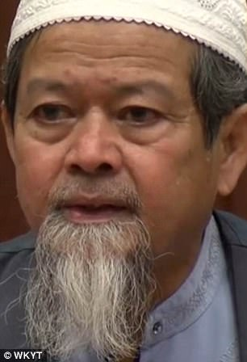
Dr. Jitmoud revived a quality beloved to Allah SWT and His Prophet SAW through his actions, not his words. His true embodiment of the teachings of Islam generated peace, harmony and dawah to Allah SWT on a large scale, something he probably didn’t even anticipate.

This is the power of ikhlas, sincerity.

He lost his 22-year-old son to a brutal murder where his throat was slit. This brutality makes anyone angry, let alone a father. But he not only forgave the killer, he hugged him, kissed him, made dua for him, and absolved him of blame, blaming the devil instead.

His true faith shone through his actions. His sincerity to Allah
Dr. Abdul-Munim Sombat Jitmud
and the teachings of Islam rose above the love of his son, and the rage, repulsion, & vengeance he must have felt for his killer.
Instead of his nafs controlling him, he controlled his nafs and
demonstrated some of the highest qualities of a believer—
love, patience, forgiveness, and pardon.

The qualities of Messengers and Prophets, and the elite believers.

Anger is from shaytaan, the enemy of Allah. Seeking revenge under the pretext of ‘justice’ is from shaytaan. Allah and His Prophet SAW have not advised us to do so. For this father to rise above his personal feelings and embody the meaning of Abd Allah, slave of Allah, was a defeat to shaytaan and his plot.

What an honor for him to be able to exercise forgiveness and pardon towards a sinner, a killer of your own son. This is a momin, a believer in Allah SWT and His Messenger SAW.

Look at the reward Allah SWT gave to this man and his family in return. He used him to elevate the name of Islam and demonstrate its teachings in a positive light.

Now let’s reverse the scene. If he screamed and shouted, called for revenge for his son’s murderer, what would happen? Nothing, really.

You and I would have never heard about him or his son because he would be among the norm, the masses who behave a certain way. It is the quality of forgiveness and afw that made him shine and receive international attention.

There are various lessons to be learned from this humble man.

- The importance of introspection and vigilance
When I am afflicted with calamity or am oppressed by someone…
  - What does Allah SWT want from me?
  - How does He SWT want me to behave?
  - What would be the most beloved action to Allah SWT, at this particular time?
  - Will my actions/behavior benefit me and the larger society?

- Allah SWT will bless the actions He loves.

- Sincerity will only show at a time of desperation, oppression, and severe hardship.

- Allah SWT will honor sincere believers.

May Allah make us among those who shine above the masses; those who are honored with the qualities beloved to Allah SWT and His Prophet SAW. May Allah SWT allow us to do actions that will benefit us, our families, our communities, society and the ummah. May we be a source of pride and honor for Islam, Muslims, and our beloved Prophet SAW. Ameen.

