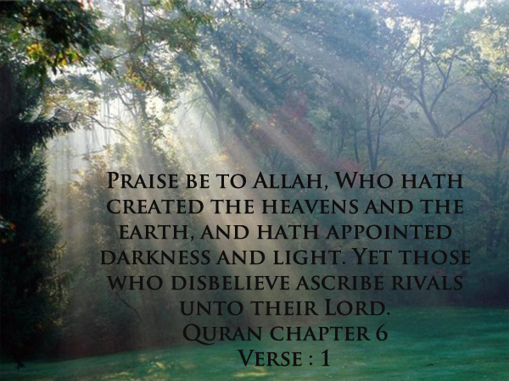

The Light and Wisdom
Of Allah SWT


INDEX
- Introduction
- The Message of Qur'an
- Conclusion
- Download Word/Pdf

Introduction
Ramadan Is The Month Of Qur'an
The Month Of The Message,
The Light, Mercy
And Wisdom From Allah Swt
Qur'an is Furqan, the criterion, the one that distinguishes right from wrong, the light. Hereunder are some of the meanings of the messages of the Qur'an on which Allah SWT emphasizes.
The Light Of Allah Swt Equals
Guidance, Closeness, To Be For Allah Swt,
Allah Swt Says,"I Will Be With The Patient One,
I Will Be With The Generous One,
I Will Be With The Righteous One"
We should ask ourselves, Do I want to be with Allah SWT? Do I want to be among the people who Allah SWT will be with, whom he will support, give light to, from his light, guidance and wisdom?"
We Need To Ask Our Selves If We Want To Be Among Those
Whom Allah Will Guard, Give Strength To,
And Take Care Of Their Affairs...
Meaning, In The End, If We Are With Allah Swt,
We Will Have No Worries
And We Will Be Worry Free!!
Now we will go through some messages I believe are very important to inculcate, reflect upon and ask serious questions, for us as individuals and as a group. After that, we should ask ourselves what we should do with the message. Please read carefully and try to read it over and over again and beg Allah to give you the comprehension of what you are reading.
Ask yourself, What is the purpose of all these messages from Allah SWT to me? What does Allah SWT want me to do after hearing it? Say, Bismillah, and beg Allah SWT to give you the understanding and ability to live the message.

Go To Top

The Message of Qur'an
Quran Chapter 2
Surah Al Baqarah
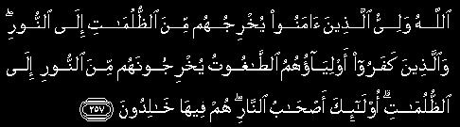
Allah is the Protecting Guardian of those who believe. He bringeth them out of darkness into light. As for those who disbelieve, their patrons are false deities. They bring them out of light into darkness. Such are rightful owners of the Fire. They will abide therein. [Verse:257]

Quran Chapter 5
Surah Al Maidah
Verse 15-16
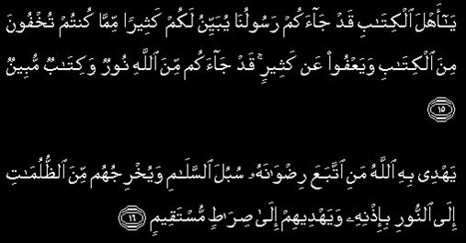
O People of the Scripture! Now hath Our messenger come unto you,expounding unto you much of that which ye used to hide in the Scripture, and forgiving much. Now hath come unto you light from Allah and plain Scripture,Whereby Allah guideth him who seeketh His good pleasure unto paths of peace. He bringeth them out of darkness unto light by His decree, and guideth them unto a straight path.

Quran Chapter 6
Surah Al Anaam
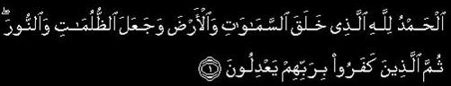
Praise be to Allah, Who hath created the heavens and the earth, and hath appointed darkness and light. Yet those who disbelieve ascribe rivals unto their Lord. [Verse:1]

Quran Chapter 6
Surah Al Anaam
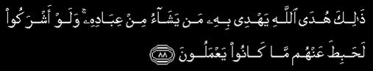
Such is the guidance of Allah wherewith He guideth whom He will of His bondmen. But if they had set up (for worship) aught beside Him, (all) that they did would have been vain. [Verse:88]

Quran Chapter 6
Surah Al Anaam
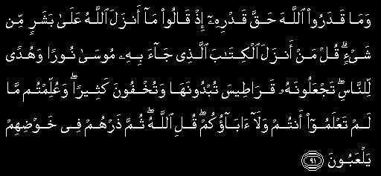
And they measure not the power of Allah its true measure when they say: Allah hath naught revealed unto a human being. Say (unto the Jews who speak thus): Who revealed the Book which Moses brought, a light and guidance for mankind, which ye have put on parchments which ye show, but ye hide much (thereof), and by which ye were taught that which ye knew not yourselves nor (did) your fathers (know it)? Say: Allah. Then leave them to their play of cavilling. [Verse:91]

Quran Chapter 6
Surah Al Anaam
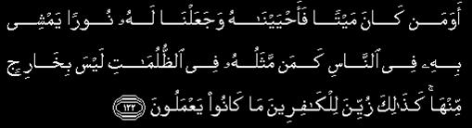
Is he who was dead and We have raised him unto life, and set for him a light wherein he walketh among men, as him whose similitude is in utter darkness whence he cannot emerge? Thus is their conduct made fairseeming for the disbelievers. [Verse:122]

Quran Chapter 7
Surah Al A'raaf
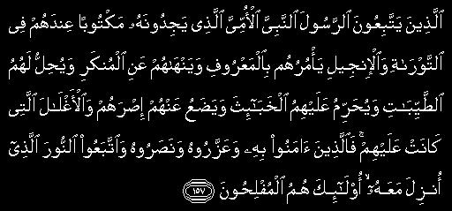
Those who follow the messenger, the Prophet who can neither read nor write, whom they will find described in the Torah and the Gospel (which are) with them. He will enjoin on them that which is right and forbid them that which is wrong. He will make lawful for them all good things and prohibit for them only the foul; and he will relieve them of their burden and the fetters that they used to wear. Then those who believe in him, and honour him, and help him, and follow the light which is sent down with him: they are the successful. [Verse:157]

Quran Chapter 14
Surah Ibrahim
Verses 1-3
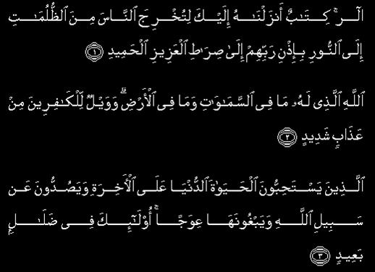
Alif. Lam. Ra. (This is) a Scripture which We have revealed unto thee (Muhammad) that thereby thou mayst bring forth mankind from darkness unto light, by the permission of their Lord, unto the path of the Mighty, the Owner of Praise, Allah, unto Whom belongeth whatsoever is in the heavens and whatsoever is in the earth. and woe unto the disbelievers from an awful doom; Those who love the life of the world more than the Hereafter, and debar (men) from the way of Allah and would have it crooked: such are far astray.

Quran Chapter 14
Surah Ibrahim
Verse 4-5
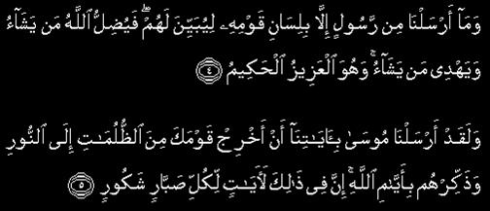
And We never sent a messenger save with the language of his folk, that he might make (the message) clear for them. Then Allah sendeth whom He will astray, and guideth whom He will. He is the Mighty, the Wise. We verily sent Moses with Our revelations, saying: Bring thy people forth from darkness unto light. And remind them of the days of Allah. Lo! therein are revelations for each steadfast, thankful (heart).

Quran Chapter 64
Surah At Taghabun
So believe in Allah and His messenger and the light which We have revealed. And Allah is Informed of what ye do. [Verse:8]

Quran Chapter 24
Surah An Noor
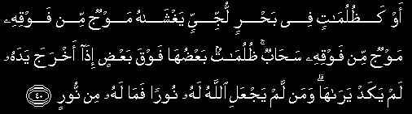
Or as darkness on a vast, abysmal sea. There covereth him a wave, above which is a wave, above which is a cloud. Layer upon layer of darkness. When he holdeth out his hand he scarce can see it. And he for whom Allah hath not appointed light, for him there is no light. [Verse:40]

Quran Chapter 42
Surah Ash Shura
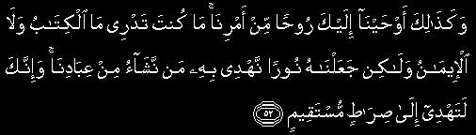
And thus have We inspired in thee (Muhammad) a Spirit of Our command. Thou knewest not what the Scripture was, nor what the Faith. But We have made it a light whereby We guide whom We will of Our bondmen. And lo! thou verily dost guide unto a right path. [Verse:52]

Quran Chapter 42
Surah Ash Shura
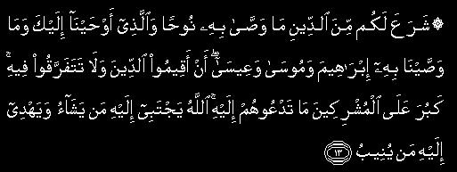
He hath ordained for you that religion which He commended unto Noah, and that which We inspire in thee (Muhammad), and that which We commended unto Abraham and Moses and Jesus, saying: Establish the religion, and be not divided therein. Dreadful for the idolaters is that unto which thou callest them. Allah chooseth for Himself whom He will, and guideth unto Himself him who turneth (toward Him). [Verse:13]

Quran Chapter 9
Surah At Tawba
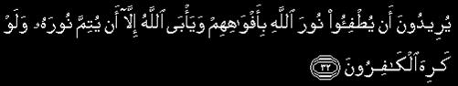
Fain would they put out the light of Allah with their mouths, but Allah disdaineth (aught) save that He shall perfect His light, however much the disbelievers are averse. [Verse:32]

Quran Chapter 27
Surah An Naml

And lo! it is a guidance and a mercy for believers. [Verse:77]

Quran Chapter 61
Surah An Naml
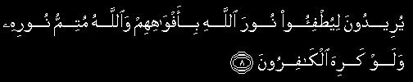
Fain would they put out the light of Allah with their mouths, but Allah will perfect His light however much the disbelievers are averse. [Verse:8]

Quran Chapter 13
Surah Ar Raad
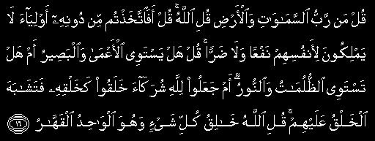
Say (O Muhammad): Who is Lord of the heavens and the earth? Say: Allah. Say: Take ye then (others) beside Him for protectors, which, even for themselves, have neither benefit nor hurt? Say: Is the blind man equal to the seer, or is darkness equal to light? Or assign they unto Allah partners who created the like of His creation so that the creation (which they made and His creation) seemed alike to them? Say: Allah is the Creator of all things, and He is the One, the Almighty. [Verse:16]

Quran Chapter 24
Surah An Noor
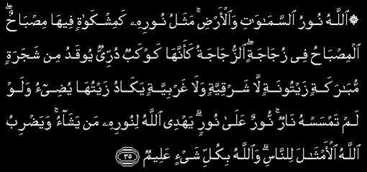
Allah is the Light of the heavens and the earth. The similitude of His light is as a niche wherein is a lamp. The lamp is in a glass. The glass is as it were a shining star. (This lamp is) kindled from a blessed tree, an olive neither of the East nor of the West, whose oil would almost glow forth (of itself) though no fire touched it. Light upon light. Allah guideth unto His light whom He will. And Allah setteth forth for mankind similitudes, for Allah is Knower of all things. [Verse:35]

Quran Chapter 24
Surah An Noor
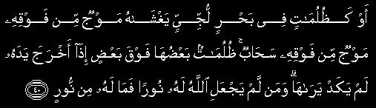
Or as darkness on a vast, abysmal sea. There covereth him a wave, above which is a wave, above which is a cloud. Layer upon layer of darkness. When he holdeth out his hand he scarce can see it. And he for whom Allah hath not appointed light, for him there is no light. [Verse:40]

Quran Chapter 33
Surah Al Ahzab
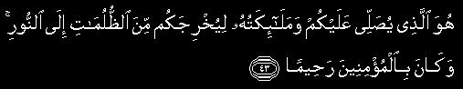
He it is Who blesseth you, and His angels (bless you), that He may bring you forth from darkness unto light; and He is Merciful to the believers. [Verse:43]

Quran Chapter 39
Surah Az Zumar
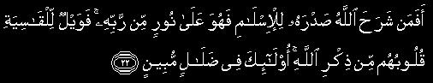
Is he whose bosom Allah hath expanded for the surrender (unto Him), so that he followeth a light from his Lord, (as he who disbelieveth)? Then woe unto those whose hearts are hardened against remembrance of Allah. Such are in plain error. [Verse:22]

Quran Chapter 57
Surah Al Hadid
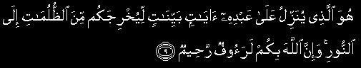
He it is Who sendeth down clear revelations unto His slave, that He may bring you forth from darkness unto light; and lo! for you, Allah is Full of Pity, Merciful. [Verse:9]

Quran Chapter 65
Surah At Talaq
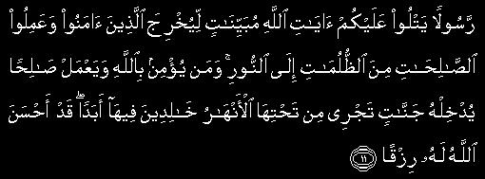
A messenger reciting unto you the revelations of Allah made plain, that He may bring forth those who believe and do good works from darkness unto light. And whosoever believeth in Allah and doeth right, He will bring him into Gardens underneath which rivers flow, therein to abide for ever. Allah hath made good provision for him. [Verse:11]

Quran Chapter 4
Surah An Nisa
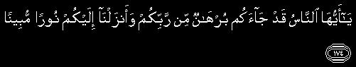
O mankind! Now hath a proof from your Lord come unto you, and We have sent down unto you a clear light; [Verse:174]

Quran Chapter 57
Surah Al Hadid
Verse 12-13
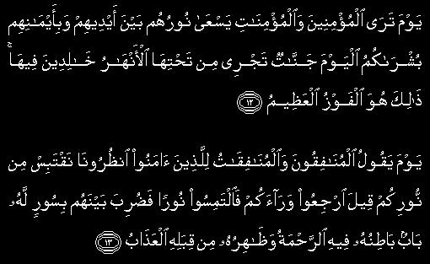
On the day when thou (Muhammad) wilt see the believers, men and women, their light shining forth before them and on their right hands, (and wilt hear it said unto them): Glad news for you this day: Gardens underneath which rivers flow, wherein ye are immortal. That is the supreme triumph. On the day when the hypocritical men and the hypocritical women will say unto those who believe: Look on us that we may borrow from your light! it will be said: Go back and seek for light! Then there will separate them a wall wherein is a gate, the inner side whereof containeth mercy, while the outer side thereof is toward the doom.

Quran Chapter 17
Surah Al Isra
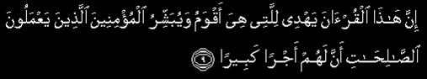
Lo! this Qur'an guideth unto that which is straightest, and giveth tidings unto the believers who do good works that theirs will be a great reward. [Verse:9]

Quran Chapter 3
Surah Al-E-Imran
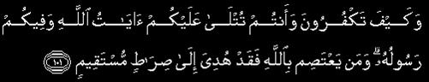
How can ye disbelieve, when Allah's revelations are recited unto you, and His messenger is in your midst? He who holdeth fast to Allah, he indeed is guided unto a right path. [Verse:101]

Quran Chapter 6 Surah Al Anaam
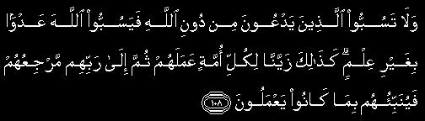
Revile not those unto whom they pray beside Allah lest they wrongfully revile Allah through ignorance. Thus unto every nation have We made their deed seem fair. Then unto their Lord is their return, and He will tell them what they used to do. [Verse:108]

Quran Chapter 19
Surah Maryam
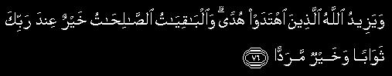
Allah increaseth in right guidance those who walk aright, and the good deeds which endure are better in thy Lord's sight for reward, and better for resort. [Verse:76]

Quran Chapter 47
Surah Muhammad

While as for those who walk aright, He addeth to their guidance, and giveth them their protection (against evil). [Verse:17]

Quran Chapter 2
Surah Al Baqarah

This is the Scripture whereof there is no doubt, a guidance unto those who ward off (evil). [Verse:2]

Quran Chapter 2
Surah Al Baqarah
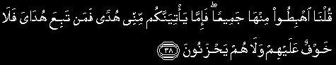
We said: Go down, all of you, from hence; but verily there cometh unto you from Me a guidance; and whoso followeth My guidance, there shall no fear come upon them neither shall they grieve. [Verse:38]

Quran Chapter 2 Surah Al Baqarah
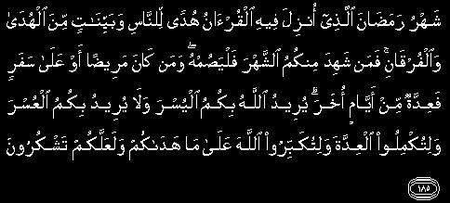
The month of Ramadan in which was revealed the Qur'an, a guidance for mankind, and clear proofs of the guidance, and the Criterion (of right and wrong). And whosoever of you is present, let him fast the month, and whosoever of you is sick or on a journey, (let him fast the same) number of other days. Allah desireth for you ease; He desireth not hardship for you; and (He desireth) that ye should complete the period, and that ye should magnify Allah for having guided you, and that peradventure ye may be thankful. [Verse:185]

Quran Chapter 3
Surah Al-E-Imran
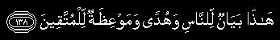
This is a declaration for mankind, a guidance and an admonition unto those who ward off (evil). [Verse:138]

Quran Chapter 27
Surah An Naml
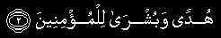
A guidance and good tidings for believers. [Verse:2]

Quran Chapter 31
Surah Luqman
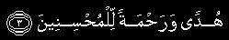
A guidance and a mercy for the good. [Verse:3]

Quran Chapter 41
Surah Fussilat
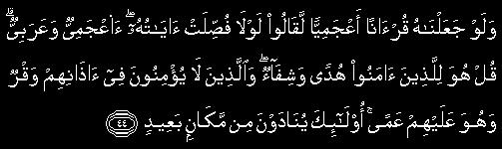
And if We had appointed it a Lecture in a foreign tongue they would assuredly have said: If only its verses were expounded (so that we might understand)? What! A foreign tongue and an Arab? - Say unto them (O Muhammad): For those who believe it is a guidance and a healing; and as for those who disbelieve, there is a deafness in their ears, and it is blindness for them. Such are called to from afar. [Verse:44]

Quran Chapter 45
Surah Jathiya
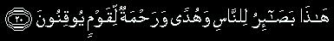
This is clear indication for mankind, and a guidance and a mercy for a folk whose faith is sure. [Verse:20]

Quran Chapter 2
Surah Al Baqarah
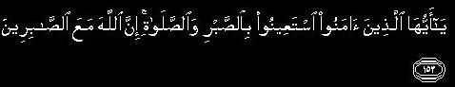
O ye who believe! Seek help in steadfastness and prayer. Lo! Allah is with the steadfast. [Verse:153]

Quran Chapter 2
Surah Al Baqarah
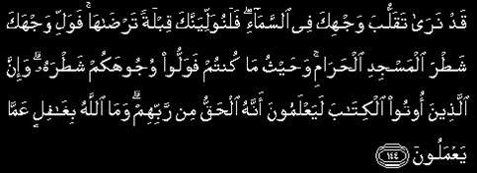
We have seen the turning of thy face to heaven (for guidance, O Muhammad). And now verily We shall make thee turn (in prayer) toward a qiblah which is dear to thee. So turn thy face toward the Inviolable Place of Worship, and ye (O Muslims), wheresoever ye may be, turn your faces (when ye pray) toward it. Lo! Those who have received the Scripture know that (this revelation) is the Truth from their Lord. And Allah is not unaware of what they do. [Verse:144]

Quran Chapter 16 Surah An Nahl

Lo! Allah is with those who keep their duty unto Him and those who are doers of good. [Verse:128]

Quran Chapter 42
Surah Ash Shura
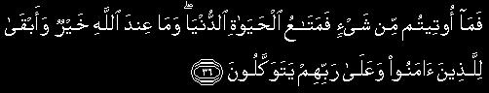
Now whatever ye have been given is but a passing comfort for the life of the world, and that which Allah hath is better and more lasting for those who believe and put their trust in their Lord. [Verse:36]

Quran Chapter 40
Surah Ghafir
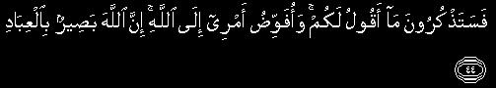
And ye will remember what I say unto you. I confide my cause unto Allah. Lo! Allah is Seer of (His) slaves. [Verse:44]

Quran Chapter 43
Surah Az Zukhruf
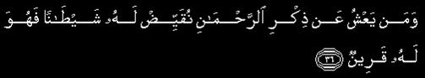
And he whose sight is dim to the remembrance of the Beneficent, We assign unto him a devil who becometh his comrade; [Verse:36]

Quran Chapter 44 Surah Ad Dukhan
Verses 1-8
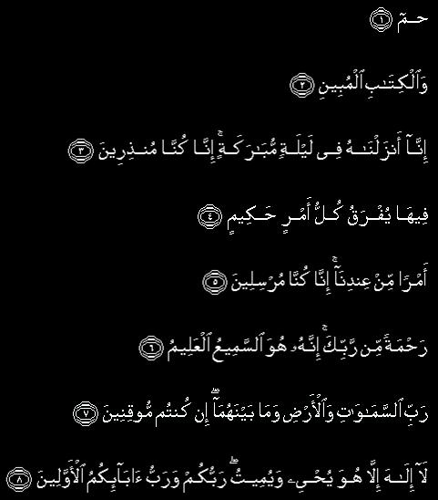
Ha. Mim. By the Scripture that maketh plain. Lo! We revealed it on a blessed night - Lo! We are ever warning - Whereon every wise command is made clear. As a command from Our presence - Lo! We are ever sending - A mercy from thy Lord. Lo! He, even He is the Hearer, the Knower, Lord of the heavens and the earth and all that is between them, if ye would be sure. There is no God save Him. He quickeneth and giveth death; your Lord and Lord of your forefathers.

Quran Chapter 44
Surah Ad Dukhan

Nay, but they play in doubt. [Verse:9]

Quran Chapter 51
Surah Ad Dhariyat
Verse 55-58
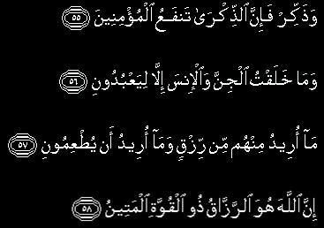
And warn, for warning profiteth believers. I created the jinn and humankind only that they might worship Me. I seek no livelihood from them, nor do I ask that they should feed Me. Lo! Allah! He it is that giveth livelihood, the Lord of unbreakable might.

Quran Chapter 24
Surah An Noor
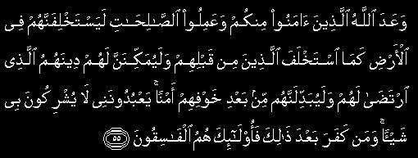
Allah hath promised such of you as believe and do good work that He will surely make them to succeed (the present rulers) in the earth even as He caused those who were before them to succeed (others); and that He will surely establish for them their religion which He hath approved for them, and will give them in exchange safety after their fear. They serve Me. They ascribe no thing as partner unto Me. Those who disbelieve henceforth, they are the miscreants. [Verse:55]

Quran Chapter 27
Surah An Naml
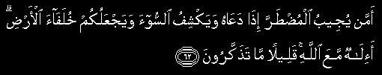
Is not He (best) Who answereth the wronged one when he crieth unto Him and removeth the evil, and hath made you viceroys of the earth? Is there any God beside Allah? Little do they reflect! [Verse:62]

Quran Chapter 33
Surah Al Ahzab
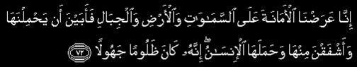
Lo! We offered the trust unto the heavens and the earth and the hills, but they shrank from bearing it and were afraid of it. And man assumed it. Lo! he hath proved a tyrant and a fool. [Verse:72]

Quran Chapter 35
Surah Fatir
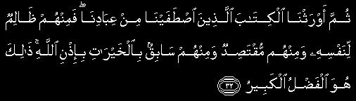
Then We gave the Scripture as inheritance unto those whom We elected of Our bondmen. But of them are some who wrong themselves and of them are some who are lukewarm, and of them are some who outstrip (others) through good deeds, by Allah's leave. That is the great favour! [Verse:32]

Quran Chapter 36
Surah Ya Seen
Verses 1-6
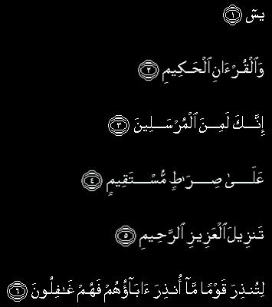
Ya Sin. By the wise Qur'an, Lo! thou art of those sent On a straight path, A revelation of the Mighty, the Merciful, That thou mayst warn a folk whose fathers were not warned, so they are heedless.

Quran Chapter 36
Surah Ya Seen
Verses 7-9
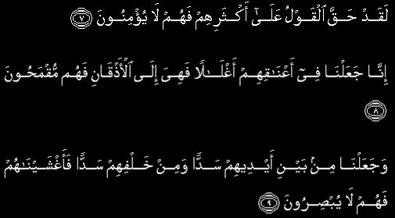
Already hath the word proved true of most of them, for they believe not. Lo! We have put on their necks carcans reaching unto the chins, so that they are made stiff-necked. And We have set a bar before them and a bar behind them, and (thus) have covered them so that they see not.

Quran Chapter 36
Surah Ya Seen
Verses 10-12
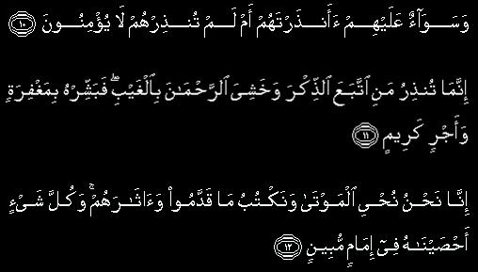
Whether thou warn them or thou warn them not, it is alike for them, for they believe not. Thou warnest only him who followeth the Reminder and feareth the Beneficent in secret. To him bear tidings of forgiveness and a rich reward. Lo! We it is Who bring the dead to life. We record that which they send before (them), and their footprints. And all things We have kept in a clear Register.

Quran Chapter 36
Surah Ya Seen
Verse 69-70
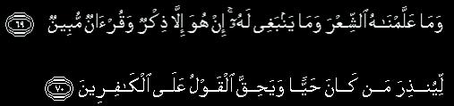
And We have not taught him (Muhammad) poetry, nor is it meet for him. This is naught else than a Reminder and a Lecture making plain, To warn whosoever liveth, and that the word may be fulfilled against the disbelievers.

Quran Chapter 36
Surah Ya Seen
Verse 82-83
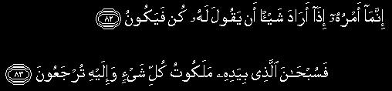
But His command, when He intendeth a thing, is only that he saith unto it: Be! and it is. Therefor glory be to Him in Whose hand is the dominion over all things! Unto Him ye will be brought back.

Go To Top

Conclusion
Questions that need to be answered...
Now that you have read the messages that the Quran has to give you,Please answer these questions, before death approaches you!
Where are you now?
Where am I?
Where is the Ummah?
What are we going to do with what we just read?
What Knowledge Benefited You...

• Did you benefit from reciting the Quran?
• Did you benefit from hearing the word of Allah SWT, the Quran during the time of Taraweeh?
• Did you try to comprehend and reflect over what you heard, i.e. the word of Allah SWT?
• Did you prepare yourself for the meeting with Allah and answer about your life, your role in life and your responsibility, the one Allah SWT granted you?
• Did you think that you might drop dead any moment and you have no time if you are a believer?
• Did you ask Allah SWT to give you the chance to renew your faith and develop the good qualities, the ones Allah SWT loves and will be pleased with?
• Did you think about where youre going, what your purpose in life is? Did you ever wonder if you are with Allah SWT or with Shaitan? What do you want?
Today We Can, Tomorrow We Cannot...
These Questions Need To Be Answered
Before You Enter The Grave.

Go To Top

Daee Ahmed Moait

