What Is Jail?
Part 3
A Reminder for Those Who Wish To Be Reminded

Messages and promises from our Lord Rabbul ‘Alameen:
Surah Yunus:
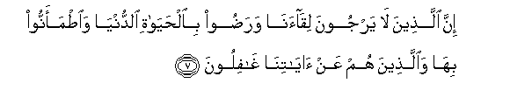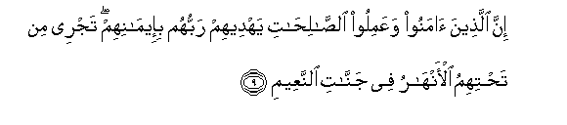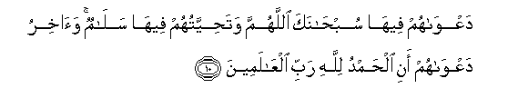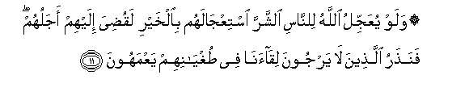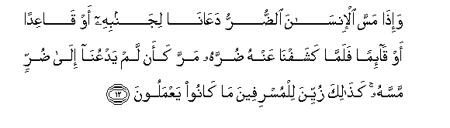
Surely those who do not hope in Our meeting and are pleased with this world's life and are content with it, and those who are heedless of Our communications: (As for) those, their abode is the fire because of what they earned. Surely (as for) those who believe and do good, their Lord will guide them by their faith; there shall flOw from beneath them rivers in gardens of bliss. Their cry in it shall be: Glory to Thee, O Allah! and their greeting in it shall be: Peace; and the last of their cry shall be: Praise be to Allah, the Lord of the worlds. And if Allah should hasten the evil to men as they desire the hastening on of good, their doom should certainly have been decreed for them; but We leave those alone who hope not for Our meeting in their inordinacy, blindly wandering on. And when affliction touches a man, he calls on Us, whether lying on his side or sitting or standing; but when We remove his affliction from him, he passes on as though he had never called on Us on account of an affliction that touched him; thus that which they do is made fair-seeming to the extravagant. (7—12)

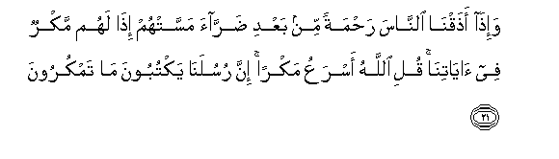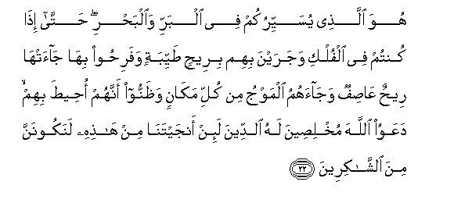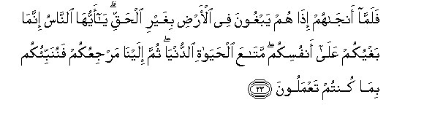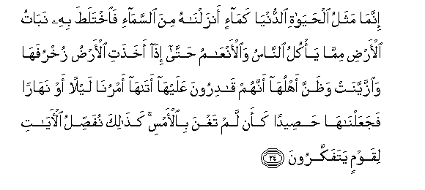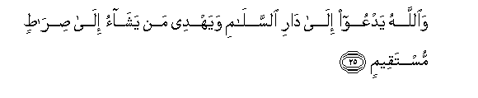
And when We make people taste of mercy after an affliction touches them, lo! they devise plans against Our communication. Say: Allah is quicker to plan; surely Our messengers write down what you plan. He it is Who makes you travel by land and sea; until when you are in the ships, and they sail on with them in a pleasant breeze, and they rejoice, a violent wind overtakes them and the billows surge in on them from all sides, and they become certain that they are encompassed about, they pray to Allah, being sincere to Him in obedience: If Thou dost deliver us from this, we will most certainly be of the grateful ones. But when He delivers them, lo! they are unjustly rebellious in the earth. O men! your rebellion is against your own souls-- provision (only) of this world's life-- then to Us shall be your return, so We will inform you of what you did. The likeness of this world's life is only as water which We send down from the cloud, then the herbage of the earth of which men and cattle eat grows luxuriantly thereby, until when the earth puts on its golden raiment and it becomes garnished, and its people think that they have power over it, Our command comes to it, by night or by day, so We render it as reaped seed; produce, as though it had not been in existence yesterday; thus do We make clear the communications for a people who reflect. And Allah invites to the abode of peace and guides whom He pleases into the right path. (21—25)
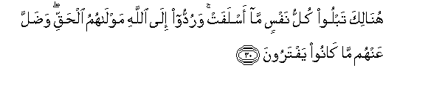
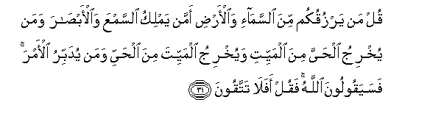
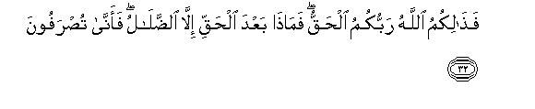
There shall every soul become acquainted with what it sent before, and they shall be brought back to Allah, their true Patron, and what they devised shall escape from them. Say: Who gives you sustenance from the heaven and the earth? Or Who controls the hearing and the sight? And Who brings forth the living from the dead, and brings forth the dead from the living? And Who regulates the affairs? Then they will say: Allah. Say then: Will you not then guard (against evil)? This then is Allah, your true Lord; and what is there after the truth but error; how are you then turned back? Thus does the word of your Lord prove true against those who transgress that they do not believe. (30—33)

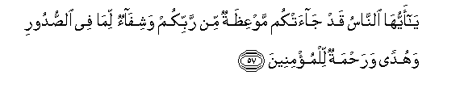
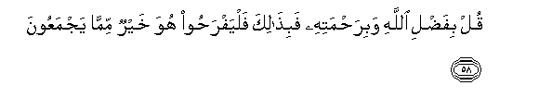

O men! there has come to you indeed an admonition from your Lord and a healing for what is in the breasts and a guidance and a mercy for the believers. Say: In the grace of Allah and in His mercy-- in that they should rejoice; it is better than that which they gather. (57—58)

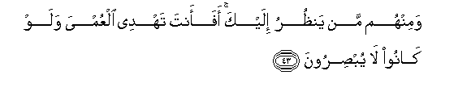
And there are those of them who look at you, but can you show the way to the blind though they will not see? (43)

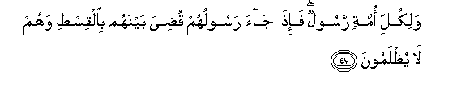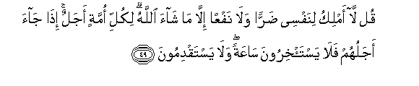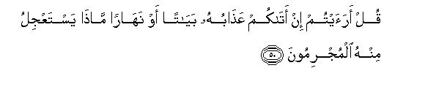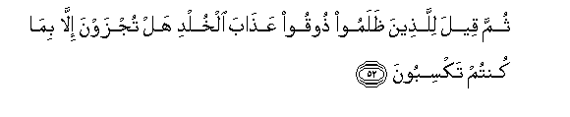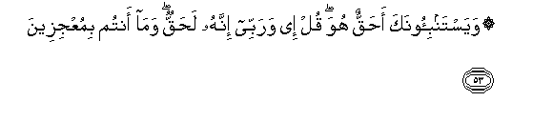
And every nation had a messenger; so when their messenger came, the matter was decided between them with justice and they shall not be dealt with unjustly. And they say: When will this threat come about, if you are truthful? Say: I do not control for myself any harm, or any benefit except what Allah pleases; every nation has a term; when their term comes, they shall not then remain behind for an hour, nor can they go before (their time). Say: Tell me if His punishment overtakes you by night or by day! what then is there of it that the guilty would hasten on? And when it comes to pass, will you believe in it? What! now (you believe), and already you wished to have it hastened on. Then it shall be said to those who were unjust: Taste abiding chastisement; you are not requited except for what you earned. And they ask you: Is that true? Say: Aye! by my Lord! it is most surely the truth, and you will not escape. (47—53)


Those who believe and guarded (against evil). (63)

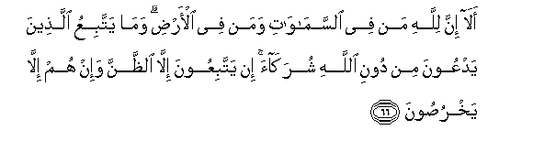
Now, surely, whatever is in the heavens and whatever is in the earth is Allah's; and they do not (really) follow any associates, who call on others besides Allah; they do not follow (anything) but conjectures, and they only lie. (66)
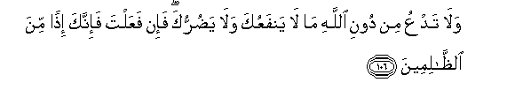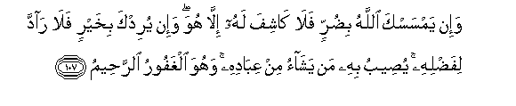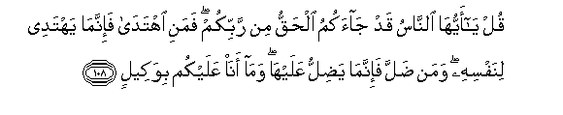
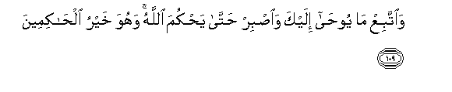
And do not call besides Allah on that which can neither benefit you nor harm you, for if you do then surely you will in that case be of the unjust. And if Allah should afflict you with harm, then there is none to remove it but He; and if He intends good to you there is none to repel His grace; He brings it to whom He pleases of His servants; and He is the Forgiving, the Merciful. Say: O people! indeed there has come to you the truth from your Lord, therefore whoever goes aright, he goes aright only for the good of his own soul, and whoever goes astray, he goes astray only to the detriment of it, and I am not a custodian over you. And follow what is revealed to you and be patient till Allah should give judgment, and He is the best of the judges. (106—109)

Surah Hud:
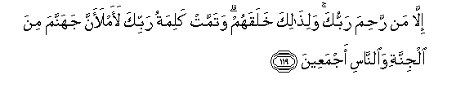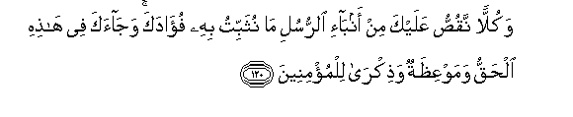
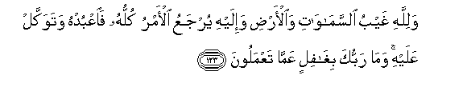
And if your Lord had pleased He would certainly have made people a single nation, and they shall continue to differ. Except those on whom your Lord has mercy; and for this did He create them; and the word of your Lord is fulfilled: Certainly I will fill hell with the jinn and the men, all together. And all we relate to you of the accounts of the messengers is to strengthen your heart therewith; and in this has come to you the truth and an admonition, and a reminder to the believers. And say to those who do not believe: Act according to your state; surely we too are acting. And wait; surely we are waiting also. And Allah's is the unseen in the heavens and the earth, and to Him is returned the whole of the affair; therefore serve Him and rely on Him, and your Lord is not heedless of what you do. (118—123)

Surah Al-Hijr:

And surely We know that your breast straitens at what they say; Therefore celebrate the praise of your Lord, and be of those who make obeisance. And serve your Lord until there comes to you that which is certain. (97—99)

Surah At-Tur:

And wait patiently for the judgment of your Lord, for surely you are before Our eyes, and sing the praise of your Lord when you rise; And in the night, give Him glory too, and at the setting of the stars. (48—49)

Surah Yaseen:
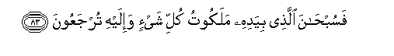
His command, when He intends anything, is only to say to it: Be, so it is. Therefore glory be to Him in Whose hand is the kingdom of all things, and to Him you shall be brought back. (82—83)

صدق الله العظيم
Allah the Magnificent has spoken the truth.

