What Is Jail?
Part 2

- Great Men
- Story Of Yusuf
- A Message
- This Life Is A Chance
- Download Word/Pdf

Great Men
Many great men have spent time in jail. Yusuf AS was in jail between 7 to 20 years for something he did not commit. But actually, Allah SWT had chosen it for him. Can you imagine one of the most beloved prophets, the son of a prophet and he ends up in jail for a crime he never committed? A scholar once said, .
You Will Never Be Out Of Surah Yusuf,
And One Way Or Another
You Have To Go Through The Trials It Mentions...

Go To Top

Story Of Yusuf AS
When Yusuf (AS) was young, he was the most beloved of his father because his father had seen the signs of prophet-hood in him, but all his brother envied him and were jealous of him.
By This Way, The First Trial
Jealousy, Envy And Hate From Your Own Family.
Second, When They Took Him And Threw Him
In The Deep Darkness Of The Well,
He Experienced Loneliness, Fear,
Unknown Darkness, Future Without Any Hope...
When he was rescued from this situation, he was sold into slavery for a meager price. Now from being a beloved son of a messenger and prophet, he is a worthless slave. He was taken to a distant, alien land as a slave, where he grew up to be a respectable and very handsome young man.
Now he faced the difficult trial of adulthood; the woman of the house fell in love with him and tried to seduce him. At this point he said his famous sentence,
Quran Chapter 2 Surah Yusuf
[Verse 33]

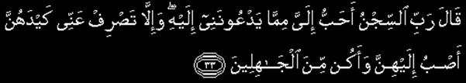
"My Lord! The prison house is dearer to me than that to which they invite me; and if Thou turn not away their device from me, I will yearn towards them and become (one) of the ignorant"
After being separated from his beloved father, being betrayed by his own brothers, and being sold into slavery was not enough, now he is thrown in jail over something he didn’t do. There he continued his worship to Allah as well as his dawah to Allah though he made a mistake. It was a minor mistake but by a man who was chosen by Allah as a Prophet, this was a big error.
Yusuf (As) Asked One Of The Men
Who Was Leaving Jail To Bring Up His Case
In Front Of The King,
Meaning He Asked The Help Of Another Human Being
Hoping He Will Be Able To Help Him Out Of This Situation.
Allah SWT trialed him by extending his stay in jail by 2 – 7 years as a punishment for his drifting from his own belief and seeking the help of someone other than Allah SWT.
Only When He Reached The Peak Of Iman
And Trust In Allah,
That Allah Swt Elevated Him...
We are talking about almost after 40 years of separation from his father and approximately 14 to 20 years in jail. Not only was he freed from jail but he was made the treasurer of Egypt, one of the most trusted and respected men in the nation. Who could have made it possible besides Allah SWT, the owner of all means? Allah SWT calls this the best story and when you read Surah Yusuf very carefully, you will know why.
Quran Chapter 2 Surah Yusuf
[Verse 100]

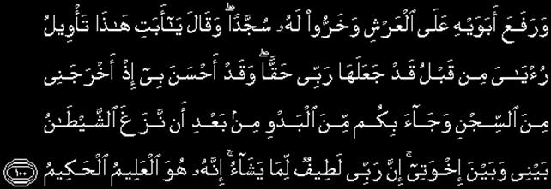
And he raised his parents high on the throne (of dignity), and they fell down in prostration, (all) before him. He said: "O my father! this is the fulfilment of my vision of old! Allah hath made it come true! He was indeed good to me when He took me out of prison and brought you (all here) out of the desert, (even) after Satan had sown enmity between me and my brothers. Verily my Lord understandeth best the mysteries of all that He planneth to do, for verily He is full of knowledge and wisdom.

Quran Chapter 2 Surah Yusuf
[Verse 101]

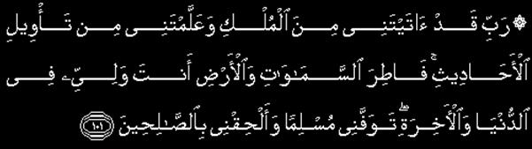
"O my Lord! Thou hast indeed bestowed on me some power, and taught me something of the interpretation of dreams and events,- O Thou Creator of the heavens and the earth! Thou art my Protector in this world and in the Hereafter. Take Thou my soul (at death) as one submitting to Thy will (as a Muslim), and unite me with the righteous."

Go To Top

VERSES 102 TO 111
CARRY THE MESSAGE FOR ALL OF US
UNTIL THE DAY OF JUDGEMENT

Quran Chapter 2 Surah Yusuf
[Verse 102]

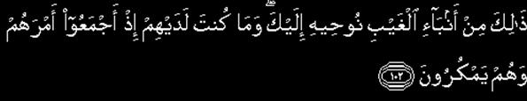
Such is one of the stories of what happened unseen, which We reveal by inspiration unto thee; nor wast thou (present) with them then when they concerted their plans together in the process of weaving their plots.

[Verse 103]


Yet no faith will the greater part of mankind have, however ardently thou dost desire it.

[Verse 104]

And no reward dost thou ask of them for this: it is no less than a message for all creatures.

[Verse 105]

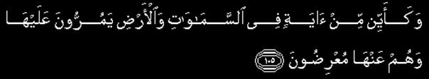
And how many Signs in the heavens and the earth do they pass by? Yet they turn (their faces) away from them!

[Verse 106]


And most of them believe not in Allah without associating (other as partners) with Him!

[Verse 107]

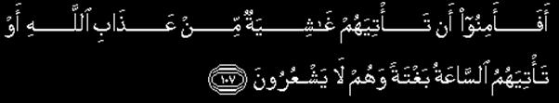
Do they then feel secure from the coming against them of the covering veil of the wrath of Allah,- or of the coming against them of the (final) Hour all of a sudden while they perceive not?

[Verse 108]

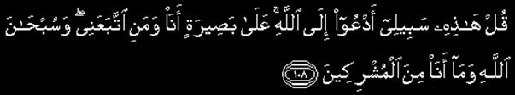
Say thou: "This is my way: I do invite unto Allah,- on evidence clear as the seeing with one's eyes,- I and whoever follows me. Glory to Allah. and never will I join gods with Allah."

[Verse 109]

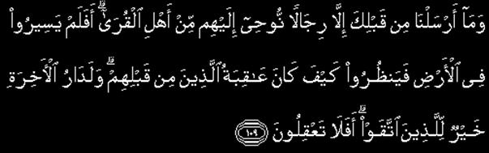
Nor did We send before thee (as apostles) any but men, whom we did inspire,- (men) living in human habitations. Do they not travel through the earth, and see what was the end of those before them? But the home of the hereafter is best, for those who do right. Will ye not then understand?

[Verse 110]

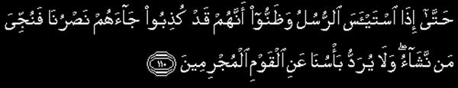
(Respite will be granted) until, when the apostles give up hope (of their people) and (come to) think that they were treated as liars, there reaches them Our help, and those whom We will are delivered into safety. But never will be warded off our punishment from those who are in sin.

[Verse 111]

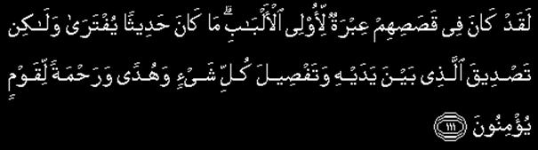
There is, in their stories, instruction for men endued with understanding. It is not a tale invented, but a confirmation of what went before it,- a detailed exposition of all things, and a guide and a mercy to any such as believe.
Allah is the owner of Qadr, and whatever He ordains is the best for us. But because of our weak imaan, shaitaan takes us to the future and we keep thinking about the future to the point we lose our present.
It doesn’t matter where we are. What matters is what we are doing, how much faith we have in Allah, and how much we rely on Allah. If you want to know your future, see how you benefit from your present.
Many Muslims Worry About The Future
Which Is A State Of Kufr;
It Is A State Of Ungratefulness To Allah;
And Almost Denying The Wisdom Of Allah...
Instead Of Benefitting
From What Allah Has Given Us
And To Use It For Allah,
We Are Busy About The Future
Over Which We Have No Control
This Is Shaitaan’s Deception...

Go To Top

This Life Is A Chance
Allah is All-Wise and the owner of Wisdom; He ordains what is best for us. As a true believer once I fully surrender to Allah, my Qadr becomes the most beloved to me; especially if I did not choose it. It is at this point that Allah is truly pleased with me and I pass my trial.
RASULALLAH SAW SAID:
DUNYAH IS THE JAIL OF THE MU’MIN,
AND THE PARADISE OF THE DISBELIEVER.
This life is a chance. Whatever goodness Allah SWT gives you, grab it. Today you can, tomorrow you cannot. The recipe of success in this life and the hereafter is to live day by day. Try to leave a legacy everywhere you go.
Grab any goodness Allah send your way. Don’t even think about the future for a second—it does not belong to you.
Be Content With Allah,
Allah Will Be Content With You
Respect The Qadr Of Allah,
And Allah Will Open For You.
All the power is located in the Quran, connect yourself to it. Allah is the owner and source of all the power and quality.


Daee Ahmed Moait
www.noora1.com

