What Is Jail?


- Introduction
- Hidden Goodness
- Ultimate Freedom
- Do You Know What The Ultimate Freedom Is?
- The Ultimate End
- Two Great Personalities Who Were In Jail
- Download Word/Pdf

Introduction
Physical jail imprisons your body in one place where it is not allowed to move freely and do the things it normally would have done. And that’s it.
But in the spiritual jail, the jail of heart and mind, the jail of waswasa (whispers) of shaitan, of wondering and worrying about future, uncertainty, doubt, fear, worry.
Spiritual Jail Is The Kind Of Jail
That Needs Being Afraid Of!
This Is The Jail That Eats You
Alive Inside...
The Real Jail Is The Darkness
Within The Heart And Soul!
This Is The One That Makes You Paralyze
This jail is the one that cannot make you gain and destroys any prospects of enjoyment and benefit. this is the kind of jail that you need to worry about because it destroys any hope and a believer never loses hope in his lord...
Go To Top

Hidden Goodness
- The spiritual jail destroys any goodness and a believer knows there is goodness hidden for him in things that he doesn’t like.
Quran Chapter 2 Surah Al Baqarah
[Verse 216]
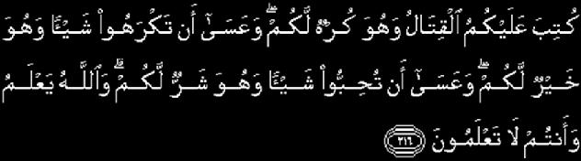
And it may be that you dislike a thing which is good for you and that you like a thing which is bad for you. Allah knows but you do not know.

- It makes one paralyzed and a believer is never paralyzed because his Lord is powerful over all things.
Quran Chapter 3 Surah Al Imran
[Verse 26]

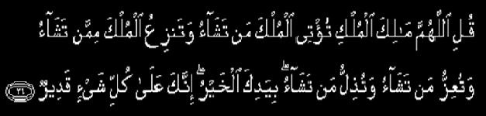
Say: "O Allah. Lord of Power (And Rule), Thou givest power to whom Thou pleasest, and Thou strippest off power from whom Thou pleasest: Thou enduest with honour whom Thou pleasest, and Thou bringest low whom Thou pleasest: In Thy hand is all good. Verily, over all things Thou hast power.

- It enslaves one without any visible chains and a believer has the power of d’ua (supplication) which is freedom in itself—to call on the All-Hearing Lord.
Quran Chapter 21 Surah Al Anbiya
[Verse 88]

So We listened to him: and delivered him from distress: and thus do We deliver those who have faith.

Quran Chapter 36 Surah Al Ya-Sin
[Verse 82]


"Indeed His command, when He desires a thing, is only to say to it 'Be' and it is"
Go To Top

Ultimate Freedom
A person can live in a beautiful house or a palace but in reality he can be in jail. In the jail of loneliness while listening to the whispers of shaitan, the real enemy who brings nothing except poverty of wealth and soul.
Quran Chapter 2 Surah Al Baqara [Verse 268]
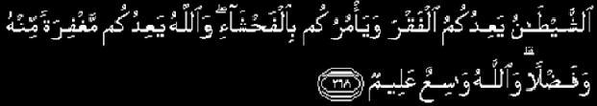
"Shaytan promises you poverty and commands you to avarice. Allah promises you forgiveness from Him and abundance. Allah is All-Encompassing, All-Knowing".
Can Anything Be Worse Than
Being In Jail Even When You Are Free?
This Trap Of Shaitan Lasts Until He Leads The Person
To The Ultimate Jail
The Hell Fire!
Whereas, on the other hand how many people are in jail yet they are free? Their hearts, minds and souls are free?
Go To Top

Do You Know What The Ultimate Freedom Is?
It is when Allah allows you to be free for him, the freedom that allows you to communicate with Allah. Therefore,
- If You Are With Allah
- If You Remember Him
- If You Have Trust In Him
- If You Love And Thank Him
- If You Are Content With Him
- If You Believe In The Qualities And Attributes Of Allah SWT
- And Know That He Is All-Wise
- He Has Chosen The Situation Of Yours For A Reason
NOW YOU ARE FREE...
At this time you are not lonely, in-fact you are busy. You are busy internally, establishing your relationship with Allah. This leads you to be free, to be happy, to be powerful, to be successful in this life and in the hereafter.
This Freedom Of Heart And Soul
Attracts The Angels;
Allah swt Descends The Angels To His Heart
Fill His Heart With Tranquility
Peace, Happiness, Contentment
Strength And Positive Feeling
This Allows Him To Benefit Himself And Others
Regardless Of Where He Is...
This Is The Real Freedom
And The Taste And Fragrance Of Jannah On Earth!
Now it is up to you to choose whether you would like to be free or jailed! Keys to both are in your own hands. If you want the keys to happiness in this life and the hereafter keep calling Allah, remember Him SWT, trust Him and believe in His wisdom and attributes.
Quran Chapter 2 Surah Al Baqara [Verse 186]
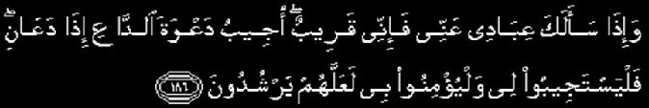
And when My servants ask you concerning Me, then surely I am very near; I answer the prayer of the suppliant when he calls on Me, so they should answer My call and believe in Me that they may walk in the right way.
Allah the Highest said in Hadith Qudsi:
"I AM AS MY SLAVE EXPECTS OF ME AND
I AM WITH HIM WHENEVER HE REMEMBERS ME"

Go To Top

The Ultimate End
Any choice other than Allah SWT will only lead to darkness, disgrace, loneliness, uncertainty, fear, worry and eventually to the ultimate misery in this life and the hereafter; regardless of the worldly comforts and material benefits one might have.
Today Majority Of Mankind Is In Jail
In The Jail Of Ignorance & Arrogance!
The Jail Of Not Knowing Allah swt
This Is The Ultimate Jail Because...
At This Time The Person’s Companion Is Shaitan!
The Enemy Who Makes Situations Uglier Than They Are...
And Fills One With Sorrow, Fear, Hopelessness And Despair For Future!
Can You See The Ultimate End Of Such People...???
As Anything Other Than Hellfire!!!
If Allah SWT opens your heart and gives you the key of Iman, trust, and knowledge of His attributes, then you have got the keys to the happiness in this life and the hereafter.
Take Your Life Day By Day,
Reflect Over Your Life
And Count Allah’s Limitless Blessings On You
And Thank Him For Them;
Now Allah Will Make You Happy
And Take Care Of Your Future.
On the other hand if you do not thank Allah and you are not content with what Allah has decided for you, then you will open the door for shaitan in your heart and he will lead you to darkness, hesitation, despair, and nothing will make you happy.
Now, instead of thanking Allah, you will worry about what future has in store for you. You won’t only lose the bounty of this time that you can utilize to get closer to Allah, but shaitan will make you fall into the trap of perpetual worry and paranoia about life and all that because of lack of thanks to Allah swt.
Go To Top

Two Great Personalities Who Were In Jail
Islamic history is full of great men who had to suffer in jail; and are two such people.
- Imam Ahmed ibn Taymiyyah
- Imam Abu Hanifa (who died in jail)
Both had two things in common
- They never committed any crimes.
- They were very happy and content to the point they never complained.
Imam Ahmed Ibn Taymiyyah Used To Say 'My Jannah Is In My Heart And Nobody Can Take It From Me.’ When He Was Asked About The Secret To His Happiness, He Said Allah Swt Has Freed Me From This World, For Him.
THIS IS THE ULTIMATE FREEDOM
AND A SIGN OF BEING CHOSEN BY ALLAH SWT.
IT IS IN THIS THAT YOU FIND THE CONTENTMENT
AND FREEDOM OF SOUL
EVEN IF YOUR BODY IS INCARCERATED...

Part2 Coming Soon


Go To Top

Daee Ahmed Moait

www.noora1.com

