Heedlessness From Meeting Our Lord

In today’s chaotic life style, our priorities have become misconstrued to the point we have lost the very purpose of our existence. We are deceived by the glamour of material life so much so that we have become obsessed with this transitory world and have forgotten our final destination.

We are living at a time when everything is tainted by confusion and doubt; misunderstandings, lack of understanding, ignorance, multiple ideologies, conspiracies, arguments and fights have seeped into every aspect of our lives. This confusion combined with our obsession with duniya (this world) has led to an erosion of our faith, understanding, manners and purpose of existence. In other words, we have fallen into a state of ghafla or heedlessness.

This ghafla is so deep that we are spiritually stunted; all the illnesses, natural disasters, injustice, killing, and even death has no effect on us. We see what is happening around us; we cluck our tongues at the mischief we see yet we remain occupied with the accumulation of this world. Our attitude towards this world is of permanency; it is as if we will not die. It is as though we are immune to the negatives, all the problems and disasters are for others and they cannot occur to us.

It is urgent that we ask ourselves:

How did we get to this state of heedlessness?

How can we remove ourselves from it?

Are our thoughts and efforts focused on the competition of this world or are we preparing for the eventual meeting with our Lord?

How best can we prepare ourselves to meet our Lord, Allah SWT?

If we truly grasp the purpose of this life we will realize that it is nothing more than to prepare ourselves for the moment of departure and for the meeting with our Lord. Read on and bi-idhnillah, you will grasp a thorough understanding of the topic.

Meeting With Allah Is Certain:

Death is the most certain thing in life yet people treat it as if it was doubtful. Allah SWT knows this forgetful nature of people and repeatedly reminds them in the Qur'an of this eventual meeting with Him.

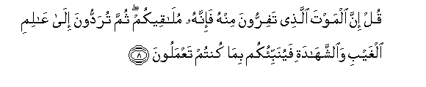
Say, "Indeed, the death from which you flee - indeed, it will meet you. Then you will be returned to the Knower of the unseen and the witnessed, and He will inform you about what you used to do." (Al-Jumu’ah 62:8)


Unquestionably, they are in doubt about the meeting with their Lord. Unquestionably He is, of all things, encompassing. (Fussilat 41:54)

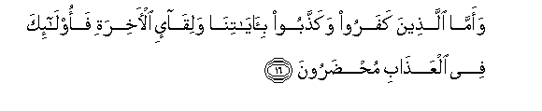
But as for those who disbelieved and denied Our verses and the meeting of the Hereafter, those will be brought into the punishment [to remain]. (Ar-Rum 30:16)

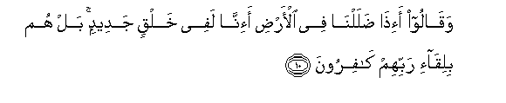
And they say, "When we are lost within the earth, will we indeed be [recreated] in a new creation?" Rather, they are, in [the matter of] the meeting with their Lord, disbelievers. (Sajdah 32:10)

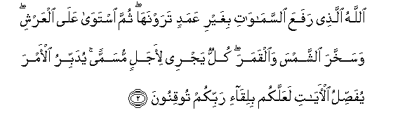
It is Allah who erected the heavens without pillars that you [can] see; then He established Himself above the Throne and made subject the sun and the moon, each running [its course] for a specified term. He arranges [each] matter; He details the signs that you may, of the meeting with your Lord, be certain. (Ar-R’ad 13:2)


O mankind, indeed you are laboring toward your Lord with [great] exertion and will meet it. (Inshiqaq 84:6)

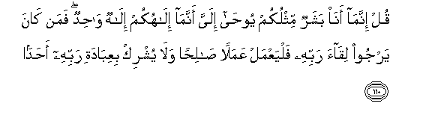
Say, "I am only a man like you, to whom has been revealed that your god is one God. So whoever would hope for the meeting with his Lord - let him do righteous work and not associate in the worship of his Lord anyone." (Al-Kahf 18:110)


Whoever should hope for the meeting with Allah - indeed, the term decreed by Allah is coming. And He is the Hearing, the Knowing. (Al-‘Ankabut 29:5)

People Are Heedless About Their Eternal Lives:

Allah SWT defines the term heedlessness in the Qur'an in order to not leave any doubt in the matter. He SWT makes it very clear that heedlessness is not in the matter of the world rather of the hereafter and that the only true source of knowledge is Allah SWT Himself:

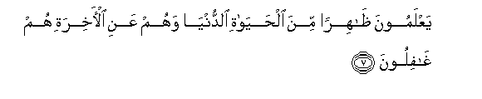
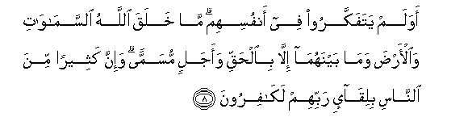
They know what is apparent of the worldly life, but they, of the Hereafter, are unaware.

Do they not contemplate within themselves? Allah has not created the heavens and the earth and what is between them except in truth and for a specified term. And indeed, many of the people, in [the matter of] the meeting with their Lord, are disbelievers. (Ar-Rum 30:7—8)

Do We Have The Right Knowledge?

Allah SWT goes on to inform us that the true knowledge which makes us aware and informed is the knowledge provided by Allah SWT:

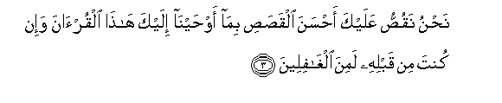
We relate to you, [O Muhammad], the best of stories in what We have revealed to you of this Qur'an although you were, before it, among the unaware. (Yusuf 12:3)

If we acquire all the knowledge of this world but are unaware of the knowledge of Allah and what He is telling us, then are we really knowledgeable? Would any of our knowledge be able to help us when we are presented before our Lord?

The real knowledge is the knowledge of death, life after death, Day of Resurrection when our deeds are presented to us, and of our eventual abodes of Paradise and hellfire. This knowledge of the hereafter is what Allah SWT calls the real knowledge, Al-Haqq (truth) and Al-Yaqeen (certainty)! And this is the knowledge we are supposed to strive for in our lives to prepare us for the long journey of the hereafter.

Islam is based on the belief of the unseen.

Belief in:
- Allah,
- His angels,
- Day of Judgment,
- Life after death,
- Jannah and Jahannam.

Allah SWT says:



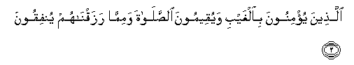
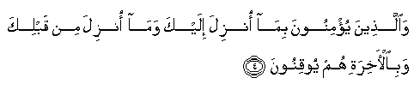


Alif, Lam, Meem.

This is the Book about which there is no doubt, a guidance for those conscious of Allah –

Who believe in the unseen, establish prayer, and spend out of what We have provided for them,

And who believe in what has been revealed to you, [O Muhammad], and what was revealed before you, and of the Hereafter they are certain [in faith].

Those are upon [right] guidance from their Lord, and it is those who are the successful. (Baqara 2:1—5)

Heedlessness vs. Awareness Of The Meeting With Allah:

Following ayah establishes the relationship between heedlessness and the awareness of the meeting with Allah SWT. It is a linear relationship where when one variable increases the other decreases.

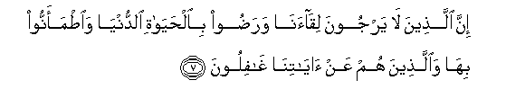
Indeed, those who do not expect the meeting with Us and are satisfied with the life of this world and feel secure therein and those who are heedless of Our signs. For those their refuge will be the Fire because of what they used to earn. (Yunus 10:7)

Allah SWT has given us numerous examples of heedless people and in one has compared them to creatures lower or dumber than cattle.

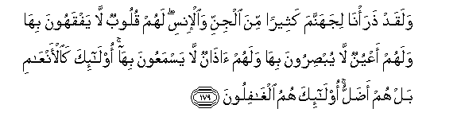
And We have certainly created for Hell many of the jinn and mankind. They have hearts with which they do not understand, they have eyes with which they do not see, and they have ears with which they do not hear. Those are like livestock; rather, they are more astray. It is they who are the heedless. (Al-A’raf 7:179)

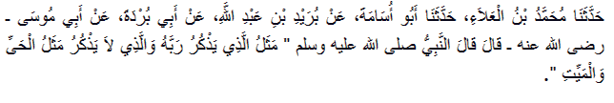
Prophet Muhammad SAW said:
“The example of the one who remembers his Lord, in comparison to the one who does not remember his Lord, is that of a living creature compared to a dead one.” (Bukhari)

Allah SWT is the owner of everything including guidance and light which is the very opposite of heedlessness. It is our negligence towards our eventual meeting with Allah that brings heedlessness from Allah SWT.

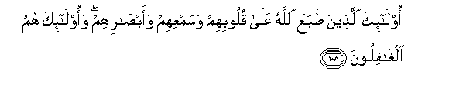
Those are the ones over whose hearts and hearing and vision Allah has sealed, and it is those who are the heedless. (An-Nahl 16:108)

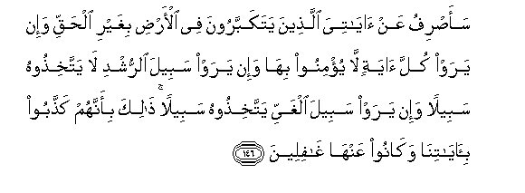
I will turn away from My signs those who are arrogant upon the earth without right; and if they should see every sign, they will not believe in it. And if they see the way of consciousness, they will not adopt it as a way; but if they see the way of error, they will adopt it as a way. That is because they have denied Our signs and they were heedless of them. (Al-A’raf 7:146)

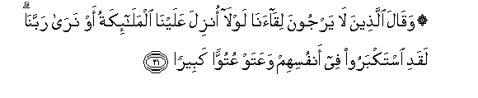
And those who do not expect the meeting with Us say, "Why were not angels sent down to us, or [why] do we [not] see our Lord?" They have certainly become arrogant within themselves and [become] insolent with great insolence. (Al-Furqan 25:21)

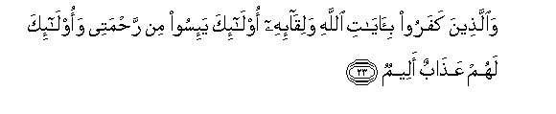
And the ones who disbelieve in the signs of Allah and the meeting with Him - those have despaired of My mercy, and they will have a painful punishment. (Al-‘Ankabut 29:23)

Message Of Islam Is An Ultimatum!

Allah SWT has promised that He will not destroy any nation that had not been given the message from Allah SWT. Once the message is delivered and the people are still heedless of their meeting with their Lord, that is when the hujja or case against them is established and Allah SWT replaces them with those sincere slaves who are more worthy of carrying this covenant.


That is because your Lord would not destroy the cities for wrongdoing while their people were unaware. (Al-An`am 6:131)

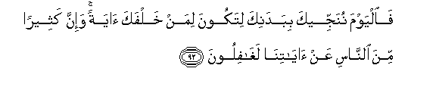
So today We will save you in body that you may be to those who succeed you a sign. And indeed, many among the people, of Our signs, are heedless. (Yunus 10:92)

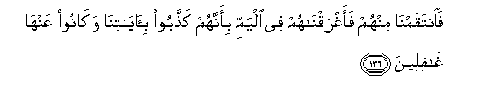
So We took retribution from them, and We drowned them in the sea because they denied Our signs and were heedless of them. (Al-A’raf 7:136)

Success vs. Failure:

Allah SWT divides those who are vigilant about their meeting with their Lord and those who are not into two separate categories; one group is to reach success and the other is doomed to fail:

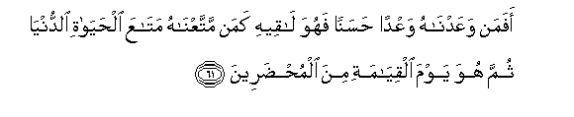
Then is he whom We have promised a good promise which he will obtain like he for whom We provided enjoyment of worldly life [but] then he is, on the Day of Resurrection, among those presented [for punishment in Hell]? (Al-Qasas 28:61)



The successful ones are those “who are certain that they will meet their Lord and that they will return to Him.” (Baqara 2:46)

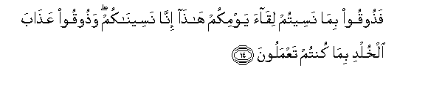
While the regrettable are those who will be told: “So taste [punishment] because you forgot the meeting of this, your Day; indeed, We have [accordingly] forgotten you. And taste the punishment of eternity for what you used to do." (As-Sajdah 32:14)

The Prophet said: "Whoever loves the meeting with Allah, Allah too, loves the meeting with him; and whoever hates the meeting with Allah, Allah too, hates the meeting with him." ...(Bukhari)

Heedless Until It Is Too Late:

Allah SWT warns us that most of the mankind will fall in the trap of shaytaan and will remain heedless until it is too late—death!


[The time of] their account has approached for the people, while they are in heedlessness turning away. (Al-Anbiya 21:1)

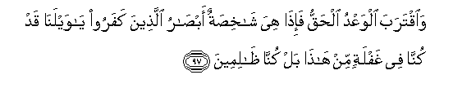
And [when] the true promise has approached; then suddenly the eyes of those who disbelieved will be staring [in horror, while they say], "O woe to us; we had been unmindful of this; rather, we were wrongdoers." (Al-Anbiya 21:97)

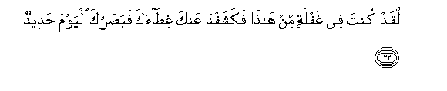
[It will be said], "You were certainly in unmindfulness of this, and We have removed from you your cover, so your sight, this Day, is sharp." (Qaf 50:22)

The Greatest Regret:

This heedlessness from the eventual meeting with his Lord will be the cause of greatest regret for a person on the Day of Judgment. Allah SWT says in the Qur'an:

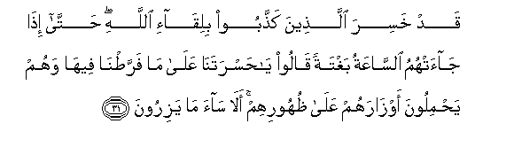
Those will have lost who deny the meeting with Allah, until when the Hour [of resurrection] comes upon them unexpectedly, they will say, "Oh, [how great is] our regret over what we neglected concerning it," while they bear their burdens on their backs. Unquestionably, evil is that which they bear. (Al-An'am 6:31)

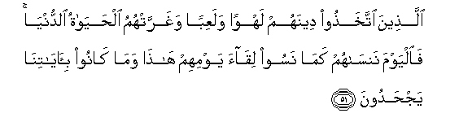
Who took their religion as distraction and amusement and whom the worldly life deluded." So today We will forget them just as they forgot the meeting of this Day of theirs and for having rejected Our verses. (Al-A’raf 7:51)

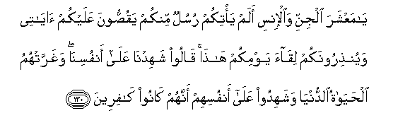
"O company of jinn and mankind, did there not come to you messengers from among you, relating to you My verses and warning you of the meeting of this Day of yours?" They will say, "We bear witness against ourselves"; and the worldly life had deluded them, and they will bear witness against themselves that they were disbelievers. (Al-An’am 6:130)

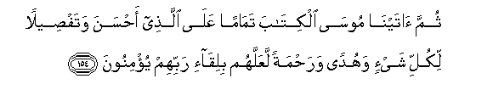
Then We gave Moses the Scripture, making complete [Our favor] upon the one who did good and as a detailed explanation of all things and as guidance and mercy that perhaps in [the matter of] the meeting with their Lord they would believe. (Al-An’am 6:154)

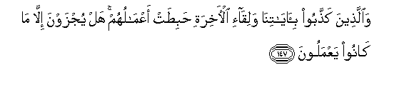
Those who denied Our signs and the meeting of the Hereafter - their deeds have become worthless. Are they recompensed except for what they used to do? (Al-A’raf 7:147)

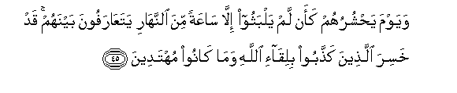
And on the Day when He will gather them, [it will be] as if they had not remained [in the world] but an hour of the day, [and] they will know each other. Those will have lost who denied the meeting with Allah and were not guided. (Yunus 10:45)

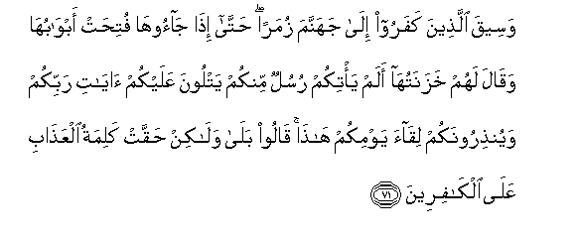
And those who disbelieved will be driven to Hell in groups until, when they reach it, its gates are opened and its keepers will say, "Did there not come to you messengers from yourselves, reciting to you the verses of your Lord and warning you of the meeting of this Day of yours?" They will say, "Yes, but the word of punishment has come into effect upon the disbelievers. (Az-Zumar 39:71)

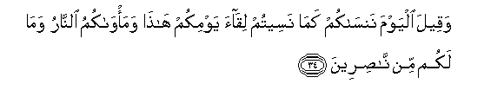
And it will be said, "Today We will forget you as you forgot the meeting of this Day of yours, and your refuge is the Fire, and for you there are no helpers. (Al-Jathiya 45:34)

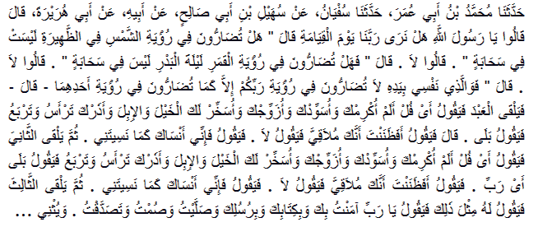

Abu Huraira reported that they (the Companions of the Holy Prophet) said: “Allah's Messenger, will we be able to see our Lord on the Day of Judgment? He said: Do you feel any difficulty in seeing the sun in the noon when there is no cloud over it? They said: No. He again said: Do you feel any difficulty in seeing the moon on the fourteenth night when there is no cloud over it? They said: No.

Thereupon he said: By Allah Who is One in Whose Hand is my life you will not face any difficulty in seeing your Lord but only so much as you feel in seeing one of them. Then Allah would sit in judgment upon the servant and would say: O, so and so, did I not honor you and make you the chief and provide you the spouse and subdue for you horses, camels, and afforded you an opportunity to rule over your subjects? He would say: Yes. And then it would be said: Did you not think that you would meet Us? And he would say: No. Thereupon He (Allah) would say: Well, We forget you as you forgot Us.

Then the second person would be brought for judgment. (And Allah would) say: 0, so and so. did We not honor you and make you the chief and make you pair and subdue for you horses and camels and afford you an opportunity to rule over your subjects? He would say: Yes, my Lord. And He (the Lord) would say: Did you not think that you would be meeting Us? And he would say: No. And then He (Allah) would say: Well, I forget you today as you forgot Us.

Then the third -one would be brought and He (Allah) would say to him as He said before. And he (the third person) would say: O, my Lord, I affirmed my faith in Thee and in Thy Book and in Thy Messenger and I observed prayer and fasts and gave charity, and he would speak in good terms like this as he would be able to do. And He (Allah) would say: Well, We will bring our witnesses to you. And the man would think in his mind who would bear witness upon him and then his mouth would be sealed and it would be said to his thighs, to his flesh and to his bones to speak and his thighs. flesh and bones would bear witness to his deeds and it would be done so that he should not be able to make any excuse for himself and he would be a hypocrite and Allah would be annoyed with him.” (Muslim)

We Have Already Testified:

Allah SWT, the Creator of heaven and earth knows the argumentative nature of humans and has already forewarned us that knowledge of Allah SWT has been given to all souls and the excuse of not knowing Him will be dismissed on the Day of Judgment:

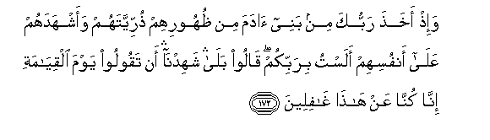
And [mention] when your Lord took from the children of Adam - from their loins - their descendants and made them testify of themselves, [saying to them], "Am I not your Lord?" They said, "Yes, we have testified." [This] - lest you should say on the day of Resurrection, "Indeed, we were of this unaware." (Al-A’raf 7: 172)

Muslims Are Representatives Of Allah On Earth:

The responsibility of a representative of Allah on earth is not easy; it demands struggles, sacrifices, constant state of watchfulness against the desires of one's soul and devil. Yet, the highest responsibility of a believer is to carry the message of Allah to humanity and bring them out of the state of heedlessness by reminding them of their eventual meeting with their Lord.


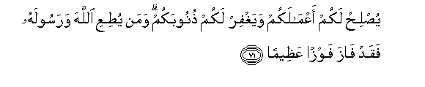
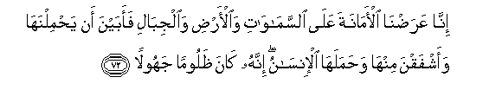
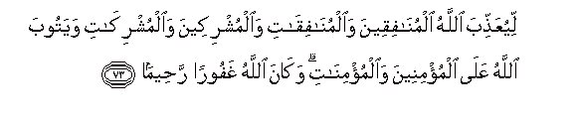
O you who have believed, fear Allah and speak words of appropriate justice.

He will [then] amend for you your deeds and forgive you your sins. And whoever obeys Allah and His Messenger has certainly attained a great attainment.

Indeed, we offered the Trust to the heavens and the earth and the mountains, and they declined to bear it and feared it; but man [undertook to] bear it. Indeed, he was unjust and ignorant.

[It was] so that Allah may punish the hypocrite men and hypocrite women and the men and women who associate others with Him and that Allah may accept repentance from the believing men and believing women. And ever is Allah Forgiving and Merciful. (Ahzab 33:70—73)

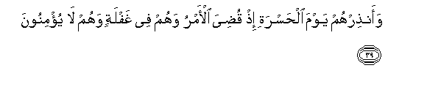
And warn them, [O Muhammad], of the Day of Regret, when the matter will be concluded; and [yet], they are in [a state of] heedlessness, and they do not believe. (Maryam 19:39)


That you may warn a people whose forefathers were not warned, so they are unaware. (Yasin 36:6)

The Prophet of Allah SAW successfully fulfilled this momentous task and left this responsibility to us. He SAW said in his final pilgrimage sermon:

"Your blood, your property and your honor are inviolable to you all like the inviolability of this day of yours, in this city of yours and in this month of yours. You will soon meet your Rabb and He will ask you about your deeds. So do not turn to disbelief after me by striking the necks of one another. Behold! Let him who is present here convey (this message ) to him who is absent; for many a person to whom a message is conveyed has more retentive memory than the one who hears it." He (PBUH) again said, "Have I conveyed the message to you? Behold! Have I conveyed the Commandments (of Allah) to you." We submitted: "Yes". He then said, "O Allah, bear witness (to this)." (Al-Bukhari and Muslim)

What Saves People From Heedlessness?

Desire to meet Allah SWT and attainment of His pleasure is the driving force of the believer. All his actions are governed by this desire and this desire is what saves him from falling into heedlessness. Everyone is responsible for his actions and will be recompensed for his deeds on the Day he meets His Lord. So what can be a better motivation for a believer than the advices and promises of His Lord SWT?

Allah SWT tells His righteous slaves in the Qur'an:

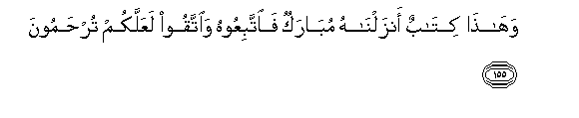
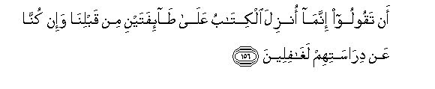
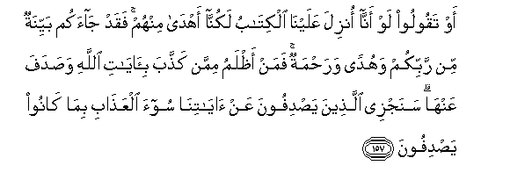
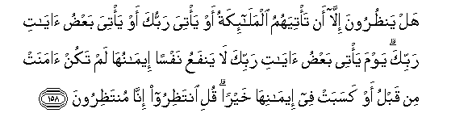
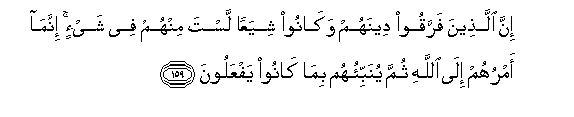
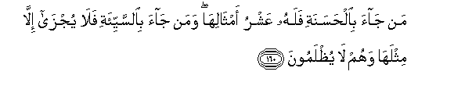
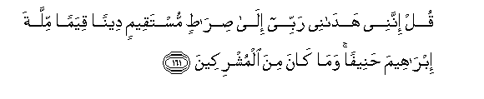
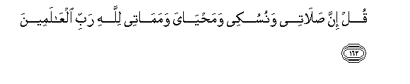

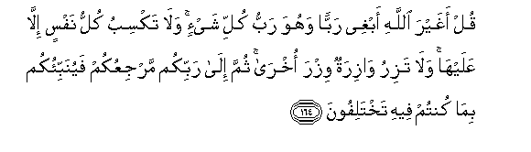
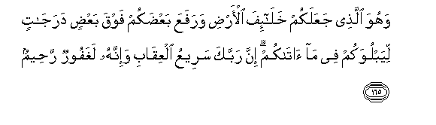
“And this [Qur'an] is a Book We have revealed [which is] blessed, so follow it and fear Allah that you may receive mercy. [We revealed it] lest you say, "The Scripture was only sent down to two groups before us, but we were of their study unaware," Or lest you say, "If only the Scripture had been revealed to us, we would have been better guided than they."

So there has [now] come to you a clear evidence from your Lord and a guidance and mercy. Then who is more unjust than one who denies the verses of Allah and turns away from them? We will recompense those who turn away from Our verses with the worst of punishment for their having turned away. Do they [then] wait for anything except that the angels should come to them or your Lord should come or that there come some of the signs of your Lord?

The Day that some of the signs of your Lord will come no soul will benefit from its faith as long as it had not believed before or had earned through its faith some good. Say, "Wait. Indeed, we [also] are waiting." Indeed, those who have divided their religion and become sects - you, [O Muhammad], are not [associated] with them in anything. Their affair is only [left] to Allah ; then He will inform them about what they used to do. Whoever comes [on the Day of Judgment] with a good deed will have ten times the like thereof [to his credit], and whoever comes with an evil deed will not be recompensed except the like thereof; and they will not be wronged.

Say, "Indeed, my Lord has guided me to a straight path - a correct religion - the way of Abraham, inclining toward truth. And he was not among those who associated others with Allah." Say, "Indeed, my prayer, my rites of sacrifice, my living and my dying are for Allah, Lord of the worlds. No partner has He. And this I have been commanded, and I am the first [among you] of the Muslims." Say, "Is it other than Allah I should desire as a lord while He is the Lord of all things?

And every soul earns not [blame] except against itself, and no bearer of burdens will bear the burden of another. Then to your Lord is your return, and He will inform you concerning that over which you used to differ." And it is He who has made you successors upon the earth and has raised some of you above others in degrees [of rank] that He may try you through what He has given you. Indeed, your Lord is swift in penalty; but indeed, He is Forgiving and Merciful.” (Al-An'am 6: 155—165)

Are We Ready For Victory?

Our world is in a state of turmoil—economically, politically, environmentally and socially. Nations and individuals alike are dealing with uncertainties and instability. We as Muslims are facing an even bigger catastrophe—spiritual instability. Muslims have succumbed to many ideologies foreign to their religion to the point they have lost their own identity and purpose of existence. The very roots of their faith have been shaken and their Islam has become hollow, devoid of its real essence.

We have to ask ourselves, why Allah SWT allowed this to happen since nothing can happen without the knowledge and will of Allah SWT. If Islam is really the deen of Allah SWT, then why are Muslims so humiliated all over the world? The answer is fairly simple.

Islam is Allah SWT's deen and He will grant it victory. The light of Allah will prevail--whether with us or without us. This brings us to the question of utmost importance:

Are we in a state of spiritual readiness that brings the mercy and victory of Allah SWT?

Victory can only come from Allah SWT and He grants it to those blessed believers who are spiritually ready to receive this honor. An honest reflection on our state according to the criteria provided by the Qur'an and Sunnah will tell us that we are in a state of deep heedlessness and far away from the true meaning of Islam. Neither have we ourselves surrendered to Allah SWT, nor have we brought this message to humanity as is our job.

This negligence and disregard for the message of Islam is what has earned us this state of heedlessness from our Lord and in turn disgrace and humiliation in this world. Instead of elevating the deen of Allah, our actions have misconstrued its image for the world.

This establishes the next points of concern:

- What is heedlessness?
- How do we fall into this state?
- And how can we remove ourselves from it?

What is Heedlessness?

Heedlessness in Arabic is called ghafla, which refers to a person who is not in a state of awareness. Like a drunkard; who is not aware of his surroundings, cannot distinguish, and cannot even remember where he lives. Similarly when a person is in the state of heedlessness, he is not aware about the message of the Almighty Creator. He forgets about the most important state of his life—his life after death. By this way he is living in one state and he is not aware and alert about the other state at all.

How Do We Fall Into This State?

Today, we are living in a state called duniya; an unstoppable, vicious cyclone of material life. The focus of this state is accumulation and its driving forces are greed and selfishness. Nothing can put a stop to it until the person is hit with an accident, a major crisis, sickness, or death.

We are so deeply drowned in this state that we are not even aware about each other, do not care about each other, and we have no consideration for each other. We have lost a lot of basic qualities such as compassion, feeling, and care which Allah SWT has given us.

This duniya is so deeply rooted in our hearts to the point this is what one generation feeds the other and the sickness of material accumulation and competition continues. This is what causes the heedlessness of the second stage—the hereafter.

When we lose the second stage which is the hereafter, our first stage which is duniya takes preference. It overtakes our entire beings—our thoughts, compassion, love…everything. It is the opposite of the message of Islam. Islam teaches us to take from this world the bare minimum for our sustenance and share the rest with those in need for sabeelillah. Our aim is to try to leave this life very light with only our good deeds and faith in our luggage to the next world.

What makes us reach this level?

After Prophet SAW passed away, the message of Islam went through many ups and downs, trial after trial, and fitna after fitna until little by little we lost the essence of the message. Add to that the fact that in last six hundred years, the whole Muslim world has been under severe attack from different colonial forces who succeeded in snatching the foundation of this message.

We were robbed of the leftover basic elements of this religion and our societies were embedded with corrupt understanding of Islam which reduced this mighty religion to a few rituals and acts of worship. Eventually it became the accepted norm all through the Muslim world to be satisfied with some rituals and prayers while being drowned in the material world. Different opinions and schools of thought were amplified among the Muslims which caused unnecessary division and we ended up being overwhelmed with duniya while fighting and arguing among ourselves over insignificant differences until we reached where we are today!

Today we are paying the price of almost six hundred years of erosion of understanding, deception, and misunderstandings. Add to that the division of ideology, philosophizing of the message and disunity among the ummah. All this, because we are sick from the disease of heedlessness!

Rasul Allah SAW has warned us about this time and has given us advices on how to deal with the situations that arise. I recommend reading the book The Book of End by Ibn Kathir as it has all the warnings and advices of RasulAllah SAW for us on how to deal with our current situation. An example of that is the following hadeeth by Hudhaifa (RA), a companion of the Prophet SAW.

حَدَّثَنَا يَحْيَى بْنُ مُوسَى، حَدَّثَنَا الْوَلِيدُ، قَالَ حَدَّثَنِي ابْنُ جَابِرٍ، قَالَ حَدَّثَنِي بُسْرُ بْنُ عُبَيْدِ اللَّهِ

الْحَضْرَمِيُّ، قَالَ حَدَّثَنِي أَبُو إِدْرِيسَ الْخَوْلاَنِيُّ، أَنَّهُ سَمِعَ حُذَيْفَةَ بْنَ الْيَمَانِ، يَقُولُ كَانَ النَّاسُ يَسْأَلُونَ رَسُولَ اللَّهِ صلى الله عليه وسلم عَنِ الْخَيْرِ، وَكُنْتُ أَسْأَلُهُ عَنِ الشَّرِّ مَخَافَةَ أَنْ يُدْرِكَنِي‏.‏ فَقُلْتُ يَا رَسُولَ اللَّهِ إِنَّا كُنَّا فِي جَاهِلِيَّةٍ وَشَرٍّ، فَجَاءَنَا اللَّهُ بِهَذَا الْخَيْرِ، فَهَلْ بَعْدَ هَذَا الْخَيْرِ مِنْ شَرٍّ قَالَ ‏"‏ نَعَمْ ‏"‏‏.‏ قُلْتُ وَهَلْ بَعْدَ ذَلِكَ الشَّرِّ مِنْ خَيْرٍ قَالَ ‏"‏ نَعَمْ، وَفِيهِ دَخَنٌ ‏"‏‏.‏ قُلْتُ وَمَا دَخَنُهُ قَالَ ‏"‏ قَوْمٌ يَهْدُونَ بِغَيْرِ هَدْيِي تَعْرِفُ مِنْهُمْ وَتُنْكِرُ ‏"‏‏.‏ قُلْتُ فَهَلْ بَعْدَ ذَلِكَ الْخَيْرِ مِنْ شَرٍّ قَالَ ‏"‏ نَعَمْ دُعَاةٌ إِلَى أَبْوَابِ جَهَنَّمَ، مَنْ أَجَابَهُمْ إِلَيْهَا قَذَفُوهُ فِيهَا ‏"‏‏.‏ قُلْتُ يَا رَسُولَ اللَّهِ صِفْهُمْ لَنَا فَقَالَ ‏"‏ هُمْ مِنْ جِلْدَتِنَا، وَيَتَكَلَّمُونَ بِأَلْسِنَتِنَا ‏"‏ قُلْتُ فَمَا تَأْمُرُنِي إِنْ أَدْرَكَنِي ذَلِكَ قَالَ ‏"‏ تَلْزَمُ جَمَاعَةَ الْمُسْلِمِينَ وَإِمَامَهُمْ ‏"‏‏.‏ قُلْتُ فَإِنْ لَمْ يَكُنْ لَهُمْ جَمَاعَةٌ وَلاَ إِمَامٌ قَالَ ‏"‏ فَاعْتَزِلْ تِلْكَ الْفِرَقَ كُلَّهَا، وَلَوْ أَنْ تَعَضَّ بِأَصْلِ شَجَرَةٍ حَتَّى يُدْرِكَكَ الْمَوْتُ وَأَنْتَ عَلَى ذَلِكَ ...

Hudhaifa RA said:

“People used to ask the Messenger of Allah (peace be upon him) about the good times, but I used to ask him about bad times fearing lest they overtake me. I said: Messenger of Allah, we were in the midst of ignorance and evil, and then God brought us this good (time through Islam). Is there any bad time after this good one? He said: Yes. I asked: Will there be a good time again after that bad time? He said: Yes, but therein will be a hidden evil. I asked: What will be the evil hidden therein? He said: (That time will witness the rise of) the people who will adopt ways other than mine and seek guidance other than mine. You will know good points as well as bad points. I asked: Will there be a bad time after this good one? He said: Yes. (A time will come) when there will be people standing and inviting at the gates of Hell. Whoso responds to their call they will throw them into the fire. I said: Messenger of Allah, describe them for us. He said: All right. They will be a people from us and speaking our language. I said: Messenger of Allah, what do you suggest if I happen to live in that time? He said: You should stick to the main body of the Muslims and their leader. I said: If they have no (such thing as the) main body and have no leader? He said: Separate yourself from all these factions, though you may have to eat the roots of trees (in a jungle) until death comes to you and you are in this state.” (Muslim)

What Is The Cure?

In order for us to remove ourselves from this state and cure this disease of heedlessness, we have to follow the pure teachings of Allah and His Prophet SAW without any ideologies and interpretations. We have to go back to the basics of Islam and develop the fundamental beliefs of our faith with the right understanding.

We have to follow the sequence of the revelation of the Qur’an and follow the approach of Allah SWT and His Prophet SAW in developing the people; first and foremost of which is development of the faith and strong relationship between Allah and His slaves.

Since heedlessness is a disease and Allah SWT has given us cures from all diseases in the Qur'an, He SWT has also given us remedy of heedlessness in His blessed book:

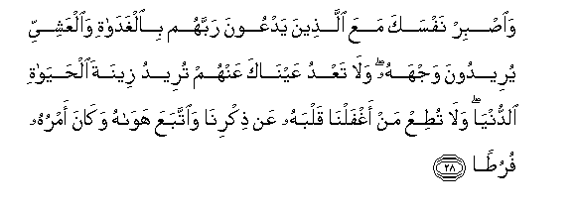
And keep yourself patient [by being] with those who call upon their Lord in the morning and the evening, seeking His countenance. And let not your eyes pass beyond them, desiring adornments of the worldly life, and do not obey one whose heart We have made heedless of Our remembrance and who follows his desire and whose affair is ever [in] neglect. (Al-Kahf 18:28)

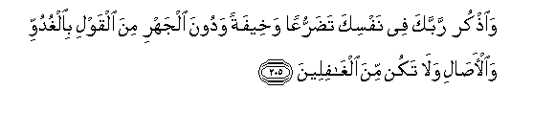
And remember your Lord within yourself in humility and in fear without being apparent in speech - in the mornings and the evenings. And do not be among the heedless. (Al-A’raf 7:205)

The Prophet SAW said:

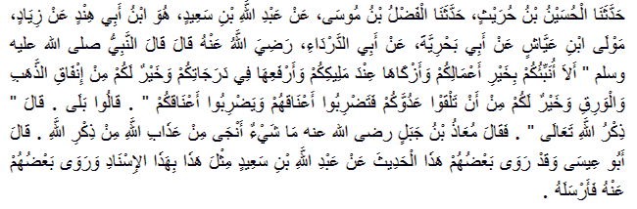

“Should I not inform you of the best of your deed, and the purest of them with your Master, and the highest of them in your ranks, and what is better for you than spending gold and silver, and better for you than meeting your enemy and striking their necks, and they strike your necks?” They said: “Of course.” He said, “The remembrance of Allah [Most High].” [Then] Mu’adh bin Jabal [may Allah be pleased with him] said: “There is nothing that brings more salvation from the punishment of Allah than the remembrance of Allah.” (Tirmidhi Hasan)

Ibn Qayyim Al-Jawziya mentions one of the merits of remembrance of God in his book 'Al-Wabil As-Sayyib Minal Kalim At-Tayyib' (Invocation of God) saying: “It endows him with proximity to God. His proximity to God is in proportion to his remembrance; his distance in proportion to his heedlessness.”

He goes on to say: “Since the heart is tarnished by two things—heedlessness and sin—it is polished by two things: remembrance and asking forgiveness.”

Ibn Qayyim Al-Jawziya mentions 120 benefits of remembrance of God in his book Invocation of God which is highly recommended and should be a must read for every Muslim.

Once Allah SWT accepts our efforts and cures us from the disease of heedlessness, we have to do everything possible to elevate the deen of Allah and bring others out of this terrible state. So that on the day of our eventual meeting with our Lord we can say “O Allah I tried my best!”

Allah Has Already Gives Us The Keys:

When we read Qur’an with the heart of a true Muslim and a Mo’min, we will find that Allah SWT has already given us the keys of all goodness. Today we want dignity, victory, elevation, unity etc and the answer is very simple. Allah SWT has promised to give us all that we want and to take care of all our worries. He has promised to unite the hearts of believers and give them success in this life and the hereafter.

All these promises are for the believers!

Will Allah SWT give victory to the heedless ones?

Will Allah be with the heedless ones?

Will Allah take care about the affairs of the heedless ones?

Meantime Allah SWT is warning us in the Qur’an that He will veil the heedless people and let them continue on their path until they destroy themselves. This destruction comes in the form of disgrace in this life and the hereafter. The disgrace of this world is to leave the person in the cyclone of duniya until it destroys the person and He wakes up in front of Allah SWT when it is too late.

Another form of disgrace is for Allah SWT to give people a clear message and then make them blind from this message. He does this by snatching away their ability to comprehend and understand what Allah wants from them and by depriving them of the honor of carrying the message of Islam to humanity.

Why?

Love of duniya!

One of our scholars said that people usually make tawba (repent) from all their sins except of loving duniya; because they never admit that they have duniya in their hearts.

We invest in education, in a job, in savings, in the decoration of our houses; how much do we invest in our grave, our jannah, and our meeting with our Lord?

This is what our condition is today and there is no way out of our current situation of disgrace and heedlessness unless we beg Allah and make real efforts to live the true message of Islam which majority of us have forgotten.

The following message from Allah SWT is a comprehensive account of our current situation:

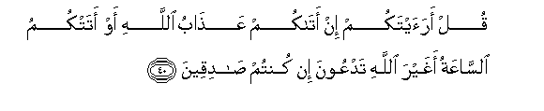
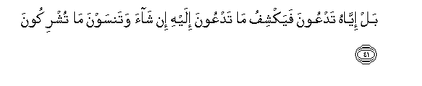
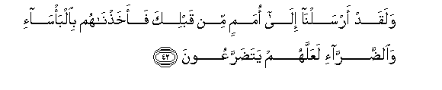
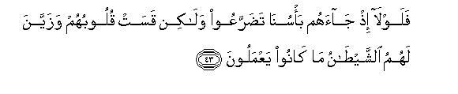
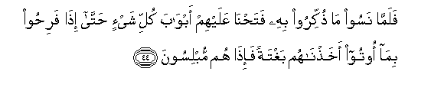

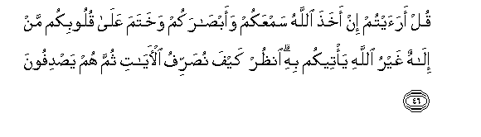
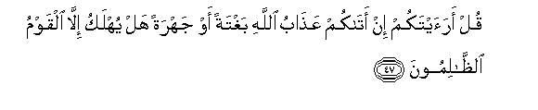
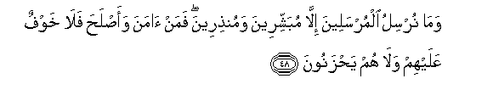
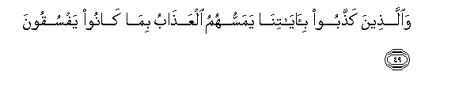
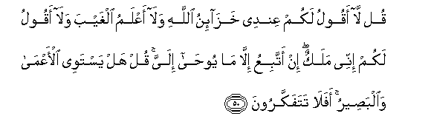
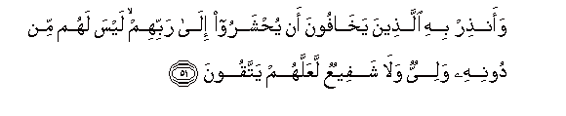
Say, "Have you considered: if there came to you the punishment of Allah or there came to you the Hour - is it other than Allah you would invoke, if you should be truthful?"

No, it is Him [alone] you would invoke, and He would remove that for which you invoked Him if He willed, and you would forget what you associate [with Him].

And We have already sent [messengers] to nations before you, [O Muhammad]; then We seized them with poverty and hardship that perhaps they might humble themselves [to Us].

Then why, when Our punishment came to them, did they not humble themselves? But their hearts became hardened, and Satan made attractive to them that which they were doing.

So when they forgot that by which they had been reminded, We opened to them the doors of every [good] thing until, when they rejoiced in that which they were given, We seized them suddenly, and they were [then] in despair.

So the people that committed wrong were eliminated. And praise to Allah, Lord of the worlds.

Say, "Have you considered: if Allah should take away your hearing and your sight and set a seal upon your hearts, which deity other than Allah could bring them [back] to you?" Look how we diversify the verses; then they [still] turn away.

Say, "Have you considered: if the punishment of Allah should come to you unexpectedly or manifestly, will any be destroyed but the wrongdoing people?"

And We send not the messengers except as bringers of good tidings and warners. So whoever believes and reforms - there will be no fear concerning them, nor will they grieve.

But those who deny Our verses - the punishment will touch them for their defiant disobedience.

Say, [O Muhammad], "I do not tell you that I have the depositories [containing the provision] of Allah or that I know the unseen, nor do I tell you that I am an angel. I only follow what is revealed to me." Say, "Is the blind equivalent to the seeing? Then will you not give thought?"

And warn by the Qur'an those who fear that they will be gathered before their Lord - for them besides Him will be no protector and no intercessor - that they might become righteous. (Al-An'am 6: 40-51)

Faith Must Translate Into Actions:

When our faith is strong, our hearts will be alert and all our efforts will be focused in one direction. Our bodies, our money, our hearts, our thoughts will all be focused on one aim—to please Allah SWT. We will be busy doing whatever we can before death overtakes us.

Today the entire ummah is suffering from calamities after calamities and yet we haven’t woken up from this state of heedlessness.

Where is this blindness coming from? It is coming from Allah SWT Himself.

Allah SWT says:

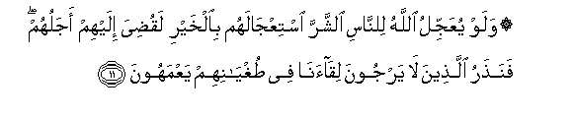
And if Allah was to hasten for the people the evil [they invoke] as He hastens for them the good, their term would have been ended for them. But We leave the ones who do not expect the meeting with Us, in their transgression, wandering blindly. (Yunus 10:11)

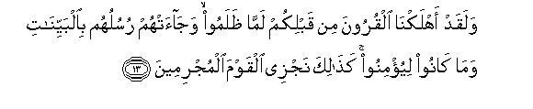
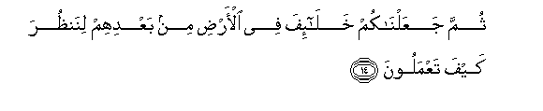
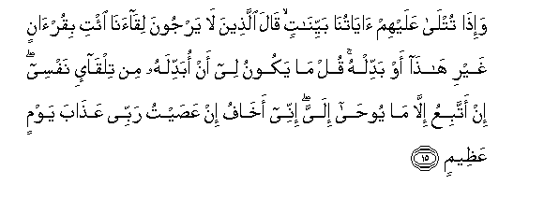
And We had already destroyed generations before you when they wronged, and their messengers had come to them with clear proofs, but they were not to believe. Thus do We recompense the criminal people

Then We made you successors in the land after them so that We may observe how you will do.

And when Our verses are recited to them as clear evidences, those who do not expect the meeting with Us say, "Bring us a Qur'an other than this or change it." Say, [O Muhammad], "It is not for me to change it on my own accord. I only follow what is revealed to me. Indeed I fear, if I should disobey my Lord, the punishment of a tremendous Day." (Yunus 10: 13—15)

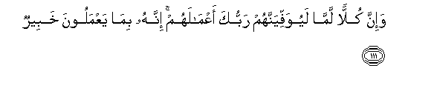
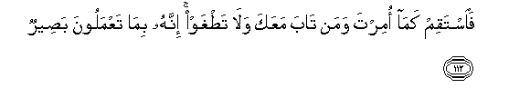
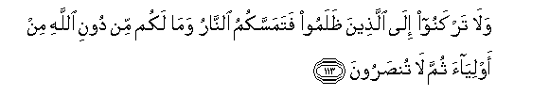
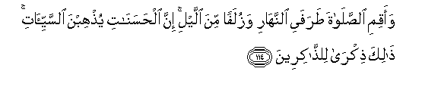

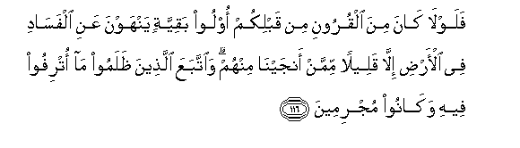


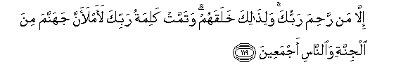
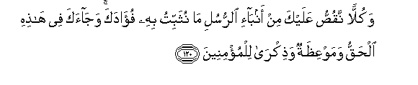


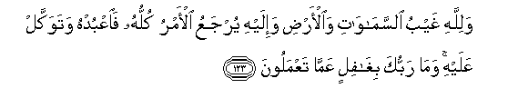
And indeed, each [of the believers and disbelievers] - your Lord will fully compensate them for their deeds. Indeed, He is Acquainted with what they do.

So remain on a right course as you have been commanded, [you] and those who have turned back with you [to Allah ], and do not transgress. Indeed, He is Seeing of what you do.

And do not incline toward those who do wrong, lest you be touched by the Fire, and you would not have other than Allah any protectors; then you would not be helped.

And establish prayer at the two ends of the day and at the approach of the night. Indeed, good deeds do away with misdeeds. That is a reminder for those who remember.

And be patient, for indeed, Allah does not allow to be lost the reward of those who do good.

So why were there not among the generations before you those of enduring discrimination forbidding corruption on earth - except a few of those We saved from among them? But those who wronged pursued what luxury they were given therein, and they were criminals.

And your Lord would not have destroyed the cities unjustly while their people were reformers.

And if your Lord had willed, He could have made mankind one community; but they will not cease to differ.

Except whom your Lord has given mercy, and for that He created them. But the word of your Lord is to be fulfilled that, "I will surely fill Hell with jinn and men all together."

And each [story] We relate to you from the news of the messengers is that by which We make firm your heart. And there has come to you, in this, the truth and an instruction and a reminder for the believers.

And say to those who do not believe, "Work according to your position; indeed, we are working.

And wait, indeed, we are waiting."

And to Allah belong the unseen [aspects] of the heavens and the earth and to Him will be returned the matter, all of it, so worship Him and rely upon Him. And your Lord is not unaware of that which you do. (Hud 11:111—123)

Allah SWT will not elevate His anger and blindness from us until we make a sincere effort to the journey of Iman.

Read the following verses, contemplate and everyday ask yourself:

- How many moments in a day I think about the akhirah?
- How many moments in a day I think about the grave?
- How many moments in a day I think about my death?
- How many moments in a day I think about Jannah and Jahannam?
- How many moments in a day I think about the condition of the ummah?
- How many moments in a day I think about what I am doing to support the deen of Allah, to elevate the deen of Allah, and to support the message?
- How many moments in a day I think about meeting my Lord?
- What will I tell Him about what I did with my time, with my life, and all the bounty and resources that He gave me?

May Allah SWT help us to wake up from our deep heedlessness before we wake up in our graves.

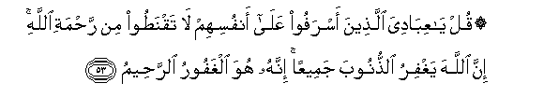
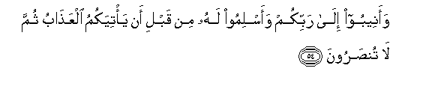
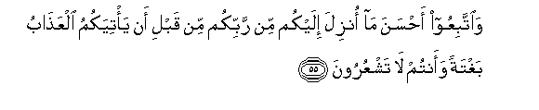
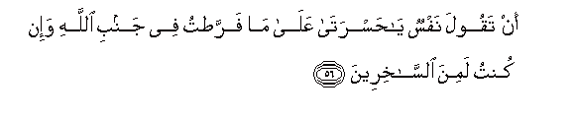

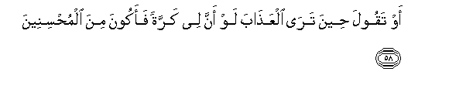
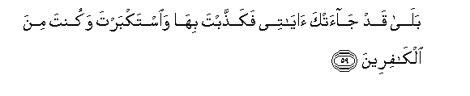
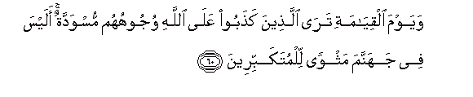
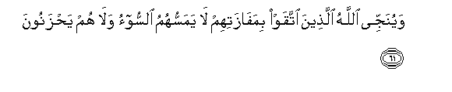
Say, "O My servants who have transgressed against themselves [by sinning], do not despair of the mercy of Allah . Indeed, Allah forgives all sins. Indeed, it is He who is the Forgiving, the Merciful."

And return [in repentance] to your Lord and submit to Him before the punishment comes upon you; then you will not be helped.

And follow the best of what was revealed to you from your Lord before the punishment comes upon you suddenly while you do not perceive,

Lest a soul should say, "Oh [how great is] my regret over what I neglected in regard to Allah and that I was among the mockers."

Or [lest] it say, "If only Allah had guided me, I would have been among the righteous."

Or [lest] it say when it sees the punishment, "If only I had another turn so I could be among the doers of good."

But yes, there had come to you My verses, but you denied them and were arrogant, and you were among the disbelievers.

And on the Day of Resurrection you will see those who lied about Allah [with] their faces blackened. Is there not in Hell a residence for the arrogant?

And Allah will save those who feared Him by their attainment; no evil will touch them, nor will they grieve. (Az-Zumar 39:53—61)

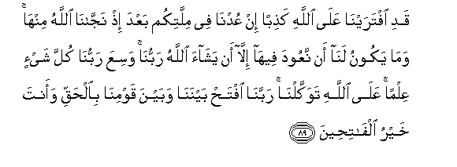
We would have invented against Allah a lie if we returned to your religion after Allah had saved us from it. And it is not for us to return to it except that Allah , our Lord, should will. Our Lord has encompassed all things in knowledge. Upon Allah we have relied. Our Lord, decide between us and our people in truth, and You are the best of those who give decision." (Al A’raf 7:89)

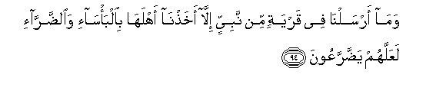
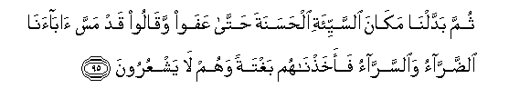
And We sent to no city a prophet [who was denied] except that We seized its people with poverty and hardship that they might humble themselves [to Allah ].

Then We exchanged in place of the bad [condition], good, until they increased [and prospered] and said, "Our fathers [also] were touched with hardship and ease." So We seized them suddenly while they did not perceive. (Al A’raf 7:94—95)

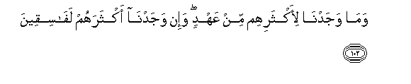
And We did not find for most of them any covenant; but indeed, We found most of them defiantly disobedient. (Al A’raf 7:102)

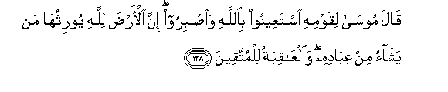
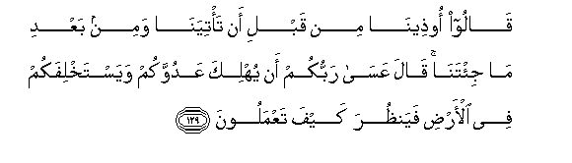
Said Moses to his people, "Seek help through Allah and be patient. Indeed, the earth belongs to Allah . He causes to inherit it whom He wills of His servants. And the [best] outcome is for the righteous."

They said, "We have been harmed before you came to us and after you have come to us." He said, "Perhaps your Lord will destroy your enemy and grant you succession in the land and see how you will do." (Al A’raf 7:128—129)

So We took retribution from them, and We drowned them in the sea because they denied Our signs and were heedless of them. (Al A’raf 7:136)

I will turn away from My signs those who are arrogant upon the earth without right; and if they should see every sign, they will not believe in it. And if they see the way of consciousness, they will not adopt it as a way; but if they see the way of error, they will adopt it as a way. That is because they have denied Our signs and they were heedless of them. (Al A’raf 7:146)
Those who denied Our signs and the meeting of the Hereafter - their deeds have become worthless. Are they recompensed except for what they used to do? (Al A’raf 7:147)

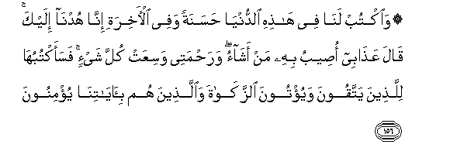
And decree for us in this world [that which is] good and [also] in the Hereafter; indeed, we have turned back to You." [ Allah ] said, "My punishment - I afflict with it whom I will, but My mercy encompasses all things." So I will decree it [especially] for those who fear Me and give zakah and those who believe in Our verses. (Al A’raf 7:156)

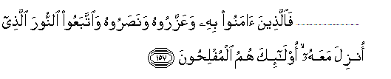

So they who have believed in him (the Prophet), honored him, supported him and followed the light which was sent down with him - it is those who will be the successful. (Al A’raf 7:157)

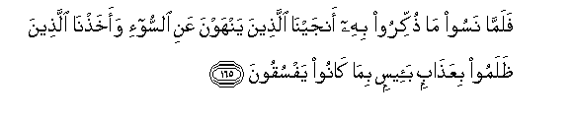
And when they forgot that by which they had been reminded, We saved those who had forbidden evil and seized those who wronged, with a wretched punishment, because they were defiantly disobeying. (Al A’raf 7:165)

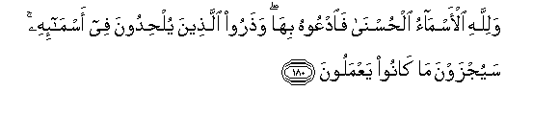
And to Allah belong the best names, so invoke Him by them. And leave [the company of] those who practice deviation concerning His names. They will be recompensed for what they have been doing. (Al A’raf 7:180)



But those who deny Our signs - We will progressively lead them [to destruction] from where they do not know.

And I will give them time. Indeed, my plan is firm. (Al A’raf 7:182—183)

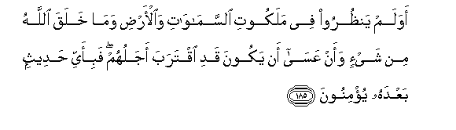
Do they not look into the realm of the heavens and the earth and everything that Allah has created and [think] that perhaps their appointed time has come near? So in what statement hereafter will they believe? (Al A’raf 7:185)

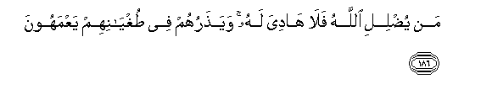
Whoever Allah sends astray - there is no guide for him. And He leaves them in their transgression, wandering blindly. (Al A’raf 7:186)

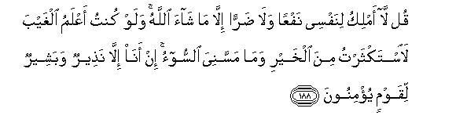
Say, "I hold not for myself [the power of] benefit or harm, except what Allah has willed. And if I knew the unseen, I could have acquired much wealth, and no harm would have touched me. I am not except a warner and a bringer of good tidings to a people who believe." (Al A’raf 7:188)


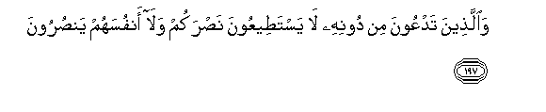
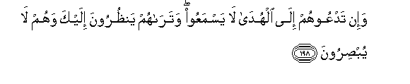

Indeed, my protector is Allah , who has sent down the Book; and He is an ally to the righteous.

And those you call upon besides Him are unable to help you, nor can they help themselves."

And if you invite them to guidance, they do not hear; and you see them looking at you while they do not see.

Take what is given freely, enjoin what is good, and turn away from the ignorant. (Al A’raf 7:196—199)

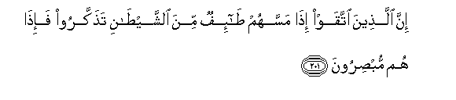
Indeed, those who fear Allah - when an impulse touches them from Satan, they remember [Him] and at once they have insight. (Al A’raf 7:201)

And remember your Lord within yourself in humility and in fear without being apparent in speech - in the mornings and the evenings. And do not be among the heedless. (Al A’raf 7:205)

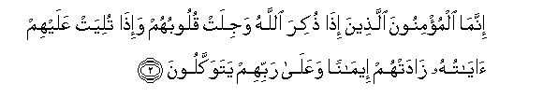

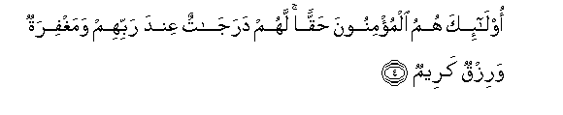
The believers are only those who, when Allah is mentioned, their hearts become fearful, and when His verses are recited to them, it increases them in faith; and upon their Lord they rely –

The ones who establish prayer, and from what We have provided them, they spend.

Those are the believers, truly. For them are degrees [of high position] with their Lord and forgiveness and noble provision. (Al Anfal 8:2—4)

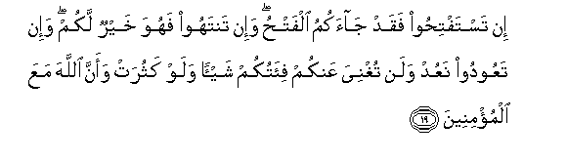
If you [disbelievers] seek the victory - the defeat has come to you. And if you desist [from hostilities], it is best for you; but if you return [to war], We will return, and never will you be availed by your [large] company at all, even if it should increase; and [that is] because Allah is with the believers. (Al Anfal 8:19)

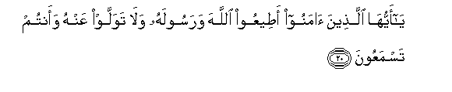

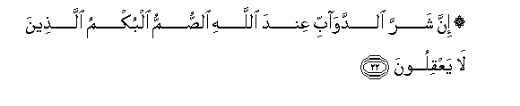
O you who have believed, obey Allah and His Messenger and do not turn from him while you hear [his order].

And do not be like those who say, "We have heard," while they do not hear.

Indeed, the worst of living creatures in the sight of Allah are the deaf and dumb who do not use reason. (Al Anfal 8:20—22)

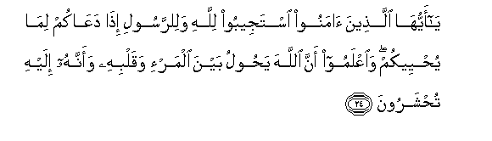
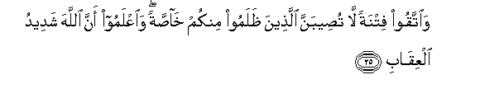
O you who have believed, respond to Allah and to the Messenger when he calls you to that which gives you life.

And know that Allah intervenes between a man and his heart and that to Him you will be gathered. And fear a trial which will not strike those who have wronged among you exclusively, and know that Allah is severe in penalty. (Al Anfal 8:24—25)

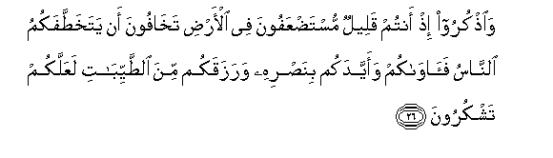
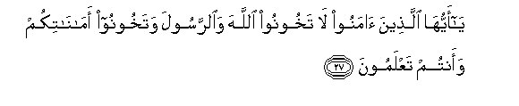

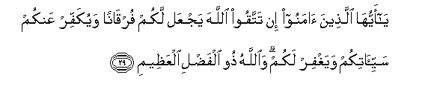

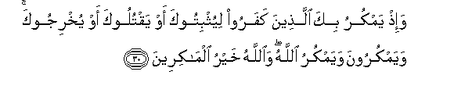
And remember when you were few and oppressed in the land, fearing that people might abduct you, but He sheltered you, supported you with His victory, and provided you with good things - that you might be grateful.

O you who have believed, do not betray Allah and the Messenger or betray your trusts while you know [the consequence].

And know that your properties and your children are but a trial and that Allah has with Him a great reward.

O you who have believed, if you fear Allah , He will grant you a criterion and will remove from you your misdeeds and forgive you. And Allah is the possessor of great bounty.

And [remember, O Muhammad], when those who disbelieved plotted against you to restrain you or kill you or evict you [from Makkah]. But they plan, and Allah plans. And Allah is the best of planners. (Al Anfal 8:26—30)

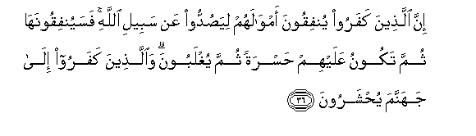
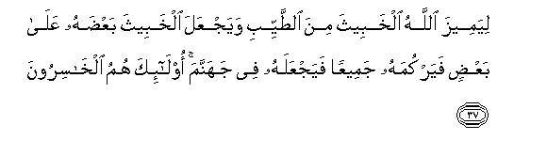
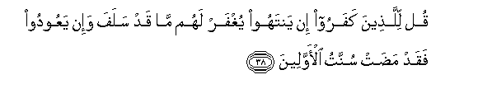
Indeed, those who disbelieve spend their wealth to avert [people] from the way of Allah . So they will spend it; then it will be for them a [source of] regret; then they will be overcome. And those who have disbelieved - unto Hell they will be gathered.

[This is] so that Allah may distinguish the wicked from the good and place the wicked some of them upon others and heap them all together and put them into Hell. It is those who are the losers.

Say to those who have disbelieved [that] if they cease, what has previously occurred will be forgiven for them. But if they return [to hostility] - then the precedent of the former [rebellious] peoples has already taken place. (Al Anfal 8:36—38)

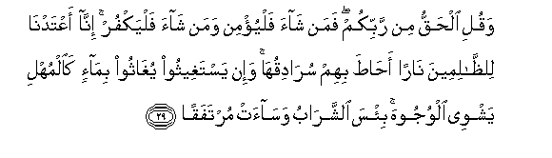
And keep yourself patient [by being] with those who call upon their Lord in the morning and the evening, seeking His countenance. And let not your eyes pass beyond them, desiring adornments of the worldly life, and do not obey one whose heart We have made heedless of Our remembrance and who follows his desire and whose affair is ever [in] neglect.

And say, "The truth is from your Lord, so whoever wills - let him believe; and whoever wills - let him disbelieve." Indeed, We have prepared for the wrongdoers a fire whose walls will surround them. And if they call for relief, they will be relieved with water like murky oil, which scalds [their] faces. Wretched is the drink, and evil is the resting place. (Al Kahf 18:28—29)

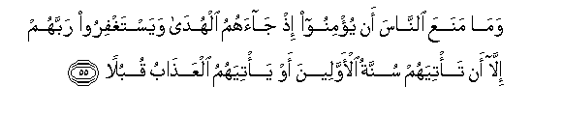
And nothing has prevented the people from believing when guidance came to them and from asking forgiveness of their Lord except that there [must] befall them the [accustomed] precedent of the former peoples or that the punishment should come [directly] before them. (Al Kahf 18:55)


And those cities - We destroyed them when they wronged, and We made for their destruction an appointed time. (Al Kahf 18:59)

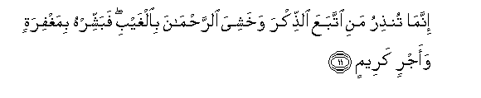
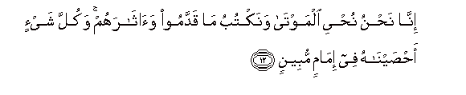
You can only warn one who follows the message and fears the Most Merciful unseen. So give him good tidings of forgiveness and noble reward.

Indeed, it is We who bring the dead to life and record what they have put forth and what they left behind, and all things We have enumerated in a clear register. (Yasin 36:11—12)


To warn whoever is alive and justify the word against the disbelievers. (Yasin 36:70)



His command is only when He intends a thing that He says to it, "Be," and it is. So exalted is He in whose hand is the realm of all things, and to Him you will be returned. (Yasin 36:82—83)

May Allah SWT lift this ghafla from our hearts that our actions have brought upon us. May Allah SWT fill our hearts with His love and an intense longing for meeting with Him. May our meetings with our Lord be filled with love, acceptance and glad tidings. Ameen Ya Rabbal ‘Alameen.

