Manners and Virtues of the Hajj

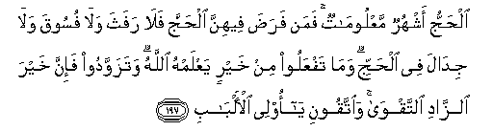
Hajj is [during] well-known months, so whoever has made Hajj obligatory upon himself therein [by entering the state of ihram], there is [to be for him] no sexual relations and no disobedience and no disputing during Hajj. And whatever good you do - Allah knows it. And take provisions, but indeed, the best provision is fear of Allah. And fear Me, O you of understanding. (2: 197)
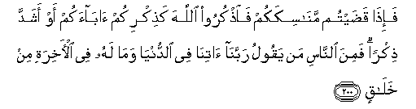
And when you have completed your rites, remember Allah like your [previous] remembrance of your fathers or with [much] greater remembrance. And among the people is he who says, "Our Lord, give us in this world," and he will have in the Hereafter no share. (2: 200)

Hajj like every other ritual in Islam has purpose, virtues and requires the pilgrims to adhere to a set of manners. We discussed the purpose of Hajj in the previous article Alhamdulillah; in here we will focus on the manners required for, and virtues of this great journey, bi-idhnillah.

Manners: Essence of All Actions
Manners are what give actions their true beauty and life. Manners of Hajj are the same as that of salah, fasting and other acts of worship: Khushoo and Khudhoo’.
Allah SWT says in Surah Al-Mu`minoon:


Certainly will the believers have succeeded: They who are during their prayer humbly submissive. (23:1—2)
Khushoo ’and Khudhoo refer to devotion and concentration—whether it is in salah, fasting or any other deed. This is the criteria of a successful believer that Allah SWT has set. When a person puts all worldly matters aside and stands in front of His Lord every day, five times a day with absolute attention and devotion, it is an act of beauty and love. This same act when done half heartedly can become a burden and a nuisance.
Just like that when a person fasts without the true manners and essence of the deed, it is an act of inflicting hunger and harm on oneself. But when done with devotion and concentration so that a person abstains himself from all things undesirable such as vain talk, vulgar speech, listening to or thinking evil thoughts etc. this same act reaches a much higher spiritual level. So in reality, Khushoo’ and Khudhoo is absolute obedience of Allah SWT to attain His pleasure, which enhances an otherwise ordinary act of worship.
Hajj is an accumulation of all the other pillars of Islam so by default the criteria of its success is also absolute devotion and concentration—only it is for a longer period of time than salah and fasting. It is as though Allah SWT prepares the worshipper through other acts of worship for this great journey.

Hajj Is a Migration
From the time a person makes the intention of Hajj, he is like a migrant.
This is a migration from:
- The state of disobedience to the obedience of Allah SWT;
- From sins to devotion of Allah; and
- From a state of egotism and self worship to absolute servitude of Allah SWT.
This is what the call of talbiyah is about. It is a call full of love, devotion, and humbleness from the slave seeking his Master’s acceptance.
‘Here I am O Allah, (in response to Your call), here I am.
Here I am, You have no partner, here I am.
Verily all praise, grace and sovereignty belong to You.
You have no partner.’

This call is an acknowledgment of the gifts and bounties of the Lord on His slave. It is the recognition of the Lord and His greatness. This acknowledgement generates love and proper manners in the heart, which then reflect through the actions of the body.

That [is so]. And whoever honors the symbols of Allah - indeed, it is from the piety of hearts. (22:32)
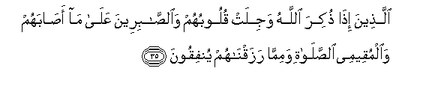
Who, when Allah is mentioned, their hearts are fearful, and [to] the patient over what has afflicted them, and the establishers of prayer and those who spend from what We have provided them. (22:35)
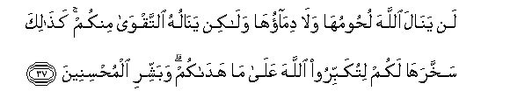
Their meat will not reach Allah, nor will their blood, but what reaches Him is piety from you. Thus have We subjected them to you that you may glorify Allah for that [to] which He has guided you; and give good tidings to the doers of good. (22:37)

Manners of Hajj:
Below we will list some of the manners of Hajj. They might seem small but they are great in magnitude. These are basic etiquettes of life that should be practiced at all times, but become imperative during Hajj. If ignored, these seemingly insignificant acts can nullify the entire Hajj.
1. A person is not allowed to oppress anyone; this involves backbiting, either by one’s own mouth or by listening to others.
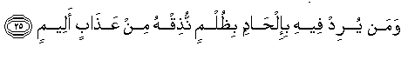
…and [also] whoever intends [a deed] therein of deviation [in religion] or wrongdoing - We will make him taste of a painful punishment. (22:25)

2. Gossiping is prohibited—whether done with others or committed inwardly, by having bad thoughts about someone.

3. A person should refrain from any talk of duniya, business, family affairs or other matters of worldly concerns. Not that they are prohibited; it is just bad manners to go to the House of Allah as His guest and keep oneself occupied with insignificant things while neglecting the host. This leads us to the next point.

4. Manners require us to keep the time we are at Hajj purely for Allah. Just like during salah we don’t communicate with anyone other than Allah or don’t think of worldly matters, we should try our best to maintain the same concern and level of devotion throughout this journey as well.

5. The person should perform the maximum amount of dhikr and salah as good deeds are multiplied in Makkah and Medina. Each salah in Medina is equal to1, 000 raka'a while in Makkah the reward is equal to100, 000 raka'a.

6. Remain focused on the purpose of the journey. It is easier said than done! You should not complain of any inconvenience you might face—be it delays of food or transportation, lost luggage, fault of the travel agent or any other matter; as in reality complaining is a denial of all the bounties of Allah SWT!
Hajj is a great journey with great rewards, and before any great gift there is a great trial. You will have trials in this journey—it’s a given! What you are responsible for is to keep your manners and restrain yourself from complaining and whining.
One of our pious predecessors said: the real manner of Hajj is to not harm anybody physically or emotionally, intentionally or unintentionally, from the time you leave your home until you return from this journey.
Tests are a must irrespective of the kind of package you buy! Whether you have a VIP package or an economy package, trials will be there since they are orchestrated by Allah SWT to test your level of sincerity, humbleness, and contentment.
It is a very common trap of shaytaan that many Muslims fall into. They believe that it their right to get their money’s worth; or that they have to teach these people a lesson so they won’t repeat the mistakes with others. These are hollow excuses that we use to satisfy ourselves. Arguments are not only highly disliked by Allah SWT and His prophet SAW, they are forbidden as shown in this verse:
…and [also] whoever intends [a deed] therein of deviation [in religion] or wrongdoing - We will make him taste of a painful punishment. (22:25)
Arguments cause the angels to leave the person and/or the gathering where they are being carried out. Prophet Muhammad SAW has discouraged his followers from involving in arguments in the following words:
I guarantee a house in the surroundings of Paradise for a man who avoids quarrelling even if he were in the right, a house in the middle of Paradise for a man who avoids lying even if he were joking, and a house in the upper part of Paradise for a man who made his character good. (Abu Dawud)
Surah Al-Furqan verse 20 explains the purpose of trials:
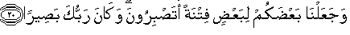
And We have made some of you [people] as trial for others - will you have patience? And ever is your Lord, Seeing. (25:20)
Once you peacefully surrender to Allah SWT and internalize this reality, you will have the courage and wisdom to deal with trials with dignity, and you will not mind even letting go of your rights. If someone hits you, pushes you, steals your food or money, you will know that this is what Allah intended for you at this time and the purpose is to test you and raise your spiritual level.
The main point I am trying to make here is that irrespective of what happens, keep your heart connected to Allah SWT and keep it pure from any dirt!
Allah SWT says:

"But only one who comes to Allah with a sound heart." (26:89)
7. To be in a state of complete obedience, surrender, humbleness and humility throughout the journey. This can only come from the recognition of whose house you are visiting and how much respect you have for Him SWT in your heart.
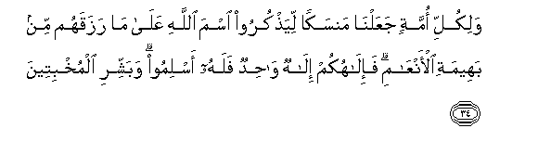
And for all religion We have appointed a rite [of sacrifice] that they may mention the name of Allah over what He has provided for them of [sacrificial] animals. For your god is one God, so to Him submit. And, [O Muhammad], give good tidings to the humble [before their Lord]. (22:34)
These are some of the manners which when practiced with love and devotion can enhance the beauty of even the simplest action.

Virtues: Fragrance of the Deeds

If worship is a flower, than virtue is its fragrance. Just like the flower attracts others by its aroma, good deeds invite others through their virtues. Virtues in themselves are not the goal of good deeds since the goal is always only to gain the pleasure of Allah SWT. Rather, they are a bonus which Allah SWT grants His slaves in order to motivate and encourage them.
It is narrated on the authority of Ibn Umar (RA) who said:

I was sitting with the Prophet SAW in the masjid in Mina when a man from the Ansaar came and a man from the Thaqeef; they gave Salaam and said,
“O Messenger of Allah, we came to ask you questions.”
So the Messenger said: “If you want I can inform you why you came and what you want to ask, and I will do so, and if you want I will hold back and you can ask me and I will answer you.”
They said: “Tell us O Messenger of Allah!”

The man from Thaqeef said to the Ansaari: “Ask.” So the Ansaari man said: “Inform me O Messenger of Allah!”
The Messenger of Allah said: “You came to me, to ask about leaving your house and aiming for the Bait-ul-Haraam and the reward for it; about praying two Raka’a after Tawaf and the reward for it; going between as-Safa and Marwa and the reward for it; your staying the evening in Mina, and the reward for it; stoning the Jamarah and the reward for it; slaughtering an animal and the reward for it; and the Tawaf of al-Ifaadh.”
The man said: “I swear by the One who sent you with the truth! This is what I came to ask you about.”

The Prophet said: “As for you leaving your homes aiming for the Bait-ul-Haraam: then your she-camel does not place its foot nor does it raise it except that Allah writes for you a reward due to it, and wipes off one of your sins. As for the two Raka’a after the Tawaf, then it is equivalent to freeing a slave from the Children of Ismail. As for your circuiting of as-Safa and al-Marwa, then it is the same as freeing 70 slaves. As for you staying till the evening in Arafah, then Allah descends to the sky of the Duniya and He boasts about you to the Angels, and says: ‘My slaves have come to Me, looking rough, from every deep valley hoping for My mercy, so if your sins were equivalent to the amount of sand or the drops of rain or like the
foam on the sea I will forgive them. So go forth My slaves! Having forgiveness and for what or who you have interceded for.’ As for stoning the Jamaar (the pillars), then for every stone that you throw, it removes a big sin from the deadly sins. As for your slaughtering, then it is saved for you with your Lord. As for shaving your head, then there is a reward for every strand of hair that you shaved, and a sin is wiped off by it. As for you performing Tawaf of the House after all this, then by this time you are performing Tawaf with no sin upon you and an Angel comes and places his hand between your shoulders saying: “Perform good deeds in what you face of the future for verily your past sins have been forgiven.” (At-Tabarani)

What higher level of mercy and benevolence can we ask for?
However, the stipulation here is that you value the honor that Allah SWT has given you by offering you this journey, and carry out your Hajj purely and sincerely for His pleasure and to seek His approval.
Anyone who dies while in the state of Ihraam will be resurrected as a Hajji (performer of Hajj) on the Day of Judgment. Our pious predecessors used to make du’a and ask others to make du’a for them that Allah takes their soul during Hajj. People who die in this state will be admitted to paradise without any reckoning.
Prophet SAW said:
"The people performing Hajj or 'Umrah are the guests of Allah. If they ask Him something He answers them and if they ask him forgiveness He forgives them." (An-Nasa'i, ibn Majah)
Imagine the honor of being the guests of Allah SWT!
The Prophet said:
"Whoever performs Hajj to this Ka'bah and does not approach his wife for sexual relations nor commit sins (while performing Hajj), he will come out as sinless as a new-born child, (just delivered by his mother)." (Bukhari)
The Prophet also said:
"There is no reward for an accepted Hajj (mabroor) except Paradise." (Bukhari and Muslim)
The prerequisite to attain this high level is abstention from oppression under all circumstances. This includes arguments, bargaining, shoving, pushing, shouting etc. (and Allah knows best.)
The rewarding of Hajj is not limited to a Hajji only. Hajj is a time of unity within the ummah. Those unable to go for this great duty are encouraged to fast and make du’a for the acceptance of those who were honored to perform this journey.

Conclusion
The real fruit of Hajj will only be manifested in a slave when he intends to make complete tawba (repentance) from his previous life of sins and heedlessness, and promises to live purely for Allah and His pleasure. Meaning he promises to sincerely migrate to the path of Allah SWT.
Allah SWT invites His slave to His house—a house that is nothing but an empty building of stones. Why didn’t Allah SWT, with all His grandeur and kingdom make a magnificent structure?
Because He wants to remind us that all this earth and what it contains is worth no more than these rocks! This takes us back to the purpose of Hajj as discussed in the previous article, which is to leave off duniya and start the journey to akhirah.

Reminder: Just like the virtues in Makkah and Medina multiply, so do the sins; the only places on earth where the sins multiply are these blessed places. So it is just as easy to lose your virtues as it is to gain them. The key of success is conscientiousness and respect for the great blessing that Allah SWT has bestowed on you by inviting you as His guests.

The message of Hajj can be summarized in the following verses:
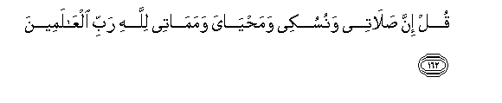

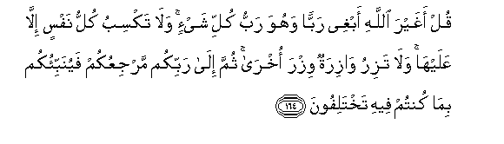
Say, "Indeed, my prayer, my rites of sacrifice, my living and my dying are for Allah, Lord of the worlds. No partner has He. And this I have been commanded, and I am the first [among you] of the Muslims." Say, "Is it other than Allah I should desire as a lord while He is the Lord of all things? And every soul earns not [blame] except against itself, and no bearer of burdens will bear the burden of another. Then to your Lord is your return, and He will inform you concerning that over which you used to differ." (6:162—164)






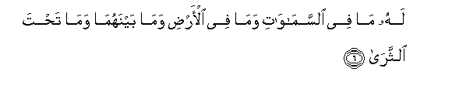

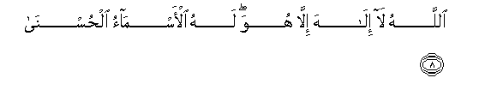

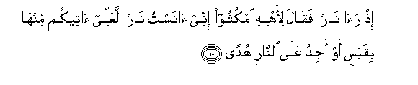





Ta Ha. We have not sent down to you the Qur'an that you be distressed But only as a reminder for those who fear [ Allah ] - A revelation from He who created the earth and highest heavens, The Most Merciful [who is] above the Throne established.
To Him belongs what is in the heavens and what is on the earth and what is between them and what is under the soil. And if you speak aloud - then indeed, He knows the secret and what is [even] more hidden.
Allah - there is no deity except Him. To Him belong the best names. And has the story of Moses reached you? - When he saw a fire and said to his family, "Stay here; indeed, I have perceived a fire; perhaps I can bring you a torch or find at the fire some guidance."
And when he came to it, he was called, "O Moses, Indeed, I am your Lord, so remove your sandals. Indeed, you are in the sacred valley of Tuwa. And I have chosen you, so listen to what is revealed [to you].
Indeed, I am Allah. There is no deity except Me, so worship Me and establish prayer for My remembrance. Indeed, the Hour is coming - I almost conceal it - so that every soul may be recompensed according to that for which it strives. (20: 1—15)
Here Allah SWT is reminding us of the ultimate manner in Islam—the recognition of absolute oneness of Allah SWT and to devote all deeds purely to Him. Allah SWT is reminding us of who He is and what our final destination is; and this reminder is the very purpose of Hajj.
May Allah SWT allow us to truly understand the magnitude of this blessed journey; to perform it with desirable manners; to recognize and respect its virtues; and to reach the ultimate success—the pleasure and forgiveness of Allah SWT. Ameen.

