Du'a: The Weapon of a Believer

I was once asked a question, ‘If I have a calamity or a trial, what kind of du’a I can make and present my case to Allah without being considered rebellious.’

I would like to share the answer to this question for the benefit of the readers, InshaAllah.
Du’a is a gift given to the nation of Muhammad SAW by Allah SWT. It is a mode of direct communication between the Lord and His creation and He SWT has promised to listen:

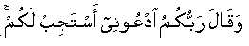
And your Lord says, "Call upon Me; I will respond to you." (Al-Ghafir: 40:60)

However, there are certain conditions for the acceptance of du’a and the most important of them is purity of heart from anything other than Allah SWT.

We have to be in a state of heart and mind where we are fully aware that no one other than Allah SWT has any control over our situation; only He SWT can give us what we want or take away what is afflicting us. Below I am sharing some verses to help us prepare our hearts to be in the state of making accepted du’a, bi-idhnillah.

Verses to Prepare Your Heart


Who, when disaster strikes them, say, "Indeed we belong to Allah , and indeed to Him we will return." Those are the ones upon whom are blessings from their Lord and mercy. And it is those who are the [rightly] guided. (Al-Baqarah 2: 156—157)
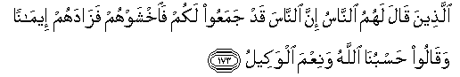
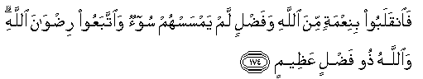
Those to whom hypocrites said, "Indeed, the people have gathered against you, so fear them." But it [merely] increased them in faith, and they said, "Sufficient for us is Allah , and [He is] the best Disposer of affairs." So they returned with favor from Allah and bounty, no harm having touched them. And they pursued the pleasure of Allah , and Allah is the possessor of great bounty. (Al-Imran 3: 173—174)

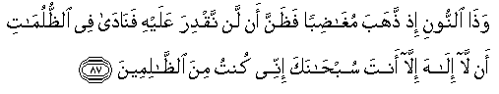

And [mention] the man of the fish, when he went off in anger and thought that We would not decree [anything] upon him. And he called out within the darknesses, "There is no deity except You; exalted are You. Indeed, I have been of the wrongdoers." So We responded to him and saved him from the distress. And thus do We save the believers. (Al-Anbiya 21: 87—88)

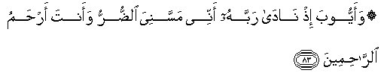
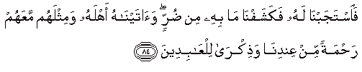
And [mention] Job, when he called to his Lord, "Indeed, adversity has touched me, and you are the Most Merciful of the merciful." So We responded to him and removed what afflicted him of adversity. And We gave him [back] his family and the like thereof with them as mercy from Us and a reminder for the worshippers [of Allah]. (Al-Anbiya 21: 83—84)

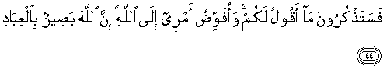

And you will remember what I [now] say to you, and I entrust my affair to Allah . Indeed, Allah is Seeing of [His] servants." So Allah protected him from the evils they plotted, and the people of Pharaoh were enveloped by the worst of punishment. (Al-Ghafir 40: 44—45)

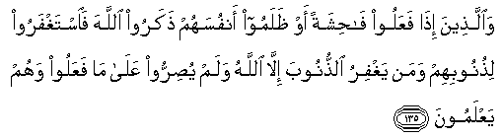
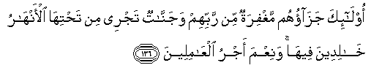

They say, "Be Jews or Christians [so] you will be guided." Say, "Rather, [we follow] the religion of Abraham, inclining toward truth, and he was not of the polytheists." Say, [O believers], "We have believed in Allah and what has been revealed to us and what has been revealed to Abraham and Ishmael and Isaac and Jacob and the Descendants and what was given to Moses and Jesus and what was given to the prophets from their Lord. We make no distinction between any of them, and we are Muslims [in submission] to Him." (Al-Imran 3: 135—136)

Verses to Gain Victory


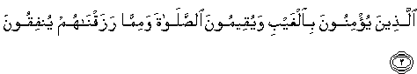
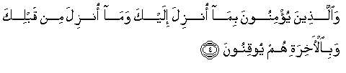

ALM. This is the Book about which there is no doubt, a guidance for those conscious of Allah - Who believe in the unseen, establish prayer, and spend out of what We have provided for them, And who believe in what has been revealed to you, [O Muhammad], and what was revealed before you, and of the Hereafter they are certain [in faith]. Those are upon [right] guidance from their Lord, and it is those who are the successful. (Al-Baqarah 2: 1—5)

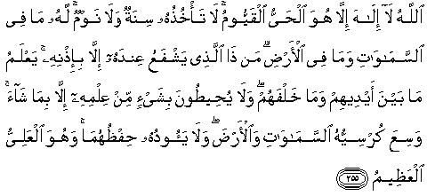
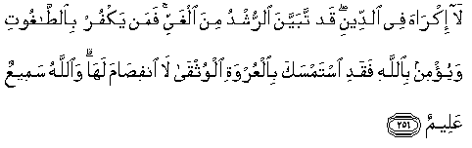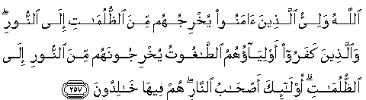

Allah - there is no deity except Him, the Ever-Living, the Sustainer of [all] existence. Neither drowsiness overtakes Him nor sleep. To Him belongs whatever is in the heavens and whatever is on the earth. Who is it that can intercede with Him except by His permission? He knows what is [presently] before them and what will be after them, and they encompass not a thing of His knowledge except for what He wills. His Kursi extends over the heavens and the earth, and their preservation tires Him not. And He is the Most High, the Most Great.

There shall be no compulsion in [acceptance of] the religion. The right course has become clear from the wrong. So whoever disbelieves in Taghut and believes in Allah has grasped the most trustworthy handhold with no break in it. And Allah is Hearing and Knowing.
Allah is the ally of those who believe. He brings them out from darknesses into the light. And those who disbelieve - their allies are Taghut. They take them out of the light into darknesses. Those are the companions of the Fire; they will abide eternally therein. (Al-Baqarah 2:255—257)

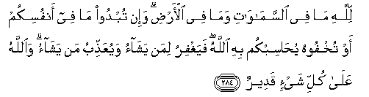
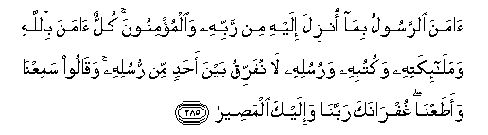
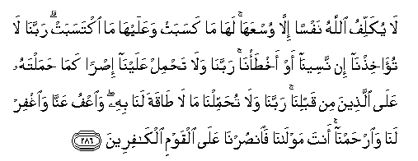

To Allah belongs whatever is in the heavens and whatever is in the earth. Whether you show what is within yourselves or conceal it, Allah will bring you to account for it. Then He will forgive whom He wills and punish whom He wills, and Allah is over all things competent.
The Messenger has believed in what was revealed to him from his Lord, and [so have] the believers. All of them have believed in Allah and His angels and His books and His messengers, [saying], "We make no distinction between any of His messengers." And they say, "We hear and we obey. [We seek] Your forgiveness, our Lord, and to You is the [final] destination."

Allah does not charge a soul except [with that within] its capacity. It will have [the consequence of] what [good] it has gained, and it will bear [the consequence of] what [evil] it has earned. "Our Lord, do not impose blame upon us if we have forgotten or erred. Our Lord, and lay not upon us a burden like that which You laid upon those before us. Our Lord, and burden us not with that which we have no ability to bear. And pardon us; and forgive us; and have mercy upon us. You are our protector, so give us victory over the disbelieving people." (Al-Baqarah 2: 284—286)

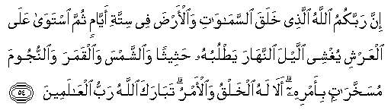

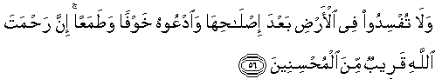

Indeed, your Lord is Allah , who created the heavens and earth in six days and then established Himself above the Throne. He covers the night with the day, [another night] chasing it rapidly; and [He created] the sun, the moon, and the stars, subjected by His command. Unquestionably, His is the creation and the command; blessed is Allah , Lord of the worlds.

Call upon your Lord in humility and privately; indeed, He does not like transgressors.
And cause not corruption upon the earth after its reformation. And invoke Him in fear and aspiration. Indeed, the mercy of Allah is near to the doers of good. (Al-‘Araf 7: 54—56)

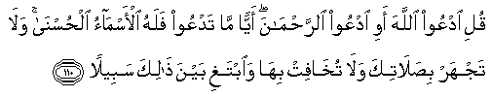
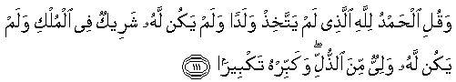

Say, "Call upon Allah or call upon the Most Merciful. Whichever [name] you call - to Him belong the best names." And do not recite [too] loudly in your prayer or [too] quietly but seek between that an [intermediate] way. And say, "Praise to Allah , who has not taken a son and has had no partner in [His] dominion and has no [need of a] protector out of weakness; and glorify Him with [great] glorification." (Al-Isra 17: 110—111)




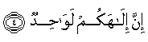







By those [angels] lined up in rows And those who drive [the clouds] And those who recite the message, Indeed, your God is One, Lord of the heavens and the earth and that between them and Lord of the sunrises.

Indeed, We have adorned the nearest heaven with an adornment of stars And as protection against every rebellious devil [So] they may not listen to the exalted assembly [of angels] and are pelted from every side, Repelled; and for them is a constant punishment, Except one who snatches [some words] by theft, but they are pursued by a burning flame, piercing [in brightness]. (As-Saffat 37: 1—10)

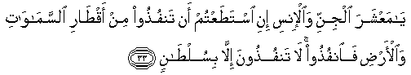
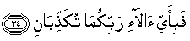


O company of jinn and mankind, if you are able to pass beyond the regions of the heavens and the earth, then pass. You will not pass except by authority [from Allah ]. So which of the favors of your Lord would you deny? There will be sent upon you a flame of fire and smoke, and you will not defend yourselves. (Ar-Rahman 55: 33—35)

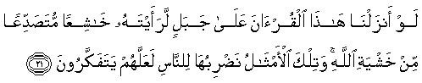
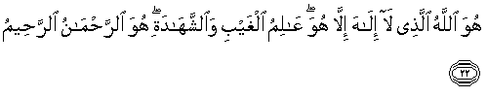
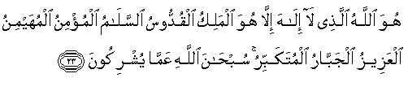
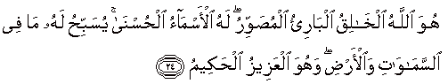

If We had sent down this Qur'an upon a mountain, you would have seen it humbled and coming apart from fear of Allah . And these examples We present to the people that perhaps they will give thought. He is Allah , other than whom there is no deity, Knower of the unseen and the witnessed. He is the Entirely Merciful, the Especially Merciful. He is Allah , other than whom there is no deity, the Sovereign, the Pure, the Perfection, the Bestower of Faith, the Overseer, the Exalted in Might, the Compeller, the Superior. Exalted is Allah above whatever they associate with Him. He is Allah , the Creator, the Inventor, the Fashioner; to Him belong the best names. Whatever is in the heavens and earth is exalting Him. And He is the Exalted in Might, the Wise. (Al—Hashr 59: 21—24)

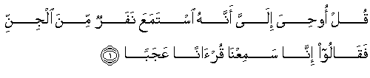
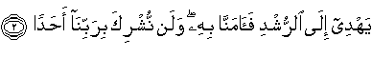
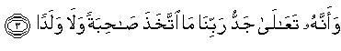
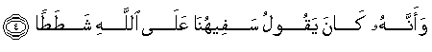

Say, [O Muhammad], "It has been revealed to me that a group of the jinn listened and said, 'Indeed, we have heard an amazing Qur'an. It guides to the right course, and we have believed in it. And we will never associate with our Lord anyone. And [it teaches] that exalted is the nobleness of our Lord; He has not taken a wife or a son And that our foolish one has been saying about Allah an excessive transgression. (Al-Jinn 72: 1—4)

Du’as to Beseech Opening From Allah SWT

The most important du’a to gain the opening from Allah is to say:



"There is no deity except You; exalted are You. Indeed, I have been of the wrongdoers." (Al-Anbiya 21:87)

The secret of acceptance of du’a is in the manner of asking and the faith in the One you are asking from!

Follow the steps below and believe with conviction that Allah will grant you what is best for you.

- Make a lot of salah ‘alan nabi (prayer on the Prophet SAW) as it is the opener of all closed doors.
- Unite your heart to Allah with complete contentment to Him SWT and say:



"Indeed we belong to Allah , and indeed to Him we will return." (Al-Baqara 2:156)

- Beseech Allah SWT with the following du’a:

“Oh Allah, choose for me and don’t make me choose except what you have chosen for me; make me content with what you choose for me; and put barakah (blessing) in what you choose for me, Ya Allah.”

Renew your oath to Allah by making du’a in the following words:

“Oh Allah, if this trial is to elevate, prepare and cleanse me, I am content, Ya Allah. And if there is any way to change this condition, please Allah don’t make me unite my heart except to You; don’t make me rely except on You; don’t make me trust except You; and open for me in a way and time you want Ya Allah. Oh Allah, I believe in qadr (destiny) and know that nothing can happen without your will; make my condition a cause of elevation in this life and the hereafter Ya Allah.”

- Call on Allah with the following du’a:

Allahumma ya ‘imada man la ‘imada lahu;
Wa ya sanada man la sanada lahu;
ya Zahra man la Zahra lahu; ya ghaayatha man la ghaayatha lahu;
ya kareem al ‘afw, ya husn at tajawwuz ya kashif al balaa ya azeem ar rajaa ya ‘awn ad du’afaa ya munqidh al gharqa, ya munje al halkaa, ya muhsinu ya mujmilu ya mun’imu ya mufaddalu;
antal ladhi sajada laka sawadu al laylee wa noor an nahari wa dau ul qamari wa shu’aaush shamsi wa dawwiyyul maaee wa hafeef ush shajaree;
Ya Allah! la shareeka laka
Ya rabbi! Ya rabbi! Ya rabb!
Ya Muhaimin, ya ‘azeezu ya jabbaru, ya fattahu, ya samee’u, ya baseeru, ya qareebu, ya mujeeb!

And after that ask for whatever you want!

An approximate translation of this powerful du’a is as follows:

Oh Allah, You are the supporter of those who have no support;
You are the one with ability for those who have no ability;
You are the one whom the desperate call on and there is no one for the desperate callers except You;
You are the most generous and the pardoner; You are the one who erases sins and You are the one who can alleviate any calamity;
Glory to You, and You alone do I seek;
You are the one for the weak; You are the one who can save a drowning man from the sea. You are the one who can guard and save those who are to be destroyed.
I call You with every quality, with every name and attribute of Yours; You are the one everything prostrates to—from darkness to light, from sun to moon, water and trees everything prostrates to You; make me prostrate to You and be desperate to You only.
Oh Allah—there is no partner with You.
You are my Lord! You are my Rabb! You are my Rabb! You are my Rabb!
The controller, the governor, the doer, the able, the powerful!

- Conclude your du’a with a lot of Salah ‘alan Nabi (prayer on the Prophet SAW).

Grab the Moment!

This is the month of Rajab, one of the most sacred months in the year and very soon we will be blessed with Ramadan and Laylatul Qadr. Get in the habit of continuous dhikr and du’a to maximize your benefit of the upcoming blessings inshaAllah, and remember to call Allah with this verse:

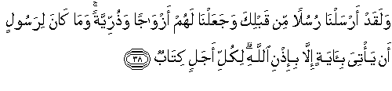
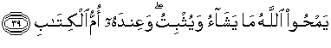

And it was not for a messenger to come with a sign except by permission of Allah . For every term is a decree. Allah eliminates what He wills or confirms, and with Him is the Mother of the Book. (Ar-Rad 13: 38—39)

