The Ultimate Honor

We Muslims are the inheritors of a great legacy; the legacy of self sacrifice and spiritual feat. Islamic history is full of stories of unimaginable self denial and immense struggles—all for one single goal: the elevation of the greatness of Allah SWT.

From the tortures endured by Bilal RA and martyrdom of Sumayya RA to the Lion of Ain Jaloot we are a nation of inspiration and beacon of guidance for the world as Allah SWT says in Surah Baqara, ayah 143:
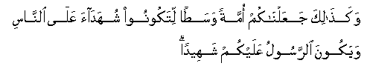
Thus, have We made of you an Ummat justly balanced, that ye might be witnesses over the nations, and the Messenger a witness over yourselves

Our ancestors reached immortality in the spiritual realm by conforming their entire beings according to the will of Allah SWT and offering their lives for the cause that they believed in. The purpose of their existence was to not only believe in, but to declare the sovereignty of Allah and to free humanity from the shackles of human servitude and bring them to the complete spiritual freedom. They will receive what is promised to them by their Lord but the true cause of concern is us.

Are we continuing this legacy of greatness? Are our lives conformed to the will of Allah SWT? Are our intentions, desires, actions, and behavior worthy enough to make us stand next to the great legends of Islam? Are our actions so that we will be recognized by the Prophet SAW, his companions and great heroes of this nation?

Greatness is not given, it is earned. The more we are in servitude to the greatest of all, Allah SWT, the more we will receive this greatness in our hearts and souls and in the eyes of others. Careful study of Islamic history shows that any time Muslims were busy with declaring the oneness of Allah, the nation was elevated and protected. And any time this struggle was dropped, we were besieged with calamities, defeat, and humiliation.

Muslims are the laughing stock of the world today; we have reached the pit of humiliation and degradation. Why? Allah SWT is Al-Mateen and Al-Azeez—the owner of dignity and honor; then why does He SWT allow this to happen? Allah SWT has promised His deen (religion) victory. But He hasn’t promised Muslims victory unless we live the true meaning of the word Muslim. Victory is for those who give Allah SWT victory and greatness is for those who have made Allah SWT great in their lives.

We give Allah SWT victory and truly manifest His greatness by fulfilling the purpose of our lives. Allah SWT created us as His vicegerents on earth. We are here to establish the worship and rule of Allah and to guide humanity to His chosen way of life. But can we really do the job outside unless we accomplish it internally? Can we establish the rule of Allah SWT on earth, if personally we are not even able to cope with situations that Allah SWT sends our way? Mother of the believers Ayesha RA reported that a month would go by without fire being lit in the house of the Prophet SAW, and they would fill themselves with dates and water. It was not poverty; by this time Islam had gained stronghold in the Arabian Peninsula and Prophet SAW was receiving booty from the newly acquired lands. It was self denial and channeling resources and energy in the right direction more than anything else. We are not going to ever be able to compete with this level of Zuhd (self denial) but we can use it as a bar to measure where we are from that. The purpose of marriage is to establish this khilafah, vicegerency on the familial level and through individual families it is to translate onto the whole society. What are our families like today and how are we establishing this khilafah in our houses? What goal have we set for ourselves as a family unit that we are working to achieve? What will happen if there is no food in the house for one day, let alone an entire month? Good cooking has become the sign of a good wife. Our criteria, ambitions, dreams, deity, worship, allegiance have all gone haywire. Our life has become a joke and we are living without any direction and purpose. Our desires dictate our behavior and attitude; if we get what we want, we are happy, otherwise there is a problem.

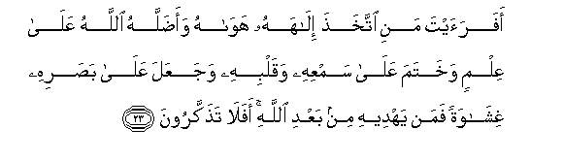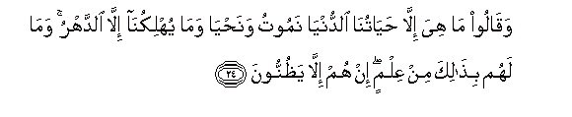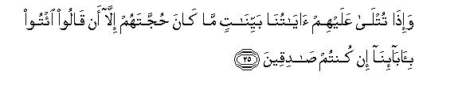
Have you ever considered [the kind of man] who makes his own desires his deity, and whom God has [thereupon] let go astray, knowing [that his mind is closed to all guidance], and whose hearing and heart He has sealed, and upon whose sight He has placed a veil? Who, then, could guide him after God [has abandoned him]? Will you not, then, bethink yourselves? (45:23—25)

In all honesty, we have no real loyalty, belonging and love for Allah SWT. I know it is hard to hear, but unless we are critical of our behavior, we cannot change ourselves and unless we change ourselves, our condition as a nation will not change. Allah SWT said:
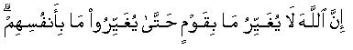
“Verily never will Allah change the condition of a people until they change it themselves (with their own souls).”(13:11)

Allah SWT called Ibraheem AS an ummah in himself. He was an entire nation because he was able to fully establish the khilafah of Allah on himself and his surroundings. All his actions, prayers, relationships, migrations, and sacrifices were solely for the sake of Allah SWT. When he passed to fully submit to the will of Allah SWT himself, Allah allowed him to establish this khilafah on his family level. His wife Hajar and their son Ismaeel also succeeded in this venture and they were given the highest reward one can get in this world—honor. They were chosen to build Ka’bah and it is their rituals that Muslims till the end of time will follow during Hajj.

Where are we from the struggles and submission of our father Ibraheem AS? Believe it or not, there are many parallels that we can draw among Ibraheem AS’s and our lives. Ibraheem AS was facing hostility and alienation, so are we; he was facing powers much stronger than himself, and so are we; he was tried to be scared into silence, and the same phenomenon is taking place against Muslims today though the methods have changed. So what is the message? This is time of great opportunity if we realize it and avail it properly. If we follow the way charted out by Ibraheem AS, why wouldn’t we be able to establish the khilafah on earth the way he was able to? Why wouldn’t we be able to achieve honor the way he did? The Lord of Him is the Lord of us and His SWT’s sunnah never changes. He has already declared victory for the believers and believers are those who always make Allah SWT the greatest in their lives.

This world is the tilling ground for the hereafter. We will be rewarded for what we do here and our status in the afterlife will be according to our deeds in this life. RasulAllah SAW said:
"The Mu'adhdhinun (callers to prayer) will have the longest necks on the Day of Resurrection.'' [Muslim]

This is metaphorically referring to the high status of the person in the hereafter. The same goes to the beauty of women in jannah; a woman will be granted beauty according to her closeness with Allah SWT and her good deeds. Believing women will surpass hoor-al-ain or women of jannah in their beauty. Another thing that will distinguish people on the Day of Judgment is their speed over the bridge called sirat.
Muslim reported from the Hadith narrated by Abu Huraira, "The people will come to the Prophet (pbuh) upon him, begging for intercession and they will be given permission to meet him. The trust and the bond of kinship will be left to stand to the right and the left of the Sirat. The first of those people will pass as speedily as lightning. Abu Huraira inquired, "May Allah bless you, Prophet (pbuh), how speedy is that?". The Prophet (pbuh) replied, "Have you not seen how lightning strikes and dissapears in a twnkling moment?" Then another person will pass like a strong wind, and a third like a swift bird and a fourth will be running while being hastened by his deeds. Your Prophet (pbuh) will be standing by the Sirat saying, "O Lord! Save us! Save us!" until the deeds become too few to help peopl cross the path, so that some people will crawl on it!" He went on, "Fixed to the two edges of the Sirat are hooks which are commanded to snatch those who were destines to be stanched. Some others will be shoved into Hellfire. By Him in Whose hand Muhammad's soul is, it would take (a person) seventy years to reach the bottom of hell." (Hadith Sahih)
Another status that an honorable believer will be granted in the afterlife is shifa’a or intercession for seventy Muslims who might have attained punishment due to their actions. What more honor when Allah allows you to be a cause of saving such a large number of people from the most dreadful end; and what honor for the person in the eyes of those his intercession is accepted for?
A true believer utilizes his stay in this world to the maximum of his ability. He does not lose any opportunity to perform good deeds and secure his reward in the hereafter. Putting off good deeds for a later time is not the quality of the mo’min as he lives with the certainty of death. All this comes when a person realizes the greatness of Allah SWT and this understanding begins to govern all his actions.

The realization of the greatness of Allah brings security, tranquility and happiness in the heart. It gives a person a solid foundation to stand on and dignity that he is responsible to answer only to the highest deity, Allah SWT and not to other human beings. This dignity and confidence in turn allow a person to be more focused on himself and vigilant about his self improvement. Now, a person is ready to establish the khilafah of Allah on himself and his immediate surroundings. This is simple and easy to talk about but in reality it can take a life time to accomplish. This struggle has to be difficult as its price is jannah which is not cheap and in reality, it is the struggle and the intention that a person will be rewarded for and not the actual outcome.
But the highest declaration of the greatness of Allah is when a person devotes his life to the propagation of Islam—the chosen way of life by Allah SWT. What better way for a slave to honor his master than by declaring his master’s greatness to everyone he meets? When a person is employed by a firm, especially if the firm has a good reputation, he feels honored to be associated with it and wear its badge with confidence. What about being employed by Allah SWT and being associated with His message? Can anything else in life bring more dignity and honor?

This is what Ibraheem AS did in his life. He devoted his loyalty, love, body, money, and heart for Allah SWT and declared his divinity and greatness through all his actions and deeds. At this time Allah SWT honored him and told him to build Ka’bah and to call all believers to perform Hajj. Ibraheem AS asked how his voice is going to reach all believers till the end of time and Allah SWT responded saying his job is to call; deliverance of it is in the hands of Allah SWT. What message can we extract from it? We are not here to guide people to the right path. It is Allah SWT who guides whom He wills; we are here to set the role model and put the word and rules of Allah in practice through our character and behavior for the world to see.
The purpose is to realize that we in ourselves don’t own any power or strength and that all greatness lies with Allah SWT. Allah wants us to make Him greater than our weaknesses, sins, disabilities, and limitations. Once we make Him SWT great in our lives the way He truly deserves to be, all our shortcomings will be turned to strength and we will be able to fulfill the purpose of our lives in this world.
The offer from Allah SWT stands, the question is who is going to take it!

Who is better in speech than one who calls (men) to Allah, works righteousness, and says, "I am of those who bow in Islam"? (41:33)

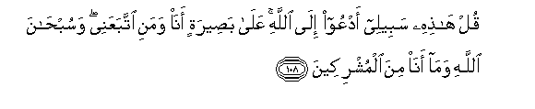 Say thou: "This is my way: I do invite unto Allah,- on evidence clear as the seeing with one's eyes,- I and whoever follows me. Glory to Allah. And never will I join gods with Allah." (12: 108)

Daee Ahmed Moait
www.noora1.com

